## Allocation policies in U.S. federally managed fisheries

## Acronym definitions

* CFMC: Caribbean Fisheries Management Council
* CFQ: Community Fishing Quota
* CPS: Coastal Pelagic Species
* DAS: Days at Sea
* FMC: Fisheries Management Council
* FMP: Fisheries Management Plan
* GFMC: Gulf of Mexico Fisheries Management Council
* HMS: Highly Migratory Species
* IFQ: Individual Fishing Quota
* ITQ: Individual Transferable Quota
* LAPP: Limited Access Privilege Program (includes ITQs and IFQs and more generally any type of rights-based management technique). Synonymous with DAP: Dedicated Access Privilege
* MAFMC: Mid-Atlantic Fisheries Management Council
* MSA: Magnuson Stevens Act
* NEFMC: New England Fisheries Management Council
* NPFMC: North Pacific Fisheries Management Council
* PFMC: Pacific Fisheries Management Council
* QS: quota share
* RSA: Research Set Aside
* SAFMC: South Atlantic Fisheries Management Council
* WPFMC: Western Pacific Fisheries Management Council

## 

## 1. New England

The NEFMC implements nine fishery management plans including two plans jointly managed with the MAFMC (**Table 1-1**). The NEFMC leads the jointly managed Monkfish FMP. As implementation of the spiny dogfish FMP is led by the MAFMC, allocation policies for this FMP are described in the MAFMC section of this document.

***Table 1-1.*** *Brief summary of the allocation policies used in NEFMC FMPs.*

|  |  |
| --- | --- |
| **FMP** | **Allocation policy summary** |
| Northeast multispecies | Spatial, sector, subsector, seasonal, catch shares, set asides |
| Small-mesh multispecies | Seasonal, set asides |
| Atlantic herring | Spatial (area), sector, subsector, seasonal, RSAs |
| Monkfish *(led by NEFMC with MAFMC)* | No allocations (except RSAs) |
| Skates | Subsector, seasonal, set asides |
| Sea scallop | Spatial (area), subsector, catch shares, set asides |
| Red crab | No allocations |
| Spiny dogfish *(led by MAFMC with NEFMC)* | Spatial (state) (see *section 2.6*) |
| Atlantic salmon | No allocations |

New England does not currently have an allocation review policy, but has considered a cross-FMP or FMP-specific trigger in response to [NOAA’s 2016 Allocation Policy](https://media.fisheries.noaa.gov/dam-migration/01-119.pdf) ([2018 Fisheries Allocation Policy Directive](https://www.nefmc.org/library/june-2018-fisheries-allocation-policy-directive)). In allocating catch across sectors, the NEFMC aims to:

1. Address bycatch issues
2. Simplify management
3. Give the industry greater control over their fate
4. Provide a mechanism for economics to shape the fleet rather than regulations (while working to achieve fishing and biomass targets)
5. Prevent excessive consolidation that would eliminate the day boat fishery.

### 

### 1.1 Multispecies (Groundfish) FMP

**Species:** The Northeast Multispecies FMP, also called the Groundfish FMP, was implemented in 1985. The FMP currently manages 13 species in 20 stocks:

* Atlantic cod (*Gadus morhua*)
* Haddock (*Melanogrammus aeglefinus*)
* Atlantic pollock (*Pollachius virens)*
* Acadian redfish (*Sebastes fasciatus*)
* Winter flounder (*Pseudopleuronectes americanus*)
* Yellowtail flounder (*Limanda ferruginea*)
* Atlantic halibut (*Hippoglossus hippoglossus*)
* Atlantic wolffish (*Anarhichas lupus)*
* White hake (*Urophycis tenuis*)
* American plaice (*Hippoglossoides platessoides*)
* Witch flounder (*Glyptocephalus cynoglossus*)
* Windowpane flounder (*Scophthalmus aquosus*)
* Ocean pout (*Zoarces americanus*)

**Prohibited species:** Possession of windowpane flounder, ocean pout, and wolffish is prohibited and possession is limited for halibut. Thus, these species are not allocated.

**International allocations:** Three stocks – Eastern Georges Bank (GB) haddock, cod, and yellowtail flounder – are managed jointly between Canada and the U.S., and allocations are recommended by the Transboundary Management Guidance Committee (TMGC), which was established in 2000. Transboundary allocations are based on historical landings (1967-1994) and current resource distribution, as assessed by fisheries independent trawl surveys ([NOAA 2022](https://repository.library.noaa.gov/view/noaa/46450)). For 2024, however, the U.S. was allocated 29% of GB cod, 31% of GB haddock, and 42% of GB yellowtail flounder, and Canada allocated the remaining 71% of GB cod, 69% of GB haddock, and 58% of GB yellowtail flounder. It is interesting to note, that in 2023 there was no agreement on the shared quota between Canada and the U.S. for haddock.

**International set asides:** While not co-managed, Canadian catch of GB winter flounder, white hake, and Atlantic halibut is estimated by the Council and removed as a set aside.

**Sector allocations:** In the U.S., only GOM haddock and GOM cod are allocated between the recreational (cod: 37.5%, haddock: 33.9%) and commercial (cod: 62.5%, haddock: 66.1%) sectors, based on catch from 2001-2006 (Amendment 16; 2010; updated with new MRIP data by Framework Adjustment 59, 2020).

**Set asides for state waters and incidental catch:** Although not considered a formal allocation by the Council, harvest in state waters and incidental catch from other fisheries is estimated and subtracted from the total ACL for some stocks (**Table 1-2**).

***Table 1-2.*** *Set asides for catch from state and other fisheries for 2024 as percent of total ACL (*[*Framework Adjustment 65 2024*](https://d23h0vhsm26o6d.cloudfront.net/230531-FR-Prpsd-Rule-GF-FW-65-2023-11494_2023-07-11-171058_bxgu.pdf)*).*

|  |  |  |  |  |  |
| --- | --- | --- | --- | --- | --- |
| **Stock** | **Midwater trawl** | **Scallop fishery** | **Small- mesh** | **State waters** | **Other\*** |
| Atlantic halibut - Northwestern Atlantic Coast |  |  |  | 20.5% | 1.6% |
| American plaice - GOM/GB |  |  |  | 0.5% | 0.5% |
| Atlantic cod -GB |  |  |  | 8.4% | 16.6% |
| Atlantic cod - GOM |  |  |  | 9.2% | 0.7% |
| Haddock -GB | 2% |  |  |  |  |
| Haddock - GOM | 1% |  |  | 2.4% | 0.3% |
| Pollock - GOM/GB |  |  |  | 4.7% | 3.7% |
| Ocean pout - Northwestern Atlantic Coast |  |  |  |  | 41% |
| White Hake - GOM/GB |  |  |  |  | 1% |
| Windowpane - GOM/GB |  | 20.7% |  | 0.5% | 8.7% |
| Windowpane - SNE/ Mid-Atlantic |  | 34.8% |  | 3.5% | 49.6% |
| Winter flounder -GB |  |  |  |  | 1% |
| Winter flounder - GOM |  |  |  | 19.8% | 1.6% |
| Winter flounder - SNE/ Mid-Atlantic |  |  |  | 3.1% | 23.8% |
| Witch flounder - Northwestern Atlantic Coast |  |  |  | 1.6% | 2.6% |
| Yellowtail flounder - Cape Cod / GOM |  |  |  | 3.2% | 4.2% |
| Yellowtail flounder - SNE/ Mid-Atlantic |  | 7.1% |  | 0.5% | 5.3% |
| Yellowtail flounder -GB |  | 16% | 1.9% |  |  |

*\* Other sub-component = estimate of catch expected from non-groundfish fisheries or recreational if no formal allocation.*

**Permit types:** To harvest regulated groundfish in federal waters, fishermen must possess one of ten federal groundfish permits. Six of these are limited access permits (category A, C, D, E, F, and HA) and the remaining four are open access permits (categories HB, I, K). Limited access permits are only issued to vessels that previously held them or to approved replacements of those permits; thus, a vessel owner wishing to obtain a limited access permit must acquire an existing permit owner. Vessel owners seeking an open access permit apply through the Greater Atlantic Region Permit Office ([NOAA NE Multispecies Management](https://www.fisheries.noaa.gov/species/northeast-multispecies-groundfish/management)).

**Management programs:** The commercial fishery for groundfish is divided between two management programs: (1) the sector program, which is only open limited access permit holders and (2) the common pool program, which is open to both limited access and open access permit holders. Before each fishing year (May 1 - Apr 30), limited access permit holders decide whether to enroll in a sector within the sector program or remain in the common pool program. Since 2010, the majority of limited access permits have annually enrolled in sectors such that ~98% of catch comes from the sector program ([NOAA NE Multispecies Management](https://www.fisheries.noaa.gov/species/northeast-multispecies-groundfish/management)).

**Sector program (catch shares):** The sector program is a catch share program in which each limited access permit holder brings their potential sector contributions (PSC) to the sector in which they enroll. PSCs are based on historic catch from 1996-2006 except for the two original sectors targeting GB cod (Hook & Fixed Gear Sectors), where it is based on 1996-2001. The sum of the PSC of permits enrolled in the sector represents the sector’s Annual Catch Entitlement (ACE). Each sector is allocated a portion of the commercial fishery sub-ACL in proportion to its ownership of ACE within the sector program. Sectors have the flexibility to distribute ACE among members as they choose, but they typically do so based on PSC. ACEs are transferable among sectors, and there is currently no cap on sector allocations.

For reference, a sector is defined as “a group of three distinct persons holding limited access vessel permits, who have voluntarily entered into a contract and agreed to certain fishing restrictions for a specified period of time, and which has been granted a quota in order to achieve objectives consistent with the applicable fishery management plan goals and objectives” ([NOAA NE Multispecies Sector Program](https://www.fisheries.noaa.gov/new-england-mid-atlantic/commercial-fishing/sector-management-northeast-multispecies-fishery)). In the 2023-2024 fishing years, there were 18 approved sectors ([NOAA NE Multispecies 2024 Sectors](https://www.fisheries.noaa.gov/new-england-mid-atlantic/commercial-fishing/sector-management-northeast-multispecies-fishery)).

**Common pool program (seasonal allocations):** The common pool fishery is primarily managed using input controls such as days-at-sea restrictions, trip limits, and gear restrictions ([NOAA NE Multispecies Common Pool Fishery](https://www.fisheries.noaa.gov/new-england-mid-atlantic/commercial-fishing/northeast-multispecies-common-pool-fishery)). The common pool fishery is managed using stock-specific seasonal allocations spread across 4-month trimesters (Trimester 1: May-Aug; Trimester 2: Sep-Dec; Trimester 3: Jan-Apr) based on historical fishing effort to ensure access throughout the season and prevent overages (**Table 1-3**). In 2010, [Amendment 16](https://d23h0vhsm26o6d.cloudfront.net/fA16inal_rule.pdf) introduced the trimester allocations based on recent (but undisclosed) catch history, but also set a framework for these to be adjusted to reflect the most recent 5-years during each biennial specifications process. In 2017, [Framework 57](https://d23h0vhsm26o6d.cloudfront.net/180501-GF-FW-57-Final-Rule.pdf), adjusted the trimester allocations for six stocks that were experiencing early closures in trimester 1 and 2 based on average landings from 2012-2016: Georges Bank cod, Gulf of Maine cod, Southern New England/Mid-Atlantic yellowtail flounder, Cape Cod/Gulf of Maine yellowtail flounder, American plaice, and witch flounder.

***Table 1-3.*** *Groundfish common pool trimester total allowable catch limits (mt) from* [*Northeast Multispecies Common Pool Fishery*](https://www.fisheries.noaa.gov/new-england-mid-atlantic/commercial-fishing/northeast-multispecies-common-pool-fishery) *for 2024. * Framework 57 stocks (2012-2016 landings).*

|  |  |  |  |
| --- | --- | --- | --- |
| **Stock** | **Trimester 1** | **Trimester 2** | **Trimester 3** |
| GB Cod* | 3.1 (28%) | 3.8 (34%) | 4.3 (38%) |
| GOM Cod* | 4.8 (49%) | 3.2 (33%) | 1.8 (18%) |
| GB Haddock | 41.3 (27%) | 50.5 (33%) | 61.2 (40%) |
| GOM Haddock | 8.2 (27%) | 7.9 (26%) | 14.3 (47%) |
| GB Yellowtail Flounder | 0.6 (18%) | 1 (30%) | 1.7 (52%) |
| SNE/MA Yellowtail Flounder* | 1.6 (21%) | 2.1 (28%) | 3.9 (51%) |
| CC/GOM Yellowtail Flounder* | 22.5 (57%) | 10.2 (26%) | 6.7 (17%) |
| American Plaice* | 105.3 (74%) | 11.4 (8%) | 25.6 (18%) |
| Witch Flounder* | 22.3 (55%) | 8.1 (20%) | 10.2 (25%) |
| GB Winter Flounder | 3.5 (8%) | 10.6 (24%) | 29.9 (68%) |
| GOM Winter Flounder | 29.2 (37%) | 29.9 (38%) | 19.7 (25%) |
| Redfish | 19.3 (25%) | 23.9 (31%) | 33.9 (44%) |
| White Hake | 6.8 (38%) | 5.6 (31%) | 5.6 (31%) |
| Pollock | 34.2 (28%) | 42.8 (35%) | 45.2 (37%) |

### 1.2 Small-Mesh Multispecies (Whiting) FMP

The [Northeast Small-mesh Multispecies FMP](https://www.nefmc.org/management-plans/small-mesh-multispecies), often known as the Whiting FMP, was implemented in 2000 by Amendment 12 to the Northeast multispecies FMP and governs the management of 3 species and 5 stocks of hake: two stocks of silver hake (*Merluccius bilinearis*), two stocks of red hake (*Urophycis chuss*), and one stock of offshore hake (*Merluccius albidus*). The silver and red hake stocks represent northern and southern stocks.

**Set asides:** [Amendment 19 to the Northeast Multispecies FMP](https://d23h0vhsm26o6d.cloudfront.net/amend19final_rule.pdf) established set asides for discards and catch taken within state waters without federal permits. The set aside for discards is calculated as the most recent 3-year moving average of discards. 3% of the remainder is then removed to account for state-water landings.

**Seasonal allocations (southern stocks only):** If landings of a species in a year exceed 2/3rds of the total allowable landings for the species, then landings in the following year are allocated quarterly to help avoid overages. The quarterly allocations are shown below and were based on the average proportion of dealer-reported landings from 2008–2010 ([Amendment 19](https://repository.library.noaa.gov/view/noaa/4618)). This only applies to the southern stocks of red hake and silver hake (whiting). These seasonal allocation have not been used by the council to date (Applegate, personal communication).

|  |  |  |  |  |
| --- | --- | --- | --- | --- |
| **Species** | **Q1: May-Jul** | **Q2: Aug-Oct** | **Q3: Nov-Jan** | **Q4: Feb-Apr** |
| Southern red hake | 33.3% | 25.3% | 17.7% | 23.7% |
| Southern silver hake (whiting) | 27% | 21.4% | 22.8% | 28.8% |

### 1.3 Atlantic Herring FMP

The NEFMC Herring FMP was implemented in 1999 and governs the management of the U.S. Atlantic herring (*Clupea harengus*) stock. Herring is jointly managed across state and federal waters by the Atlantic States Marine Fisheries Commission (ASMFC). The NEFMC is charged with management in federal waters while the ASMFC leads management in state waters.

**Sector allocations:** There is no recreational allocation as recreational fishing makes up less than 1% of the catch. Up until 2005, the Commission allocated catch to be fished (Total Allowable Level of Foreign Fishing (TALFF))) or processed (total foreign processing: Joint Venture Processing (JVP) and Internal Waters Processing (IWP), but set these allocations to zero once U.S. fishing and processing matched the available resource. Amendment 4 in 2011 fully removed the option to allocate to TALFF, JVP, and IWP from the FMP. Thus, there are no sector allocations.

**Area allocations:** Currently, commercial catch is allocated across four distinct management zones: 1A: Inshore Gulf of Maine. (28.9%), 1B: Offshore Gulf of Maine (4.3%), 2: South Coastal Area (27.8%), and 3: Georges Bank (39%).

. 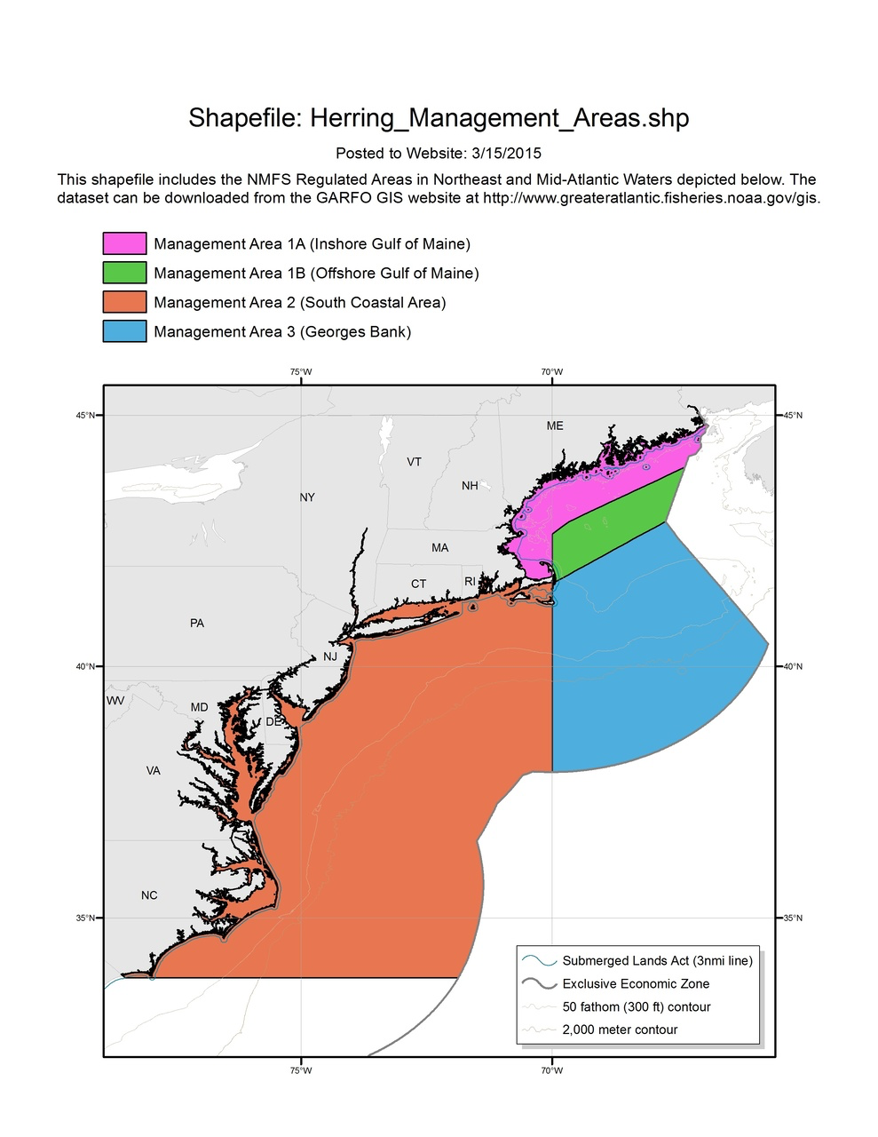

***Figure 1-1.*** *Herring management areas (red=2, blue=3, green=1B, pink=1A).*

**Subsector:** Of the Area 1A sub-ACL, up to 30 metric tonnes are set-aside for the fixed gear fishery west of Cutler, Maine until November 1, at which point it is allocated to the general Area 1A sub-ACL. Up to 5% of the TAC for each area is set aside as bycatch in non-herring fisheries.

**Seasonal allocations:** To provide herring when demand for lobster bait is highest (and therefore best meet the need of the fishery), managers currently allocate 72.8% of the 1A sub-ACL to Season 1 (June 1 - September 30), and 27.2% to Season 2 (October 1 - December 31) (Framework adjustment 1 of FMP). However, based on the recommendation of Maine, New Hampshire, and Massachusetts, the ASMFC annually chooses between bi-monthly, trimester, or seasonal periods. Percents associated with each type of temporal allocation structure is based on vessel trip reports from 2000-2007. Sub-ACL for areas 1B, C, D can also be seasonally allocated to maximize profitability for industry, but this option has not been implemented.

**Research set asides:** In the past, 3% of each area’s sub-ACL had been allocated as research set-aside (RSA). However, to match declines in sub-ACLs, the council has allocated 0% to RSA since 2022.

**Additional allocation measures:** As of spring 2024, the NEFMC is holding scoping meetings to develop a proposal for Amendment 10. The Council is considering additional allocation measures along with other management alternatives “to account for the role of Atlantic herring as forage in the ecosystem and minimize user conflicts” ([Framework Adjustment 2](https://www.federalregister.gov/documents/2013/10/04/2013-24271/fisheries-of-the-northeastern-united-states-atlantic-herring-fishery-framework-adjustment-2-and); [MAPA-4 Seasonal Structure Amendment](https://www.maine.gov/dmr/sites/maine.gov.dmr/files/regulations-2023-03/MAPA%204%20Chapter%2036%20Herring%202023%20Administrative%20Updates_web.pdf); [Herring FMP Summary](https://www.fisheries.noaa.gov/management-plan/atlantic-herring-management-plan); [Amendment 1](http://www.asmfc.org/uploads/file/herringAmend1.pdf); [Amendment 3](http://www.asmfc.org/uploads/file/5b2138d8AtlHerringAmendment3_revisedJune2018.pdf); [Amendment 4](https://www.federalregister.gov/documents/2010/10/18/2010-26195/fisheries-of-the-northeastern-united-states-atlantic-herring-fishery-amendment-4); [Amendment 10 Scoping Doc](https://d23h0vhsm26o6d.cloudfront.net/240216-Herring-Amendment-10-Scoping-Doc_FINAL.pdf); [ASMFC Atlantic Herring Summary](http://www.asmfc.org/species/atlantic-herring#:~:text=Atlantic%20Coastal%20Management,the%20fixed%20gear%20set%2Daside.)).

### 1.4 Monkfish FMP

The Monkfish FMP was implemented in 1998/89 and is led by the MAFMC and jointly managed with the NEFMC. Subsequent framework adjustments and amendments have updated management of monkfish. For more historical context and allocation changes, other actions to look at include Frameworks 2, 4, 7, 8, and 10 and Amendment 5 ([Framework Adjustment 13](https://d23h0vhsm26o6d.cloudfront.net/FR-Monkfish-FW-13-2023-17198.pdf); [50 CFR § 648.92](https://www.law.cornell.edu/cfr/text/50/648.92)).

**No formal allocation:** Although the monkfish fishery is managed through the “allocation” of days at sea (DAS) for vessels with limited entry permits to use in either the Southern or Northern Fishery Management Area, we judged that this does not constitute “allocation” as conceived in this paper. Instead, it represents an effort control, in tandem with trip limits, used to keep catch within the ABC. It closely resembles a catch share program in that it is a limited entry program in which participants are issued equal shares that are tradable; however, it is not formally classified as a catch share program. The following summary justified this decision.

**Management summary:** Monkfish are managed as two stocks located in a northern (NFMA) and southern management area. ABCs for each zone are derived for using an empirical-harvest control rule that scales recent catch based on an index of abundance from trawl surveys in each zone. This catch limit is achieved through a annual days-at-sea (DAS) limits and trip limits. Each limited entry vessel is issued 46 days-at-sea per year and can use up to 35 in the northern area and up to 37 in the southern area. A maximum of 4 unused days-at-sea can be carried over from the previous year. Days-at-sea are transferable between vessels.

**Research set asides:** 500 DAS are set aside for the [Monkfish Research Set-Aside program](https://www.fisheries.noaa.gov/new-england-mid-atlantic/funding-and-financial-services/research-set-aside-programs) each year.

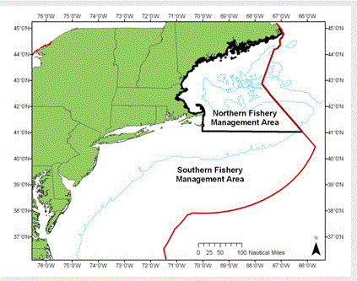

***Figure 1-2.*** *Monkfish management areas.*

### 1.5 Skate Complex FMP

The NEFMC Skate FMP was implemented in 2003 and governs the management of seven skate species barndoor skate (*Dipturis laevis*), clearnose skate (*Raja eglanteria*), little skate (*Leucoraja erinacea*), rosette skate (*Leucoraja garmani*), smooth skate (*Malacoraja senta*), thorny skate (*Amblyraja radiata*), and winter skate (*Leucoraja ocellata*). Winter and little skates dominate the commercial fishery, with winter skates targeted for wings and little skates for bait. However, the following rules apply to all species in the complex.

**Set asides:** The first deduction from the annual catch target is a deduction for expected recreational catch, state landings, and discards.

**Subsector allocations:** The annual skate complex federal TAL is then allocated between the skate wing fishery (66.5%) and the bait fishery (33.5%) based on proportional average landings between 1995-2006. Winter and little skates dominate the commercial fishery, with winter skates targeted for wings and little skates for bait. However, these rules apply to all species in the complex.

**Seasonal allocations:** For both the wing and bait fisheries, catch is allocated across seasons so that the management council can more closely manage harvest, and to maximize catch during season when most fishing happens. For the skate wing fishery, 57% of TAL can be harvested in season 1 (May 1 - August 31), and the remaining TAL in season 2 (September 1 - April 30). For the skate bait fishery, 30.8% can be harvested in season 1 (May 1-July 31), 37.1% can be harvested in season 2 (August 1-October 31), and the remaining TAL can be harvested in season 3 (November 1-April 30). These were set by [Amendment 3](https://repository.library.noaa.gov/view/noaa/3854) based on landings from 1998-2006. ([Framework Adjustment 8](https://www.federalregister.gov/documents/2020/04/27/2020-07805/fisheries-of-the-northeastern-united-states-northeast-skate-complex-framework-adjustment-8-and); [50 CFR § 648.322](https://www.law.cornell.edu/cfr/text/50/648.322#:~:text=(i)%20Season%201%E2%80%94May,Season%201%20shall%20be%20allocated.); [Framework Adjustment 3](https://d23h0vhsm26o6d.cloudfront.net/Final-Rule-Skate-FW3.pdf)).

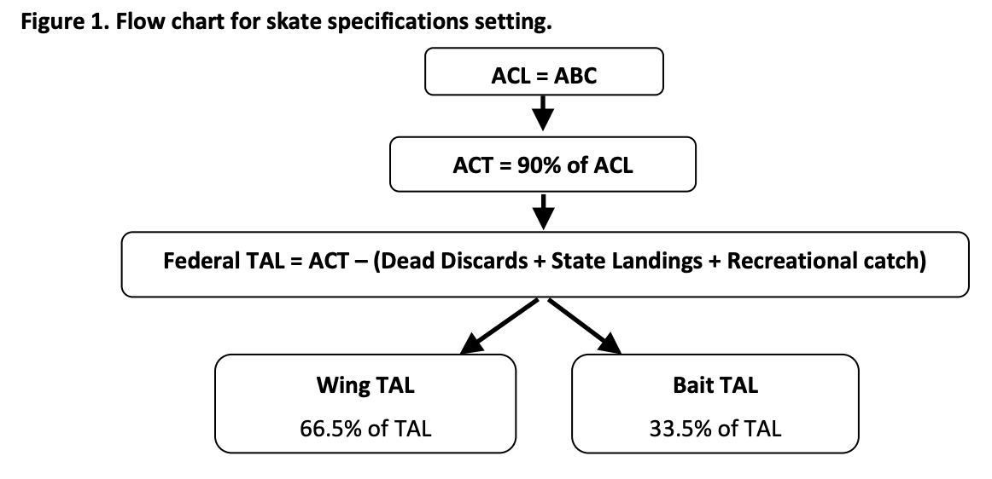

***Figure 1-3.*** *Flowchart illustrating allocation in the skate fishery (*[*Framework Adjustment 12*](https://d23h0vhsm26o6d.cloudfront.net/240530-Skate-FW12-final-submission.pdf)*).*

### 1.6 Atlantic Sea Scallop FMP

The NEFMC Atlantic Sea Scallop FMP was implemented in 1982 and governs the management of Atlantic sea scallop (*Placopecten magellanicus*).

**Set asides:** Before allocation among commercial subsectors, some of the ABC is first set aside for: (1) incidental catch; (2) research set-asides (RSA); (3) observer programs; (4) the Industry-Funded Scallop (IFS) Observer Program (1% of ABC); and (5) the Northern Gulf of Maine (NGOM) Permit Holders and General Category IFQ fleet.

**Subsector and spatial allocations:** After these set-asides are subtracted, the remaining landings are allocated among the limited access fleet (i.e. larger ‘trip boats’) at 94.5%, the LAGC IFQ fleet (i.e. smaller ‘day boats’) at 5%, and the combo fleet (limited access vessels that also have LAGC IFQ permits) at 0.5% ([Amendment 11](https://d23h0vhsm26o6d.cloudfront.net/Amendment_11FSEIS_0709_Submission_v1.pdf)). The rationale for these allocations was that 5% reflects a percentage similar to the long-term average, but a little higher to recognize more recent growth and participation in the general category fishery. Furthermore, in 2004, the fishing year the control date was implemented, the general category fishery was landing about 5% of total scallop landings. The Council believes it is a level of catch that would ideally provide enough landings to be spread among various general category vessels that participate in this fishery at a variety of levels without substantial impacts on the existing limited access fishery.

Allocation for the limited access fleet is set by days-at-sea in open areas and trips (set poundage) to rotational access areas (**Figure 1-4**). As of 2024, full-time permit holders are allocated 20 DAS in open areas and 3 12,000 pound trips in specified access areas. Part-time permit holders are allocated 8 DAS in open areas and 1 trip in a specified access area. Occasional permit holders are allocated 1.67 DAS in open areas; however, there are currently no active occasional permit holders in the fishery (Jonathon Peros, personal communication). Unharvested pounds for one access area can be exchanged for poundage in another access area (one-for-one access area trip exchange program).

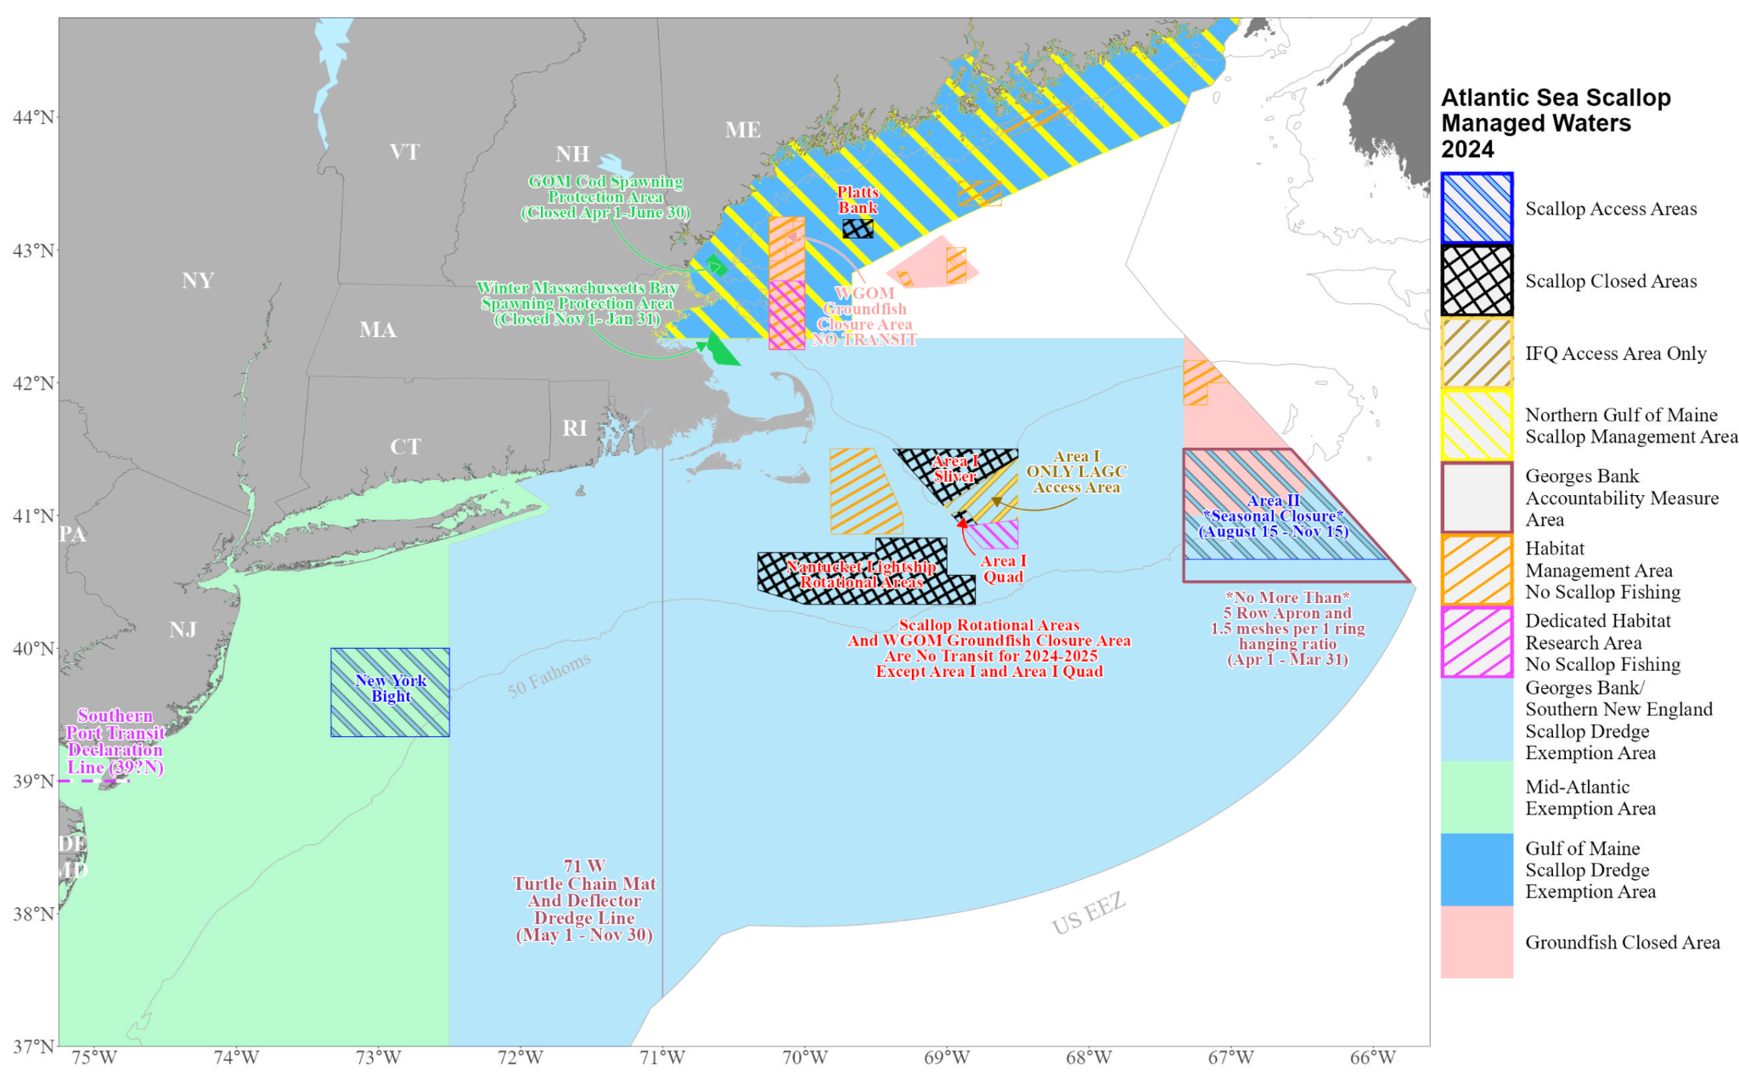

***Figure 1-4.*** *Map of Atlantic scallop management areas.*

**Catch share allocations:** IFQs were initially distributed to fishery participants who had harvested significant landings between 2000-2004. Initial IFQ allocations were set according to the number of years active between 2000-2004, and the highest annual landings in this period. Quota can be temporarily or permanently transferred among members of the LAGC IFQ fleet. Amendment 21 permitted leasing of quota from combo vessels (limited access vessels with IFQ) to IFQ-only vessels (2022). Members of the LAGC IFQ fleet are also allocated a number of trips into the scallop access areas (856 in 2024) ([50 CFR § 648.59](https://www.law.cornell.edu/cfr/text/50/648.59); [Amendment 21](https://d23h0vhsm26o6d.cloudfront.net/2022-00367.pdf); [50 CFR § 648.62](https://www.law.cornell.edu/cfr/text/50/648.62); [MCFA Scallop Info](https://www.mainecoastfishermen.org/scallops); [Amendment 11](https://www.federalregister.gov/documents/2008/04/14/E8-7795/fisheries-of-the-northeastern-united-states-atlantic-sea-scallop-fishery-amendment-11); [NOAA Scallop Profile](https://www.fisheries.noaa.gov/species/atlantic-sea-scallop/management); [Framework Adjustment 38](https://www.federalregister.gov/documents/2024/02/12/2024-02236/fisheries-of-the-northeastern-united-states-framework-adjustment-38-to-the-atlantic-sea-scallop); [Framework Adjustment 38 press release](https://d23h0vhsm26o6d.cloudfront.net/NEFMC-Advances-Scallop-Framework-Adjustment-38-for-Fishing-Year-2024-Higher-VMS-Ping-Rates-Part-of-the-Package.pdf); [Atlantic Sea Scallop Permit Details](https://www.fisheries.noaa.gov/permit/atlantic-sea-scallop)).

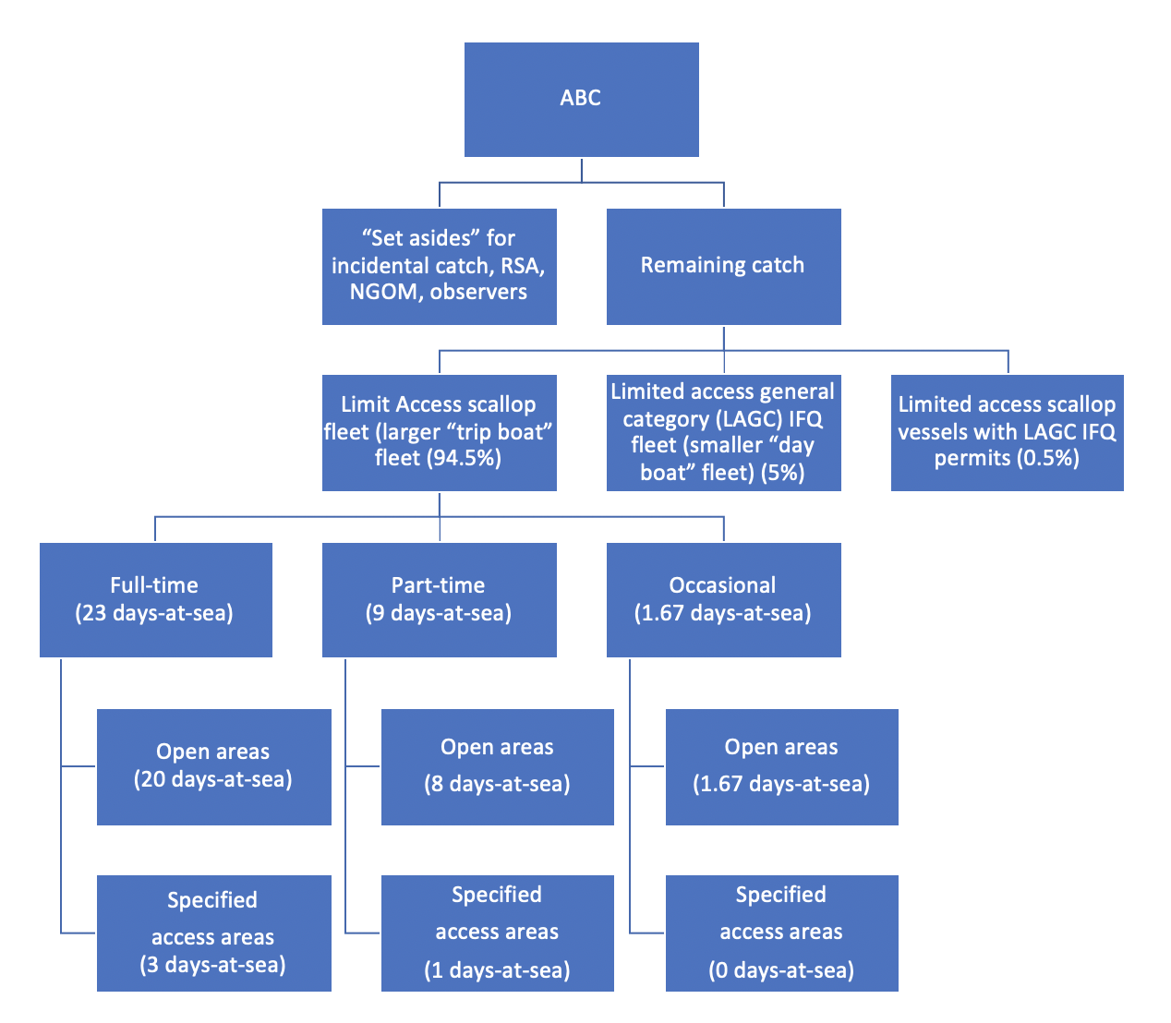

***Figure 1-5.*** *Flowchart illustrating catch allocations in the scallop fishery.*

## 2. Mid-Atlantic

The MAFMC implements seven fishery management plans including two plans jointly managed with the NEFMC (**Table 2-1**). The MAFMC leads the jointly managed Spiny Dogfish FMP.

***Table 2-1.*** *FMPs implemented by the MAFMC.*

|  |  |  |
| --- | --- | --- |
| **FMP** | **Species** | **Brief allocation summary** |
| Summer Flounder, Scup, Black Sea Bass | Summer flounder | Sector and state allocations |
| Summer Flounder, Scup, Black Sea Bass | Scup | Sector, state, seasonal allocations |
| Summer Flounder, Scup, Black Sea Bass | Black sea bass | Sector and state allocations |
| Mackerel, Squid, Butterfish | Atlantic mackerel | International, sector, subsector |
| Mackerel, Squid, Butterfish | Chub mackerel | None |
| Mackerel, Squid, Butterfish | Longfin squid | Sector and seasonal |
| Mackerel, Squid, Butterfish | Shortfin squid | None |
| Mackerel, Squid, Butterfish | Butterfish | None |
| Surfclams, Ocean Quahogs | Surfclams | Individual transferable quotas |
| Surfclams, Ocean Quahogs | Ocean quahogs | Individual transferable quotas |
| Bluefish | Bluefish | Sector and state allocations |
| Golden and Blueline Tilefish | Golden tilefish | Subsector allocations and IFQs |
| Golden and Blueline Tilefish | Blueline tilefish | Sector allocations |
| Spiny Dogfish *(led by MAFMC with NEFMC)* | Spiny Dogfish | State allocations |
| Monkfish *(led by the NEFMC with MAFMC)* | Monkfish |  |

When setting and/or revising allocations, the MAFMC uses tools, such as triggered allocation revisions, phased allocation changes, and *de minimis* allocations proportions, to minimize the impact of significant allocation shifts across years and ensure long-term stability within fisheries:

* **Triggers** are set to change an allocation percentage when a previously specified threshold is surpassed, often pounds of quota.
* **Phase-in/out approaches** are used to spread out the change in allocation over a pre-specified amount of time, which is useful when large allocation shifts occur. Phasing in or out new allocation policies spread the burden associated with the allocation change over many years to avoid significant negative impacts to fishing communities.
* ***De minimis* allocations** are often used in joint-management endeavors with the Atlantic States Marine Fisheries Commission (ASMFC). They ensure that all states retain at least some portion of the coastwide allocation each year. *De minimis* allocations are removed from catch limits before the remainder is allocated according to protocol.

**Research set asides (RSA):** The MAFMC previously “set-aside” a percentage of landings to support research and data collection activities. This was approved in 2001 as part of [Framework Adjustment 1](https://www.mafmc.org/s/Research_Set-Aside_FW1.pdf) for four FMPs: (1) Mackerel, Squid, and Butterfish, (2) Summer Flounder, Scup, and Black Sea Bass, (3) Bluefish, and (4) Tilefish. The Amendment allowed the MAFMC to set aside up to 3% of a species' allowable landings for research. RSA quota allocations were used from 2001-2014, but in 2014, the Council voted to suspend the program due to funding and administrative challenges and no RSA allocations have been made since.

### 2.1 Summer Flounder, Scup, and Black Sea Bass FMP

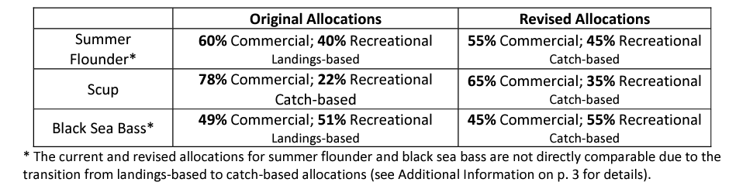

***Table 2-2.*** *Original and revised (Amendment 22, 2022) sector allocations for summer flounder, scup, and black sea bass.*

#### 2.1.1 Summer Flounder

Summer flounder (*Paralichthys dentatus*) is managed through the [Summer Flounder, Scup, and Black Sea Bass FMP](https://www.mafmc.org/s/SFSCBSB__FMP.pdf) (1988 and 1996) and subsequent frameworks and amendments.

**Sector allocations:** Allocations were originally set at 60% commercial and 40% recreational in the mid-1990s using landings-based data from 1980-1989. These allocations were revised through [Amendment 22](https://www.mafmc.org/s/SFSBSB_com_rec_allocation_EA-final_6-24-22.pdf) (2022) based on updated catch data from a slightly updated time period (1981-1989) used for the original allocations. Now, the commercial sector is allocated 55% and the recreational sector is allocated 45% of the acceptable biological catch. The timeframes used to set the new allocations was maintained (the exclusion of 1980 was only because it was not included in the updated MRIP data) because it represented a period of relatively unrestricted fishing effort and, therefore, could serve as a proxy for each sector’s level of effort and interest in the fishery prior to implementation of management controls.

**State (spatial) allocations:** Summer flounder also has commercial state allocations that vary with overall stock abundance and resulting commercial quotas and that are affected by a trigger point. For all years when the annual commercial quota is at or below a specified annual commercial quota trigger level (9.55 million pounds), the state allocations remain status quo (**Table 2-3**). In years when the annual coastwide quota exceeds the specified trigger, the trigger amount is distributed according to the status quo allocations, and the additional quota beyond that trigger is distributed in equal shares (with the exception of Maine, New Hampshire, and Delaware, which split 1% of the additional quota above 9.55 million pounds). The 9.55 million pound trigger was derived as the average of the values for the 5-year period from 2014-2018 (2014-2018 million lbs) and the 10-year period from 2009-2018 (10.71 million lbs). The original state allocations were based on 1980-1989 landings (Amendment 2) and were slightly modified by Amendment 4 to account for previously unrecorded landings in Connecticut.

***Table 2-3.*** *Allocation of summer flounder commercial quota to states based on a quota threshold.*

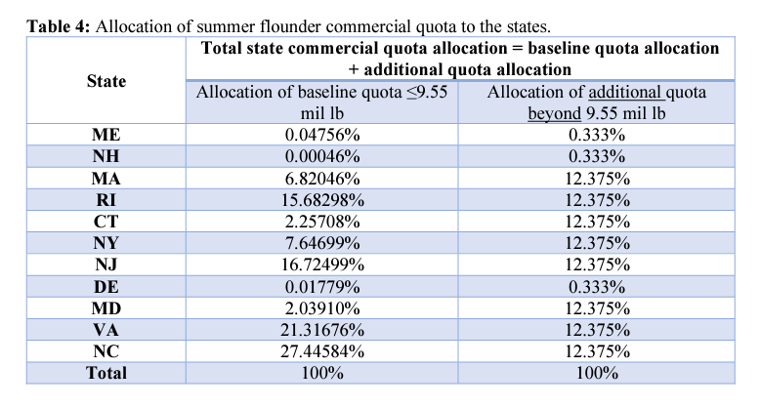

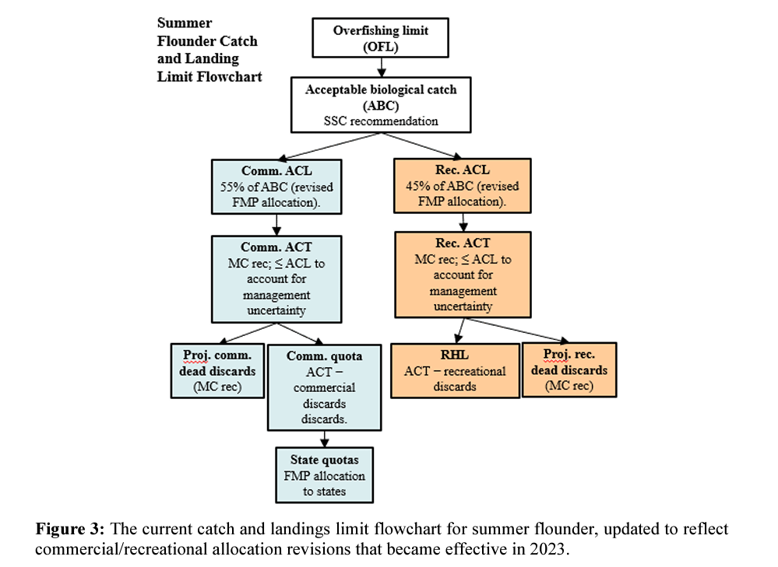

***Figure 2-1.*** *Flowchart illustrating catch allocation in the summer flounder fishery.*

#### 2.1.2 Scup

Scup (*Stenotomus chrysops*) is managed through the [Summer Flounder, Scup, and Black Sea Bass FMP](https://www.mafmc.org/s/SFSCBSB__FMP.pdf) (1988 and 1996) and subsequent frameworks and amendments.

**Sector allocations:** Allocations were originally set at 78% commercial and 22% recreational in the mid-1990s using catch-based data from 1988-1992. These allocations were revised through [Amendment 22](https://www.mafmc.org/s/SFSBSB_com_rec_allocation_EA-final_6-24-22.pdf) (2022) based on updated catch data from the same years (1988-1992) used for the original allocations. Now, the commercial sector is allocated 65% and the recreational sector is allocated 35% of the overall acceptable biological catch (ABC). The timeframes used to set the new allocations were not updated because they represented periods of relatively unrestricted fishing effort and, therefore, could serve as a proxy for each sector’s level of effort and interest in the fishery prior to implementation of management controls.

**Seasonal allocations:** Commercial quota is allocated across three quota periods (i.e., Winter I, Summer, and Winter II) for states from Maine to North Carolina. These quota periods were initially established through a 1996 regulatory amendment based on commercial landings from 1983-1992 ([1996 Amendment](https://static1.squarespace.com/static/511cdc7fe4b00307a2628ac6/t/57ec1a3229687f46fea561d3/1475090998727/SFSBSB_Regulatory_Amend_1996.pdf)) and the periods were updated in 2018 through Framework 11 though the percentages were retained ([Framework 11](https://static1.squarespace.com/static/511cdc7fe4b00307a2628ac6/t/5ad7726d2b6a28c3854d1cdc/1524069140871/Scup_quota_period_FW_EA_resubmission2_Feb2018.pdf)). The seasonal allocations were intended to spread out the catch to ensure access for small boats later in the season. Once the quota for a given period is reached, the commercial fishery is closed for the remainder of that period. If the full winter I quota is not harvested, unused quota is added to the winter II period. Any quota overages during the winter I and II periods are subtracted from the quota allocated to those periods in the following year. Quota overages during the summer period are subtracted from the following year’s quota only in the states where the overages occurred.

***Table 2-4.*** *Dates, allocations, and possession limits for the commercial scup quota periods. Winter period possession limits apply in both state and federal waters.*

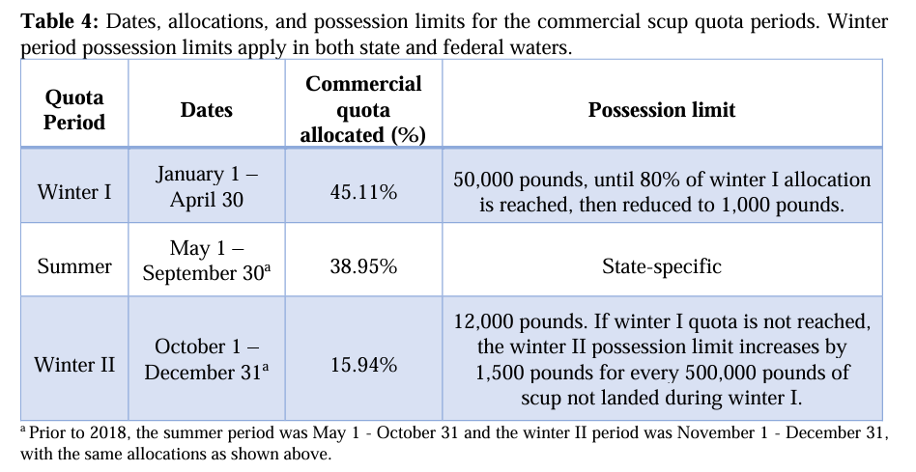

**State allocations:** The summer commercial quota is further allocated among states based on the percentages in **Table 2-5** below.

**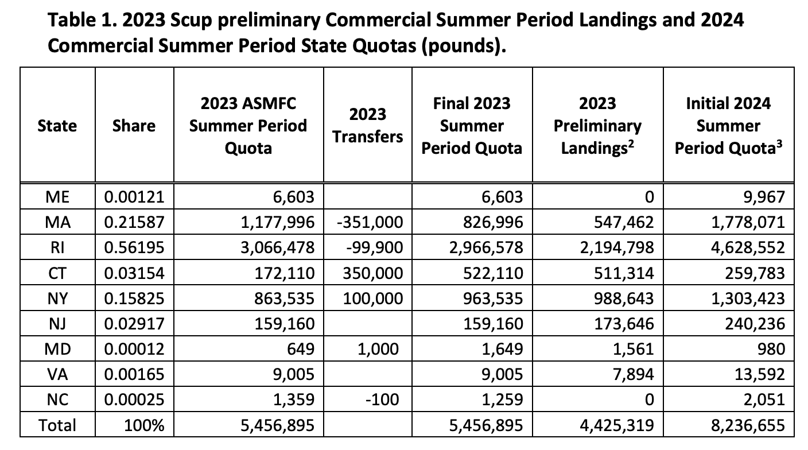*Table 2-5.*** *State-by-state quotas for the commercial scup fishery during the summer quota period (May-Sep) (*[*ASMFC 2023*](https://asmfc.org/uploads/file/6570d6832024ScupBSBCommercialQuota_Dec2023.pdf)*).*

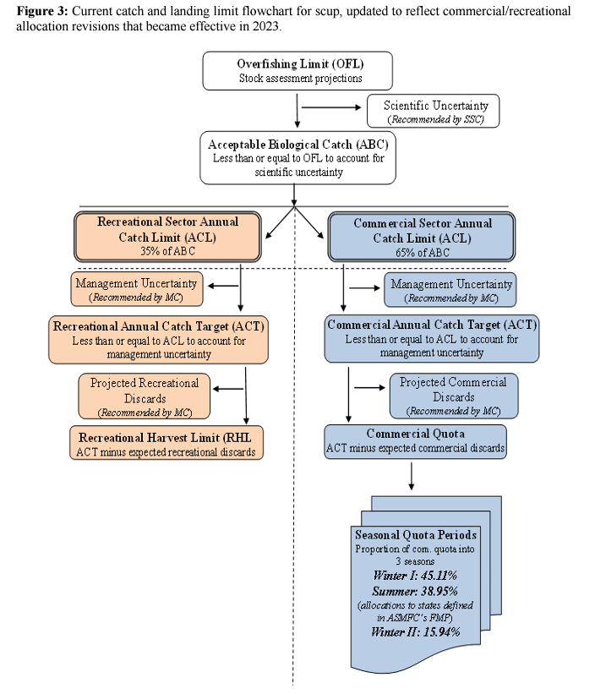

***Figure 2-2.*** *Flowchart illustrating catch allocations in the scup fishery.*

#### 2.1.3 Black Sea bass

Black sea bass (*Centropristis striata*) is managed through the Summer Flounder, Scup, and Black Sea Bass FMP (1988 and 1996) and subsequent frameworks and amendments.

**Sector allocations:** Allocations were originally set at 49% commercial and 51% recreational in the mid-1990s using landings-based data from 1983-1992. These allocations were revised through Amendment 22 (2022) based on updated landings data from the same years (1983-1992) used for the original allocations. Now, the commercial sector is allocated 45% and the recreational sector is allocated 55% of the acceptable biological catch (ABC). The timeframes used to set the new allocations were not updated because they represented periods of relatively unrestricted fishing effort and, therefore, could serve as a proxy for each sector’s level of effort and interest in the fishery prior to implementation of management controls.

**State allocations:** The commercial black sea bass fishery also has a separate set of allocations for the states. These were first implemented in 2003 through Amendment 13 and were “loosely based on historical landings from 1980-2001”. They were revised in 2021 through the ASMFC’s Addendum 33 ([ASMFC 2021](https://asmfc.org/uploads/file/63e3ee81BSB_AddendumXXXIII_Revised_Aug_2021.pdf)) to increase New York and Connecticut’s allocation given the increase in black sea bass abundance in their waters since the original allocation. Annually, 75% of the coastwide quota is distributed to states using the baseline allocations. The remaining 25% of the coastwide quota will first be allocated regionally based on the most recent regional biomass proportions from the stock assessment. Then, regional quotas are distributed to the states within each region in proportion to their baseline allocations, with the exception of Maine and New Hampshire. Maine and New Hampshire each receive 1% of the northern region quota. The regional biomass proportions used to allocate 25% of the coastwide quota are dependent on information from the most recent stock assessment. Therefore, they are updated by future stock assessments, which may result in changes to the state allocations. These state specific allocations are implemented by the ASMFC, but as of 2023, the MAFMC has refused to integrate them into the FMP because of the additional administrative burden. These allocations were proposed in draft Amendment 23, but ultimately excluded from the Final Rule.

***Table 2-6.*** *Changes in baseline state allocations from historical allocations under Addendum 33.*

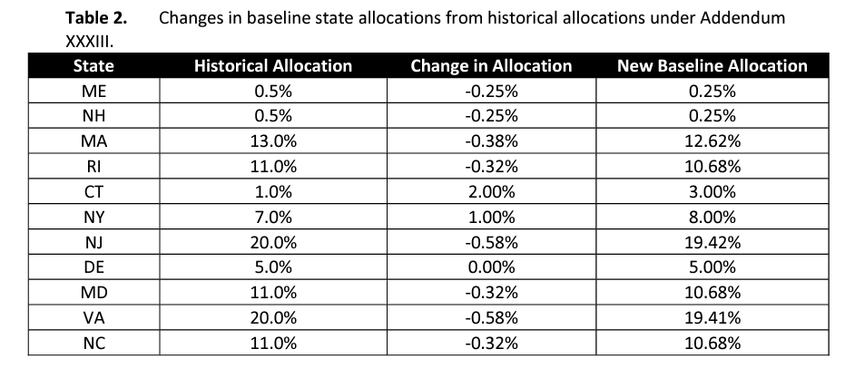

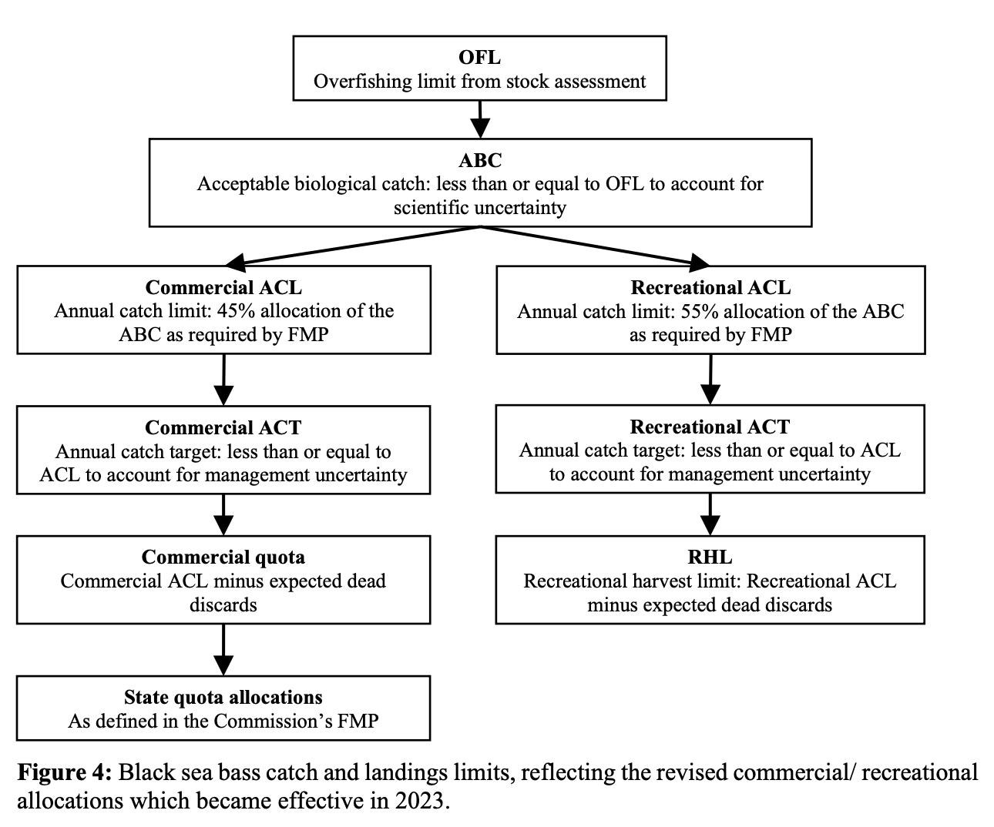

***Figure 2-3.*** *Flowchart illustrating catch allocations in the black sea bass fishery (*[*MAFMC 2024*](https://static1.squarespace.com/static/511cdc7fe4b00307a2628ac6/t/6683032fa306b9070227348b/1719862063436/2024_BSB-fishery-info-doc.pdf)*).*

### 2.2 Mackerel, Squid, and Butterfish FMP

#### 2.2.1 Atlantic mackerel

Atlantic mackerel (*Scomber scombrus*) is managed through the [Atlantic Mackerel FMP](https://www.mafmc.org/s/SMB__Mackerel__Original_Plan.pdf) (1978), [the Merged FMP](https://www.mafmc.org/s/SMB_Merged_FMP.pdf) (1983), and subsequent frameworks and amendments.

**Original FMP:** In 1978, total harvest was initially partitioned for domestic commercial fishers (3,500 mt), the domestic recreational sector (4,500 mt), and foreign fishing interests (1,200 mt). For the U.S. portion, the sector split was approximately 64% recreational and 36% commercial. Foreign quotas were allocated among 10 nations with a small portion reserved.

**Amendment 11 revisions:** [Amendment 11](https://www.mafmc.org/s/Amendment-11-FEIS-FINAL_2011_05_12.pdf) developed a new limited access system for allocating commercial catch among the commercial tiers:

1. Tier 1: At least 400,000 pounds landed in any one year between 1997-2005.
2. Tier 2: At least 100,000 pounds landed in any one year between 3/1/1994-2005.
3. Tier 3: At least 1,000 pounds landed in any one year between 3/1/1994-2005.

Tier 3 vessels are constrained to a maximum of 7% of the commercial quota with the remainder allocated to the Tier 1-2 vessels. Tier 1 has no trip limit when the fishery is open, Tier 2 has a 135,000 pound trip limit, and Tier 3 has a 100,000 pound trip limit.

The recreational fishery is allocated 7.3% of the catch, which was the percentage of the ABC that corresponded to the proportion of total U.S. landings that were accounted for by the recreational fishery from 1997-2007 from MRFSS database times 1.5.

**Framework 13 revisions:** [Framework 13](http://www.mafmc.org/s/Mack-Rebuild-FW-EA_signed-FONSI.pdf) (2019) revised the 7.3% recreational allocation due to a lack of direct control over the fishery. The revised structure replaced a percentage allocation with a set-aside for expected recreational catch (reducing the commercial quota accordingly).

**International allocations:** The stockwide ABC includes Canadian waters. Expected Canadian landings are deducted from the stockwide ABC to derive a U.S. ABC.

#### 2.2.2 Chub mackerel

In 2020, [Amendment 21](https://www.mafmc.org/s/MSB-Am21_Chub-Mackerel_Final-EA.pdf) added chub mackerel (*Scomber japonicus*) to the MSB FMP. There is currently no separation of catch limits into commercial and recreational components.

#### 2.2.3 Longfin squid

Longfin inshore squid (*Doryteuthis pealeii*) are managed through the Squid FMP (1978), the Merged FMP (1983), and subsequent frameworks and amendments.

**Sector allocations:** Although sector allocations were used in the original FMP, they were removed by Amendment 5 in 1996. Total harvest was initially allocated to domestic commercial fishers, the recreational sector, and to foreign fishing interests. However the total allowable level of foreign fishing was set equal to zero in Amendment 5 (1996), and the recreational catch is believed to be negligible relative to commercial catch.

**Seasonal allocations:** The quota has been allocated into seasons to ensure sustainable harvest rates. The quota is divided into three 4-month trimesters: (1) T1, Jan-Apr gets 43% of the quota; T2, May-Aug gets 17% of the quota; and T3, Sep-Dec gets 40% of the quota. These allocations are based on landings from 1994-1998 (Didden, personal communication) and were intended to ensure that different portions of the fleet (inshore vs. offshore) had access at different points of the year (Didden, personal communication). It is also likely to spread out catch so that any cohort of this sub-annual species is not subject to maximum fishing pressure from the whole quota (Didden, personal communication).

Unused quota can roll over into later trimesters within a year depending on the amount of longfin landed. Underages from T1 that are greater than 25% are reallocated to trimesters 2 and 3 in even splits. However, the T2 quota may only be increased 50% above its base and the remaining portion of the underage is reallocated to T3. Any underages for T1 that are less than 25% of the T1 quota are applied only to T3 of the same year. Any overages for T1 and T2 are subtracted from T3 of the same year as needed.

#### 2.2.4 Shortfin squid

Northern shortfin squid (*Illex illecebrosus*) are managed through the [Squid FMP](https://www.mafmc.org/s/SMB__Mackerel__Original_Plan.pdf) (1978), the [Merged FMP](https://www.mafmc.org/s/SMB_Merged_FMP.pdf) (1983), and subsequent frameworks and amendments.

**Sector allocations:** Although sector allocations were used in the original FMP, they were removed by Amendment 5 in 1996. Total harvest was initially allocated to domestic commercial fishers, the recreational sector, and to foreign fishing interests, however the total allowable level of foreign fishing was set equal to zero in Amendment 5 (1996), and the recreational catch is believed to be negligible relative to commercial catch.

#### 2.2.4 Butterfish

Butterfish (*Peprilus triacanthus*) are managed through the Butterfish FMP (1978), the Merged FMP (1983), and subsequent frameworks and amendments.

**Sector allocations:** Although sector allocations were used in the original FMP, they were removed by Amendment 5 in 1996. Total harvest was initially allocated to domestic commercial fishers, the recreational sector, and to foreign fishing interests, however the total allowable level of foreign fishing was set equal to zero in Amendment 5 (1996), and the recreational catch is believed to be negligible relative to commercial catch.

### 2.3 Atlantic Surfclam and Ocean Quahog FMP

Atlantic surfclams (*Spisula solidissima*) and ocean quahogs (*Arctica islandica*)are managed through the Atlantic Surfclam and [Ocean Quahog FMP](https://www.mafmc.org/s/SCOQ__FMP.pdf) (1977) and subsequent frameworks and amendments ([amendments](https://www.mafmc.org/scoq)).

**Original FMP (seasonal):** Within the original FMP, Atlantic surfclam quota was originally allocated across quarterly periods while ocean quahog was allocated using a single yearly quota until revised in [Amendment 1](https://www.mafmc.org/s/SCOQ_Amend_1.pdf) and [Amendment 2](https://www.mafmc.org/s/SCOQ_Amend_2.pdf) to reflect updated quotas.

**Amendment 8 (ITQ):** Then, [Amendment 8](https://www.mafmc.org/s/SCOQ_Amend_8.pdf) (1988) replaced the regulated fishing time system in the surfclam and ocean quahog fisheries with an individual transferable quota (ITQ) system that was implemented in 1990. Allocations of ITQ quota share for both species were made available to owners of all permitted vessels that harvested surfclams and/or ocean quahogs in the Atlantic EEZ from January 1, 1979 through December 31, 1988. The MAFMC based 80% of the allocation on the vessel’s average annual historical catch over this time period (1979-1988), with the worst two years dropped and the best four years counted twice. The remaining 20% of the allocation was based on the vessel’s capacity (length x width x depth). ITQ quota share is issued in the form of cage tags that must be attached to the cages used to transport the catch. ITQ quota share may be transferred in amounts not less than 160 bushels (i.e., 5 cages) to any person eligible to own a U.S. fishing vessel. The transfer is not effective until the new owner receives an ITQ allocation permit from NMFS. While implementation of the ITQ program ended the moratorium of new entrants to the fishery, the high cost of entry has led to low numbers of new participants. In 2022, the MAFMC implemented the excessive shares amendment ([Amendment 20](https://www.mafmc.org/s/SCOQ-Excessive-Shares-EA_final-Signed.pdf)), which created two quota share caps: (1) one on quota share ownership (surfclam: 35%, quahog: 40%) and (2) a higher annual allocation cap (annual cage tags) that an individual or entity can possess (surfclam: 65%, quahog: 70%). The Council is required to review the ITQ program every 10 years, or sooner if necessary ([Amendment 20](https://static1.squarespace.com/static/511cdc7fe4b00307a2628ac6/t/636bbaebaed4be66dbb00ad7/1668004594810/SCOQ+Excessive+Shares+EA_final+Signed.pdf)). The first review for this fishery was conducted in 2019 ([Northern Economics 2019](https://static1.squarespace.com/static/511cdc7fe4b00307a2628ac6/t/5ce6b5c04785d3804e234bbb/1558623695725/SCOQ+ITQ+Program+Review+Final+20190517.pdf)).

### 2.4 Bluefish FMP

Atlantic Bluefish (*Pomatomus saltatrix*) is managed through the [Bluefish FMP](https://www.mafmc.org/s/Bluefish__FMP.pdf) (1990) and subsequent frameworks and amendments.

**Original FMP:** Sector-based allocations were originally established for the commercial (20%) and recreational fisheries (80%), recognizing the importance of bluefish as a key marine sport fish along the Atlantic coast. Further decisions to implement controls on the bluefish fishery were based on three-year moving averages and trends that focused on the current year's landings compared to the previous year.

**Amendment 1:** In 2000, [Amendment 1](https://www.mafmc.org/s/Bluefish_Amend_1_Vol_1.pdf) revised the commercial (17%) and recreational allocations (83%) using a time series from 1981-1989 and required that a commercial quota and recreational harvest limit be based on projected stock size estimates as derived from the latest stock assessment. The same time series was also used to implement commercial allocations to the states, which offer opportunities for northern or southern states to all access the fishery throughout the year, or whenever the highly migratory species is present in state-specific coastal waters. Also under Amendment 1, transfers of quota were allowed from the recreational to commercial sector and were capped at 10.5 million pounds as the commercial quota, and were authorized in the commercial sector between states to increase the flexibility of the system in responding to yearly variations in fishing practices or landings patterns.

**Amendment 7:** In 2021, [Amendment 7](https://www.mafmc.org/s/Bluefish-Amendment-7-EA.pdf) reallocated the commercial (14%) and recreational (86%) sectors using updated catch and landings data through 2018 (three periods inform similar allocations: 1981-2018, 2009-2018, 2014-2018), revised the commercial allocations to the states with landings data from 2009-2018 over a 7-year phase-in period and a *de minimis* allocation to all states of 0.1% **(Table 2-7)**, and updated the transfer provisions to allow transfers of quota to occur to or from either sector (i.e., not only recreational to commercial).

***Table 2-7.*** *Allocation of the 2024 commercial bluefish quota among states. Percentages are fixed but the pounds vary based on the catch limit.*

|  |  |  |
| --- | --- | --- |
| **State** | **Percent Share** | **Quota (pounds)** |
| Maine | 0.43 | 10,388 |
| New Hampshire | 0.33 | 7,975 |
| Massachusetts | 8.17 | 198,025 |
| Rhode Island | 8.01 | 194,025 |
| Connecticut | 1.19 | 28,821 |
| New York | 14.4 | 348,947 |
| New Jersey | 14.4 | 348,898 |
| Delaware | 1.29 | 31,139 |
| Maryland | 2.54 | 61,471 |
| Virginia | 9.3 | 225,380 |
| North Carolina | 32.05 | 776,452 |
| South Carolina | 0.06 | 1,561 |
| Georgia | 0.05 | 1,194 |
| Florida | 7.8 | 188,899 |

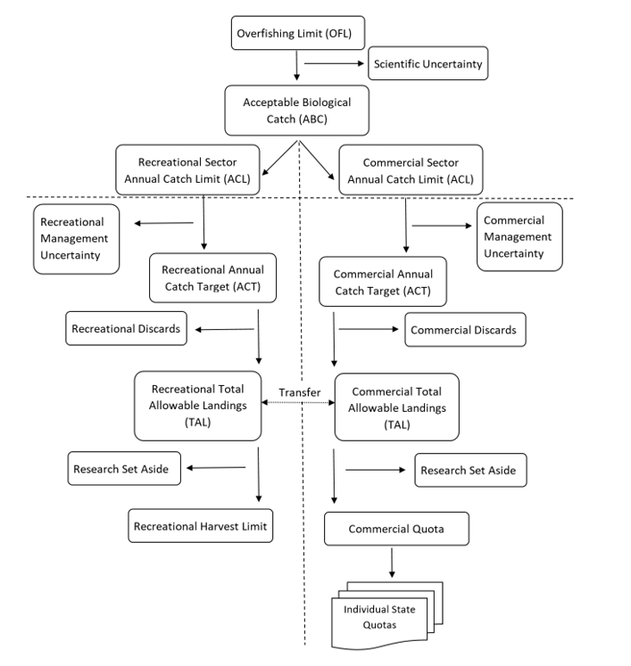

***Figure 2-4.*** *Flowchart illustrating catch allocations in the bluefish fishery.*

### 2.5 Tilefish FMP

#### 2.5.1 Golden tilefish

Golden tilefish (*Lopholatilus chamaeleonticeps*) is managed through the [Tilefish FMP](https://www.mafmc.org/s/Tilefish_FMP.pdf) (2001) and subsequent frameworks and amendments.

**Incidental catch:** 5% of catch limit is set aside for incidental catch and the remaining 95% is used for the directed commercial fishery, which is divided into subsectors described below.

**Subsector allocations:** In 2001, the Council adopted an allocation structure with a two-tier full-time category, where a vessel would have had to land at least 250,000 pounds per year for three years between 1993 and 1998 to be in tier 1. The vessels in this full-time tier 1 category received 66% of the annual quota. To be in the full-time tier 2 category, a vessel would have had to land at least 30,000 pounds per year for 3 years between 1993 and 1998 and this tier 2 category would receive 15% of the annual quota allocation. To be in the part-time category, a vessel would have had to land 10,000 pounds of tilefish in one year between 1988 and 1993 and 10,000 pounds in one year between 1994 and 1998, or have landed 28,000 pounds of tilefish in one year between 1984 and 1993. This part-time category received 19% of the annual quota allocation.

***Table 2-8.*** *Subsector definitions and allocations in the golden tilefish fishery.*

|  |  |  |
| --- | --- | --- |
| **Tier** | **Qualification criteria** | **Percent of quota** |
| Tier 1 | >250,000 lbs in 3 years from 1993-1998 | 66% |
| Tier 2 | >30,000 lbs in 3 years from 1993-1998 | 15% |
| Part-time | >10,000 lbs in 1 year from 1988-1993 and 1 year from 1994-1998 **OR** >28,000 lbs in 1 year from 1984-1993 | 19% |

**IFQ allocations:** In 2008, the MAFMC established an IFQ system implemented in 2009 ([Amendment 1](https://www.mafmc.org/s/Tilefish_Amend_1_Vol_1-y2ij.pdf)) for any combination of tier 1, tier 2, and part-time participants, which would receive a specific percentage of their group quotas (after adjustments for the incidental category have been made). IFQ shares would be issued to participants in denominations equaling the shareholders share of the quota initially allocated to their respective categories. For IFQ share allocation purposes, average landings for the 2001-2005 period were used to allocate IFQ shares to full-time tier 1 and 2 vessels. For part-time vessels, an equal allocation for vessels that landed tilefish during the 2001-2005 period was used to allocate IFQ shares to that permit category.

Prior to the beginning of each fishing season (or at times commercial quota adjustments are required), the percentage of the quota allocated to IFQ permit holders would be specified in both whole (live) and gutted (landed) weight. Under this allocation structure, shareholders are permitted to permanently transfer or lease their IFQ and are subject to a share accumulation limit of 49% of the TAL. Lastly, the IFQ program is subject to a review process at least every seven years.

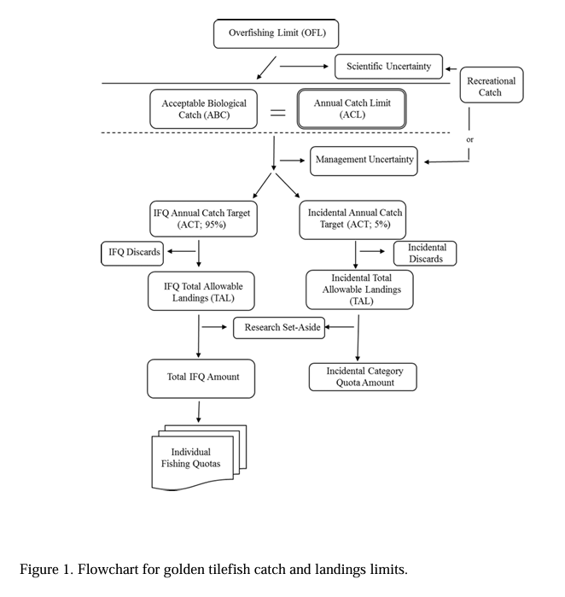

***Figure 2-5.*** *Flowchart illustrating catch allocations in the golden tilefish fishery.*

#### 2.5.2 Blueline tilefish

Blueline tilefish (*Caulolatilus microps*) is managed through [Amendment 6](https://static1.squarespace.com/static/511cdc7fe4b00307a2628ac6/t/5c1810d98a922d4272fd4f21/1545081051493/Blueline+Tilefish+Amendment_Final+EA_09-12-2017.pdf) to the [Tilefish FMP](https://www.mafmc.org/s/Tilefish_FMP.pdf) (2017) and subsequent frameworks and amendments.

**Management history:** In 2014, blueline tilefish catch significantly increased in the Mid-Atlantic without any restrictions in Federal waters, and the long-lived and sedentary nature of blueline tilefish was expected to make them susceptible to overfishing. Therefore, following a Council request to address the issue, in 2015, NMFS implemented emergency regulations north of North Carolina, limiting commercial vessels to 300 pounds (whole weight) of blueline tilefish per trip and recreational fishermen to 7 blueline tilefish per person per trip, as well as requiring commercial and for-hire permitting and reporting. These emergency measures were extended via an interim rule through December 14, 2016.

**Sector allocations:** In 2017, the Council developed and approved [Amendment 6](https://static1.squarespace.com/static/511cdc7fe4b00307a2628ac6/t/5c1810d98a922d4272fd4f21/1545081051493/Blueline+Tilefish+Amendment_Final+EA_09-12-2017.pdf), which included sector-based allocations that were set using median catch percentages from 2009-2013 (2014 was excluded given that it was anomalously high and triggered the emergency action), resulting in catch percentages of 73% recreational and 27% commercial. These allocation percentages have remained status quo through 2024.

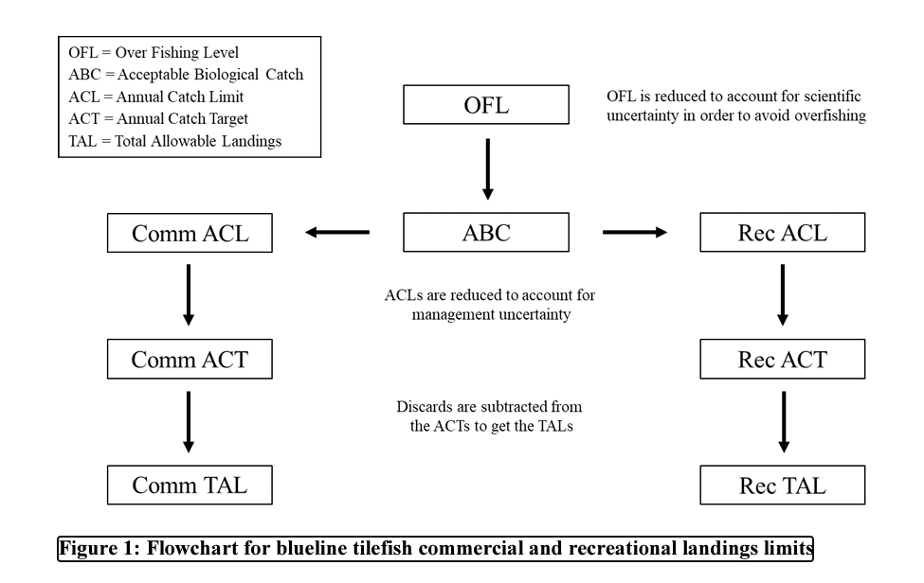

***Figure 2-6.*** *Flowchart illustrating catch allocations in the blueline tilefish fishery.*

### 2.6 Spiny Dogfish FMP

Spiny dogfish (*Squalus acanthias*) is co-managed by the MAFMC and NEFMC in federal waters through the [Spiny Dogfish FMP](https://www.mafmc.org/s/Spiny_Dogfish_FMP.pdf) (2000) and subsequent frameworks and amendments, and in state waters by the [Atlantic States Marine Fisheries Commission](https://www.asmfc.org/species/spiny-dogfish) (ASMFC).

**Seasonal allocations (temporary):** Seasonal allocations of the commercial quota were used to control fishing mortality when the stock was under the rebuilding plan. While under the rebuilding plan, the commercial quota was distributed between quarters based on the percentage of commercial landings for each quarterly period during the years 1990-1997.

As with many co-managed species, regulations can often become convoluted. In 2014, [Amendment 3](https://www.mafmc.org/s/Spiny-Dogfish-Amd-3.pdf) eliminated the allocation of commercial quota due to problems that exist in the absence of a joint Council and Commission FMP for spiny dogfish. For example, there was often confusion and inadvertent possession violations when waters under the different jurisdictions were open/closed at different times. This was largely due to a mismatch in the way the annual quota was allocated geographically by the ASMFC and seasonally by the Councils. Ultimately, removing the allocation was perceived as the least disruptive approach to fishery operations that were subject to management measures established under both the federal and interstate FMPs.

**State allocations:** Currently, allocations still exist, but only under state management. These allocations were implemented by [Addendum III (2011](http://www.asmfc.org/uploads/file/spinyDogfishAddendumIII.pdf)) using a two stage approach. The division between the northern and southern regions is based on commercial landings from 1990-1997 and the division between southern states is based on a combination of historical (1988-2002) and recent (2003-2009) landings. Maine through Connecticut receive 58% of the quota and are limited by a maximum possession limit of 6,000 pounds per day. The southern state shares are allocated as follows: New York (2.7%); New Jersey (7.6%); Delaware (0.9%); Maryland (5.9%); Virginia (10.8%); and North Carolina (14.0%). Any overages from the previous fishing seasons are paid back by the region or state in the following season. Transfers of quota between states are permitted.

### 2.7 Monkfish FMP

See *Section 1.4* for a summary of the allocation policies used for monkfish, which is co-managed with the New England FMC, who acts as the lead for this FMP.

## 3. South Atlantic

The SAFMC implements eight FMPs including two plans jointly managed with the GFMC (**Table 3-1**). The SAFMC leads the jointly managed Coastal Migratory Pelagic FMP.

Of these eight FMPs, only the Coastal Migratory Pelagic FMP, Dolphin Wahoo FMP, and Snapper Grouper FMP include allocation rules. Allocations were first implemented in the South Atlantic in 1985. In line with MSA National Standard 4, the Council aims to make allocations *“fair and equitable to fishery participants in both the recreational and commercial sectors*” so that *“no particular individual, corporation, or other entity would acquire excessive share.”* The Council formed an allocations committee in 2007, culminating in the Comprehensive ACL Amendment in 2012 that set a standard allocation process, and created sector allocations for multiple species that were not previously allocated. In 2019, the Council approved an allocation review trigger policy to formalize allocation review triggers and the allocation process for all fisheries with sector allocations. Most recently, the Council developed [Allocation Decision Trees: A Blueprint for Applying Biological, Social, and Economic Considerations in Allocation Decisions](https://safmc.net/documents/sep_a5a_allocationdecisiontreeblueprint_apr2022-pdf/) to guide and standardize the allocation process in the region ([SAFMC Sector Allocations](https://safmc.net/fishery-management/sector-allocations/#allocations); [ACL Amendment](https://www.federalregister.gov/documents/2012/03/16/2012-6450/fisheries-of-the-caribbean-gulf-of-mexico-and-south-atlantic-comprehensive-annual-catch-limit); [ACL Amendment Summary](https://safmc.net/documents/attach1_comp-acl-summary-092211-pdf/); [Allocation in SA presentation](https://safmc.net/documents/a06b_allocations_presentation-pdf/); [GAO 2020 Report](https://www.gao.gov/assets/gao-20-216.pdf)).

The Council has consistently used both historical (1986-2008) and recent (2006-2008) landings to set allocations across sectors. A similar formula is used across many FMPs (see *sections 3.2-3.3*). Additionally, the Allocations Committee has recently expressed interest in expanding allocation decision making to include qualitative sources such as oral histories ([SAFMC 2019](https://safmc.net/documents/a06b_allocations_presentation-pdf/); [SAFMC SSC 2021](https://safmc.net/documents/a17_allocationdecisiontreeblueprint-pdf/)).

***Table 3-1.*** *Brief summary of the allocation policies used in SAFMC FMPs.*

|  |  |
| --- | --- |
| **FMP** | **Allocation policy summary** |
| Coastal Migratory Pelagic  *(led by SAFMC with GFMC)* | Sector, region, gear, and season allocations |
| Coral | No allocations |
| Dolphin Wahoo | Sector allocations |
| Golden Crab | No allocations |
| Sargassum | No allocations |
| Shrimp | No allocations |
| Snapper Grouper | Sector allocations and catch shares |
| Spiny Lobster *(led by GFMC with SAFMC)\** | No allocations |

### 3.1 Coastal Migratory Pelagics FMP

The original [Coastal Migratory Pelagics FMP](https://safmc.net/documents/cmp-fishery-management-plan/), jointly managed by the GFMC and SAFMC, was implemented in 1982. The FMP manages Gulf of Mexico and South Atlantic king mackerel and Spanish mackerel and Gulf of Mexico cobia. All three species are currently allocated between the recreational and commercial sectors. The FMP also employs regional, gear-based, seasonal, and catch share allocation strategies ([FMP history](https://safmc.net/fishery-management-plans/coastal-migratory-pelagics/)).

#### 3.1.1 Cobia

**Sector allocations:** The Atlantic migratory group of cobia (*Rachycentron canadum*) was first allocated between recreational (92%) and commercial sectors (8%) in 2012 by Amendment 18 based on both 2000-2008 and 2006-2008 landings. In 2017, the Atlantic States Marine Fisheries Commission (ASMFC) approved an interstate FMP for the Atlantic migratory group, initiating cooperative management of the stock by ASMFC, GFMC, and SAFMC. In 2019, Amendment 31 removed the Atlantic group from the FMP and transitioned management from the FMCs to the ASMFC “*to allow for more equitable distribution of harvest and facilitate better coordination of management of Atlantic cobia in state and federal waters”* (Amendment 31). Currently, only Gulf Group cobia within the Florida East Coast Zone (FLEC) are allocated by the Councils. This portion of the Gulf Group cobia stock is allocated between commercial (8%) and recreational (92%) sectors using the same strategy as Amendment 18 ([Amendment 32](https://gulfcouncil.org/wp-content/uploads/CMP-Amendment-32-Final-Draft-COMPLETE_508_02172022.pdf)).

#### 3.1.2 King mackerel

King mackerel (*Scomberomorus cavalla*) is currently allocated by sector, region, season, and gear. The original FMP considered king mackerel to be one stock across the Gulf and South Atlantic, and only allocated to sectors. There have been multiple changes in allocation policy aiming to reduce overfishing through the duration of the FMP as summarized in **Table 3-2**. King mackerel is now managed as two migratory groups – a South Atlantic and a Gulf of Mexico migratory group – with different approaches to allocation used for each stock. As of 2005, a limited access permit is required to commercially target king mackerel.

**South Atlantic group (sector/region/season allocations):** Since 1985 (Amendment 1), the South Atlantic group has been allocated between the recreational and commercial sectors (62.9% recreational, 37.1% commercial). The allocation is based on the years between 1979 and 1985 for which concurrent recreational and commercial catch data were available ([Amendment 34](https://safmc.net/documents/cmp-amendment-34/)). The commercial allocation is then allocated by region with the Northern Zone (NY, CT, RI to the NC/SC border) receiving 23.04%, and the Southern Zone (NC/SC border to Miami-Dade/Monroe County line, FL) receiving 76.96% based on landings from 2002/2003 to 2011/2012. In the Southern Zone, the commercial quota is also allocated by season (Season 1: March 1-September 30 = 60%; Season 2: October 1 - end of Feb = 40%). These percentages were determined through expert judgment of fishery dynamics ([Amendment 26](https://safmc.net/documents/cmp-amendment-26/)).

**Gulf of Mexico group (sector/region/gear allocations):** Amendment 1 also allocated the Gulf group by sector (68% recreational, 32% commercial) based on the largest number of years between 1979-1985 with both recreational and commercial catch data. The commercial allocation is then allocated by region and gear with the Western Zone: 40%, Northern Zone: 18%, Southern Zone Handline: 21%, and Southern Zone Gillnet: 21%. [Amendment 34](https://gulfcouncil.org/wp-content/uploads/CMPAmend34_FINAL.pdf) reviewed and retained this allocation policy stating that *“king mackerel has been functioning well with the current sector allocations, however regional allocations may need to be addressed in the future with changes in landing distributions due to climate change”.*

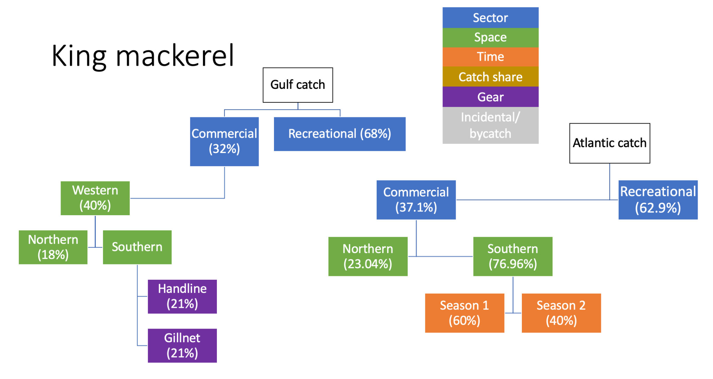

***Figure 3-1.*** *Flow chart illustrating the allocation of king mackerel catch for both the Atlantic and Gulf of Mexico migratory groups.*

***Table 3-2.*** *Significant changes to allocation policy for king mackerel by the SAFMC.*

|  |  |
| --- | --- |
| **FMP Amendment** | **Implemented allocation policies** |
| Original FMP (1982) | * Single stock across Gulf and Atlantic states * Recreational 76% and commercial 24% * Hook and line 43% and net gear 57% |
| Amendment 1 (1985) | * Recognizes two migratory groups: Gulf and Atlantic, boundary varies by season * Establishes method of allocation for Gulf group (primarily managed by GFMC)   + Largest number of years beginning in 1979 for which concurrent recreational and commercial catch data are available will be used to calculate the average percent distribution of the catch between recreational and commercial fishermen   + 2% of recreational catch transferred to commercial allocation if bag limit does not change   + Set at 68% recreational 32% commercial   + 6% of commercial quota up to 0.4 M for purse seine quota   + 69% eastern zone (FL) and 31% western zone (AL, MS, LA, TX) * Establishes method of allocation for Atlantic group (primarily managed by SAFMC)   + Largest number of years beginning in 1979 for which concurrent recreational and commercial catch data are available will be used to calculate the average percent distribution of the catch between recreational and commercial fishermen   + Set at 62.9% recreational 37.1% commercial |
| Amendment 2 (1987) | * TAC divided based on catch ratios from 1975-1979 * Eliminates purse seine allocations because they are not traditionally used in fishery * Eliminates 2% transfer in Gulf group allocations |
| Amendment 7 (1994) | * Gulf king mackerel   + Sub-divided Eastern Zone Gulf king mackerel commercial quota in the Eastern Zone (FL) at the Dade/Monroe, FL, county line     - 50%: Dade through Volusia County (North area)     - 50%: Monroe county through FL/AL border (South/West Area)       * Equally divided between hook and line and net gear users     - Passed in response to multiple factors (policy and environment) leading to commercial quota being filled in south Florida before schools migrated north |
| Amendment 8 (1996) | * Established a moratorium on permits   + A permit may only be issued if its owner was an owner of a vessel that had a commercial king and Spanish mackerel permit prior to the control date of October 16, 1995   + To qualify, the owner or operator must show that during 1 of the 3 calendar years preceding the application at least 25% of their earned income or atleast $10,000 was derived from commercial sale of catch or charter or headboat fishing   + Owners can transfer permit to another vessel with a qualifying owner or operator or to a new owner of vessel through written agreement   + No new commercial king mackerel permits are to be issued |
| Amendment 9 (1998) | * Gulf king mackerel   + Reallocated Eastern Zone commercial allocation from 50:50 to to 46.15% north and 53.85% south/west to better represent recent historical catches   + Subdivided commercial hook and line allocation into subzones by areas to help insure historical participation in fishery, and preventone area from taking full TAC before fish are available in the other area     - Subzone 1: Dade/Monroe to Collier/Lee County Line     - Subzone 2: Collier/Lee County line to AL/FL state line   + Established regional allocations of commercial hook and line for king mackerel in south/west area of eastern zone based on historical catches from new subzones, motivated by shifts in landings caused by increased participation and availability of fish in Florida Panhandle     - 7.5% of Eastern Zone allocation from **Subzone 2**     - Remainder       * Florida east coast: 50%       * Florida west coast: 50%         + Net fishery: 50%         + Hook and line fishery 50% (**Subzone 1**) * Established moratorium on the issuance of commercial king mackerel gillnet endorsements |
| Amendment 12 (2000) | * Extended commercial king mackerel permit moratorium (Amendment 8) |
| Amendment 14 (2002) | * Gulf king mackerel   + Established 3-year moratorium on issuance of charter vessel and headboat permits |
| Amendment 15 (2005) | * Established an indefinite limited access program. Commercial LAP replaced existing commercial king mackerel permits * Separate Gulf gill-net permit replaced current gill-net endorsement in the Gulf * LAP similarly renewable and transferable as described by moratoriums (Amendments 8,9) |
| Amendment 17 (2006) | * Extended charter/headboat vessel permit moratorium in Gulf (Amendment 14) |
| Amendment 20B (2015) | * Atlantic king mackerel   + Establish quotas for N (NC-NY; 33.3%) and S (SC, GA, FL; 66.7%) Zones     - Quota based on proportion of landings in that zone from 2002/2003-2011/2012   + Allow for transfer of quota between regions (NC and FL designated as coordinating states for transfer requests)     - Similar to quota transfer between states for Mid-Atlantic summer flounder, and would provide a way for unused quota to be moved and utilized without negatively impacting the stock |
| Amendment 26 (2017) | * Adjusted management boundary for Gulf and Atlantic king mackerel to a single year round boundary at Miami-Dade/Monroe county line (GFMC responsible for management measures in mixing zone) * Atlantic king mackerel   + Established seasonal allocations in Southern Zone to ensure Atlantic Southern Zone quota is available in later months of fishing year, even if harvest is higher in earlier months     - Season 1: March 1-September 30 = 60%     - Season 2: October 1 - end of Feb = 40%     - Remaining quota from season 1 transfers to season 2 * Gulf king mackerel   + Reallocate ACL across newly drawn regions because Florida East Coast Subzone is integrated into Atlantic Southern Zone; will ideally lead to longer commercial fishing season in all three zones, but especially in N zone     - Western zone (TX, LA, MS, AL): 40%     - Northern zone (Collier/Lee County line to AL/FL state line): 18% (addressed historic under-allocation; participants have previously complained that Northern Zone quota is landed before charter fleet concludes tourist season and/or fish migrate east and south along western FL coastline to make fishing profitable)     - Southern zone (Collier/Lee County line to Monroe/Dade County line)       * Handline: 21%       * Gillnet: 21% |
| Amendment 34 (2023) | * Atlantic king mackerel   + Intentionally retained current recreational and commercial sector allocations at 62.9% and 37.1% respectively (originally based on catches in the 70-80s)   + “king mackerel has been functioning well with the current sector allocations, however regional allocations may need to be addressed in the future with changes in landing distributions due to climate change” |

#### 3.1.2 Spanish mackerel

Sector allocations were first implemented for [Spanish mackerel](https://www.fisheries.noaa.gov/species/spanish-mackerel) (*Scomberomorus maculatus*) by Amendment 2 in 1987, based on average ratio of catch from 1979-1985. At this time, the Council recognized two migratory groups of Spanish mackerel: (1) the Gulf group and (2) the Atlantic group.

**Gulf group (sector allocations):** The Gulf group was initially and still is allocated at 57% commercial and 43% recreational. This was based on catch from 1979-1985.

**Atlantic group (sector allocations):** The Atlantic Group was initially split at 76% commercial and 24% recreational based on catch from 1979-1985. Amendment 4 (1989) reallocated the Atlantic Group at 50/50 commercial/recreational to increase access by the recreational sector in response to overfishing by the commercial sector. The Atlantic Group sector allocations were most recently revised in 1999 with a regulatory amendment ([64 FR 45457](https://www.govinfo.gov/content/pkg/FR-1999-06-02/pdf/99-13960.pdf)) because the recreational sector had consistently failed to catch its allocation and commercial sector was near meeting or exceeding their allocation. Currently, the Atlantic Group is allocated 55/45 commercial/recreational.

**Atlantic group (spatial allocations):** Atlantic Spanish mackerel is also regionally allocated between the Northern (NY/CT/RI - NC) and Southern Zones (SC - Miami/Dade, FL). These allocations were established in March 2015 based on the average proportion of landings in each zone from the 2002/2003 fishing season through the 2011/2012 fishing season.

### 3.2 Dolphin and Wahoo FMP

The Council implemented the [Dolphin Wahoo FMP](https://safmc.net/documents/dolphin-wahoo-fishery-management-plan/) in 2004. The FMP highlights the historical importance of both species for recreational fisheries, and aims to prevent the development of new commercial fisheries.

#### 3.2.1 Dolphinfish

Dolphinfish (*Coryphaena hippurus*) in U.S. federal waters along the Atlantic coast are managed through the Dolphin Wahoo FMP. The original FMP included a commercial landing soft-cap (non-binding) at greater than 1.5 million lbs or 13%. Sector allocations were later set by the Comprehensive ACL Amendment (2012) formula that takes into account historical and recent catch trends ((50% * average of long term catch range (lbs)) + (50% * average of recent catch trend (lbs)). Since 2022, the stock ACL has been allocated between the recreational (93%) and commercial sectors (7%) in order to avoid a decrease in the quota available to either sector ([Amendment 10](https://safmc.net/documents/dolphin-wahoo-amendment-10/)). These allocations are no longer based on a formula or given set of years, but rather were chosen to maintain pounds of dolphinfish available to each sector.

#### 3.2.2 Wahoo

Since 2004, wahoo (*Acanthocybium solandri*) in U.S. federal waters along the Atlantic coast have been managed through the Dolphin Wahoo Fishery Management Plan. Amendment 2 set commercial and recreational allocations at 4.3% and 95.7%, respectively (2012; see 3.2.1 for formula). As of 2022, 2.45% of the stock is allocated to the commercial sector to roughly match the previously existing commercial ACL (70,542 lbs), and the remaining portion (97.55%) is allocated to the recreational sector ([Amendment 10](https://safmc.net/documents/dolphin-wahoo-amendment-10/); [Amendments 8, 9, and 34](https://safmc.net/documents/dolphin-wahoo-amendment-8-snapper-grouper-amendment-34-golden-crab-amendment-9/)).Thus, this is an implicit sector allocation, as is it not based on an explicit target percentage. It is also not based on a reference time period.

### 3.3 Snapper-Grouper Fishery

The Snapper Grouper Fishery Management Plan, established in 1983, manages 55 species in the U.S. South Atlantic ([Snapper Grouper website](https://safmc.net/fishery-management-plans/snapper-grouper/)). Multiple species are managed as a part of a complex, including the deepwater complex, the grunts complex, the jacks complex, the porgy complex, the shallow-water grouper complex, and the snappers complex.

Allocations between commercial and recreational sectors for most species are based on the basic formula from the Comprehensive ACL Amendment that balances historical and recent landings ((50% * average of long term catch range (lbs)) + (50% * average of recent catch trend (lbs)). Typically, historical landings = 1986-2008 and recent landings = 2006-2008, although this varies for some species based on data availability (e.g. black grouper started in 1991) and these exceptions are highlighted below (**Table 3-3**).

This formula was applied to catch estimates available at the time of the Comprehensive ACL Amendment, which (depending on the species) included recreational catch as estimated by the Marine Recreational Information Program (MRIP) using effort estimates from the Coastal Household Telephone Survey (CHTS) or the Marine Recreational Fisheries Statistics Survey (MRFSS). Both of these estimation methodologies have been discontinued and replaced by the MRIP using effort estimates from the mail-based Fishing Effort Survey, beginning in 2018. Although the recreational catch estimation method has changed, the Council is still working through updating sector allocation percentages to include the current recreational data. Therefore, most allocation percentages continue to be based on catch data that includes MRIP CHTS or MRFSS estimates.

For the complexes, the percentages shown in **Table 3-3** were the results of applying the Comprehensive ACL Amendment formula and dividing sector landings by total landings for each individual species. Sector annual catch limits (ACL) for each complex were developed by summing the sector-specific landings results for all species included in the complex. Different species within a complex had different magnitudes of landings during the time period used in the formula, and complexes are managed collectively under sector annual catch limits (i.e. landing a complex species fish counts against the sector ACL for the entire complex, not a species-specific ACL). Therefore, the species-specific allocation percentages shown in **Table 3-3** may not reflect the effective allocation percentages of sector ACLs for the entire complex.

Some stocks are allocated by jurisdiction in coordination with the Gulf of Mexico Reef Fish FMP (i.e. black grouper, yellowtail snapper, mutton snapper), and these are highlighted in the sections below. South Atlantic/Gulf of Mexico jurisdictional allocations split at the Monroe (Florida Keys) County boundary ([Amendment 51](https://safmc.net/documents/snapper-grouper-amendment-51-final-03-02-2023/); [Draft Snapper-Grouper SAFE](https://rpubs.com/chipcollier/1028240)).

***Table 3-3.*** *Sector allocations managed by the South Atlantic Snapper-Grouper FMP.*

|  |  |  |  |  |  |  |
| --- | --- | --- | --- | --- | --- | --- |
| **Species** | **Comm. Allocation** | **Rec. Allocation** | **Basis years (if not default)** | **First Allocated** | **Next Allocation Review** | **Most Recent Allocation Review** |
| Atlantic spadefish | 18.53% | 81.47% |  | 2012 | 2031 | 2024 |
| Bar jack | 21.25% | 78.75% |  | 2012 | 2022 |  |
| Black grouper | 36.88% | 63.12% | 1991-2008 | 2012 | 2026 |  |
| Black sea bass | 43.00% | 57.00% | 1999-2003 | 2007 | 2023 |  |
| Blueline tilefish | 50.07% | 49.93% |  | 2012 | 2020 |  |
| Gag | 51.00% | 49.00% | 2015-2019 | 2009 | 2030 | Oct 2023 (Am 53) |
| Golden tilefish | 96.7%  (25% H&L, 75% longline) | 3.3% |  | 2011 | 2030 | Dec 2023 (Am 52) |
| Gray triggerfish | 43.56% | 56.44% |  | 2012 | 2023 |  |
| Greater amberjack | 35% | 65% |  | 2012 | 2030 | Oct 2023 (Am 49) |
| Hogfish GA-NC | 69.13% | 30.87% |  | 2012 | 2024 | Aug 2017 (Am 37) |
| Hogfish FLK/EFL | 9.63% | 90.37% |  | 2012 | 2024 | Aug 2017 (Am 37) |
| Mutton snapper | 17.02% | 82.98% |  | 2012 | 2023 |  |
| Red grouper | 44.00% | 56.00% |  | 2012 | 2023 |  |
| Red porgy | 51.43% | 48.57% |  | 2009 | 2030 | Jan 2023 (Am 50) |
| Red snapper | 28.07% | 71.93% |  | 2012 | 2024 | Reg 35 (under dev.) |
| Scamp | 65.34% | 34.66% |  | 2012 | 2022 | Am 55 (under dev.) |
| Snowy grouper | 87.55% | 12.45% | 1986-2005 | 2009 | 2030 | Nov 2023 (Am 51) |
| Speckled hind | 65.59% | 34.41% |  | 2012 |  |  |
| Warsaw grouper | 17.79% | 82.21% |  | 2012 |  |  |
| Vermilion snapper | 68.00% | 32.00% |  | 2009 | 2021 |  |
| Wreckfish | 95.00% | 5.00% | Fisher input | 2012 | 2019 | Am 48 (under dev.) |
| Yellowtail snapper | 52.56% | 47.44% |  | 2012 | 2021 | Amendment 44/55 |
| Goliath grouper | n/a | n/a |  |  |  |  |
| Nassau grouper | n/a | n/a |  |  |  |  |
| **Deepwater Complex** | | | | | | |
| Yellowedge grouper | 90.77% | 9.23% |  | 2012 | 2024 |  |
| Silk snapper | 73.95% | 26.05% |  | 2012 | 2024 |  |
| Misty grouper | 83.42% | 16.58% |  | 2012 | 2024 |  |
| Sand tilefish | 22.17% | 77.83% |  | 2012 | 2024 |  |
| Queen snapper | 92.50% | 7.50% |  | 2012 | 2024 |  |
| Blackfin snapper | 29.91% | 70.09% |  | 2012 | 2024 |  |
| **Jacks Complex** | | | | | | |
| Almaco jack | 48.70% | 51.30% |  | 2031 | 2024 |  |
| Banded rudderfish | 26.01% | 73.99% |  | 2031 | 2024 |  |
| Lesser amberjack | 46.07% | 53.93% |  | 2031 | 2024 |  |
| **Snappers Complex** | | | | | | |
| Gray snapper | 24.23% | 75.77% |  | 2012 | 2025 |  |
| Lane snapper | 14.75% | 85.25% |  | 2012 | 2025 |  |
| Cubera snapper | 19.57% | 80.43% |  | 2012 | 2025 |  |
| **Grunts Complex** | | | | | | |
| White grunt | 31.59% | 68.41% |  | 2012 | 2024 |  |
| Sailor’s choice | 0.00% | 100.00% |  |  | 2024 |  |
| Tomtate | 0.00% | 100.00% |  |  | 2024 |  |
| Margate | 18.88% | 81.12% |  | 2012 | 2024 |  |
| **Shallow-Water Groupers Complex** | | | | | | |
| Red hind | 73.60% | 26.40% |  | 2012 | 2026 |  |
| Rock hind | 60.90% | 39.10% |  | 2012 | 2026 |  |
| Yellowfin grouper | 52.70% | 47.30% |  | 2012 | 2026 |  |
| Coney | 24.45% | 75.55% |  | 2012 | 2026 |  |
| Graysby | 15.74% | 84.26% |  | 2012 | 2026 |  |
| **Porgy Complex** | | | | | | |
| Jolthead porgy | 4.15% | 95.85% |  | 2012 | 2027 |  |
| Knobbed porgy | 51.18% | 48.82% |  | 2012 | 2027 |  |
| Saucereye porgy | 0.01% | 99.99% |  | 2012 | 2027 |  |
| Scup | 0.00% | 100.00% |  |  | 2027 |  |
| Whitebone porgy | 1.05% | 98.95% |  | 2012 | 2027 |  |
| **Scamp and yellowmouth group complex** | | | | | | |
| Scamp | 64.90% | 35.10% |  | 2024 | 2031 | 2024 |
| Yellowmouth grouper | 64.90% | 35.10% |  | 2024 | 2031 | 2024 |

#### 3.3.1 Black grouper

The comprehensive ACL amendment established a jurisdictional allocation for black grouper (*Macolor niger*), allocating 53% to the Gulf of Mexico and 47% to the South Atlantic using the general Comprehensive ACL Amendment formula (see section **3.3**). The comprehensive ACL amendment allocated black grouper catch within the South Atlantic between the recreational (63.12%) and commercial (36.88%) sector based on historic and recent catch, but the historic time series began in 1991 instead of 1986 (2012).

#### 3.3.2 Black sea bass

In an effort to curb overfishing, black sea bass (*Centropristis striata*) were allocated between the commercial and recreational sectors in 2006–409,000 lbs to the recreational sector (57% of the TAC) and 309,000 lbs to the commercial sector (43%) ([Amendment 13c](https://safmc.net/documents/snapper-grouper-amendment-13c/)). These allocation proportions still hold true, and are based on historical catch from 1999-2003 within the recreational sector.

#### 3.3.3 Goliath and Nassau grouper

The harvest of the goliath grouper (*Epinephelus itajara*) has been prohibited since 1990 and therefore ACL = 0. However, the Comprehensive ACL Amendment retains federal management for the stocks if needed. Additionally, the Amendment establishes co-management for goliath grouper between the Gulf of Mexico and the South Atlantic (2012).

#### 3.3.4 Gag grouper

Gag grouper (*Mycteroperca microlepis*) was first allocated between recreational and commercial sectors in 2009 using landings from 1999-2003 (Amendment 16). With [Amendment 53](https://safmc.net/documents/snapper-grouper-amendment-13c/) (2023), the sector allocations will transition to 50%-50% in 2027 to reflect total average commercial and recreational landings from 2015-2019.

#### 3.3.5 Golden tilefish

Golden tilefish (*Lopholatilus chamaeleonticeps*) are allocated to the commercial (96.7%) and recreational (3.3%) sectors. They are further broken down by commercial gear type, with 25% going to the hook-and-line component and 75% to the longline component. The gear allocation (implemented in 2013 with [Amendment 18B](https://safmc.net/documents/snapper-grouper-amendment-18b/)) restored access to hook-and-line fishermen to proportions observed before 2006 ([Amendment 52](https://safmc.net/documents/snapper-grouper-amendment-52-final-may-2023/); [50 CFR 622](https://www.federalregister.gov/documents/2023/11/22/2023-25821/fisheries-of-the-caribbean-gulf-of-mexico-and-south-atlantic-re-opening-of-commercial-fishery-for#:~:text=For%20the%202023%20fishing%20year,percent%20to%20the%20longline%20component.)). Section 5.4 outlines the Council’s rationale for the 75 (longline)-25 (hook & line) split. In short, the Council saw that commercial landings at the time were about a 90-10 split, but fishermen from the Carolinas, which mostly (if not all) use hook & line and fish later in the year than fishermen from Florida, were not getting an opportunity to harvest because the quota was all harvested within the first few months of the year by the FL longliners. As a result, the Council diverted from a strict landings percentage basis for allocations to a more *ad hoc* strategy that would better enable a reasonable amount of quota to be available for the Carolina hook and line fishermen.

#### 3.3.6 Mutton snapper

The comprehensive ACL amendment established a jurisdictional allocation for mutton snapper (*Lutjanus analis*) between the Gulf of Mexico and the South Atlantic (2012), with a current split of 18%/82%, respectively. Jurisdictional allocations integrate historic (1990-2008) and recent (2006-2008) landings data from the two jurisdictions, weighing recent years higher as typical of Comprehensive ACL Amendment. The South Atlantic allocation is split 17.02% commercial and 82.98% recreational, again based on historic (1986-2008) and recent (2006-2008) landings data. There is no sector allocation for the Gulf of Mexico allocation ([Appendix Q](https://safmc.net/documents/attach5c_mutton-snapper-actions-pdf/); [Amendment 41](https://safmc.net/documents/a5b_am41_decisiondoc-pdf/)).

#### 3.3.7 Speckled hind

The speckled hind (*Epinephelus drummondhayi*) catch was first allocated in 2012 with the comprehensive ACL amendment following the general formula. However, as of 2019, harvest is not allowed for speckled hind.

#### 3.3.8 Warsaw grouper

The Warsaw grouper (*Hyporthodus nigritus*) catch was first allocated in 2012 with the comprehensive ACL amendment. However, as of 2019, harvest is not allowed for warsaw grouper.

#### 3.3.9 Yellowtail snapper

The comprehensive ACL amendment established a jurisdictional allocation for yellowtail snapper between the Gulf of Mexico and the South Atlantic (2012), with a current split of 25%/75%, respectively. Jurisdictional allocations integrate historic (1993-2008) and recent (2006-2008) landings data from the two jurisdictions, following the general Comprehensive ACL Amendment formula. The South Atlantic allocation is split 52.56% commercial 47.44% recreational, again based on historic (1986-2008) and recent (2006-2008) landings data ([Amendment 44](https://safmc.net/documents/sg_a3b_amendment44workingdraftamendment_202306-pdf/); [YTS Discussion Paper](https://safmc.net/documents/sg_a4_yts-discussion-paper_06_2021-pdf/)).

#### 3.3.10 Wreckfish

Wreckfish (*Polyprion americanus*) is allocated by sector and by catch share through the U.S.’s oldest finfish ITQ program.

**Sector allocations:** The stock was first allocated by sector in 2012 with the Comprehensive ACL Amendment, establishing an allocation between the recreational (5%) and commercial sector (95%) *“based on public input and guidance from the advisory panel”* (2012). However, there have been zero records of recreational wreckfish landings since 2012.

**Catch shares:** The commercial sector is managed through the [South Atlantic ITQ program](https://safmc.net/documents/sg_a1c_wreckfishitqeligibilitypresentation-pdf/) established in 1992 in response to a “*rapid escalation of effort of vessels”* (Amendment 5) ([Program Review](https://safmc.net/documents/finalwreckfishitqreview/); [50 CFR § 622.172](https://www.law.cornell.edu/cfr/text/50/622.172)). Shares are based on historical landings from 1987-1990 ([webpage](https://safmc.net/amendments/snapper-grouper-amendment-5/)). Activity in the fishery declined following the formation of the ITQ program. In response to this decline in activity, the council reduced the number of shareholders by defining any shares held by a shareholder who had not reported landings between April 16, 2006 and January 14, 2011 as inactive. These shares were then distributed amongst active shareholders using landings from the same period (Amendment 20A; 2012). This amendment also established a sharecap of 49%, and established an appeals process for redistribution of inactive shares. However, there is no annual allocation cap. Shares are transferable, and ITQ coupons can be spread over multiple vessels owned by a shareholder. SAFMC has approved [Amendment 48](https://safmc.net/amendments/snapper-grouper-amendment-48/), which aims to modernize the SA wreckfish ITQ program, and is developing the final amendment for submission to NOAA Fisheries for implementation. This Amendment recommends reallocating 3% of the ACL from recreational to commercial, and a transition to an electronic reporting system for ITQ management.

#### 3.3.11 Scamp-Yellowmouth complex

[Amendment 55](https://safmc.net/documents/sg_amendment55_finaldraft_202409_nonepapage_websiteversion_202410/) established a scamp-yellowmouth grouper complex that will be implemented midway through 2025. The allocations between commercial and recreational sectors will change over 5 years based on **Table 3-4** below.

***Table 3-4.*** *Changes to sector allocations from 2025-2029 for scamp-yellowmouth complex.*

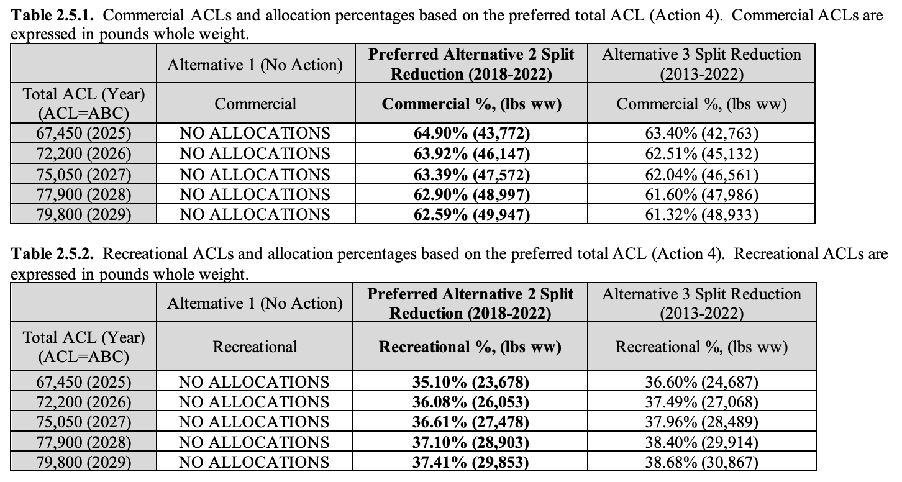

## 

## 4. Gulf of Mexico

The GFMC implements nine fishery management plans including two plans jointly managed with the SAFMC (**Table 4-1**). The GFMC leads the jointly managed Spiny Lobster FMP. Of these FMPs, only the Coastal Migratory Pelagic FMP (lead by SAFMC) and the Reef Fish FMP include allocation polices. As implementation of the Coastal Migratory Pelagic FMP is led by the SAFMC, allocation policies for this FMP are described in the SAFMC section of this document.

***Table 4-1.*** *Brief summary of the allocation policies used in GFMC FMPs.*

|  |  |
| --- | --- |
| **FMP** | **Allocation policy summary** |
| Coastal Migratory Pelagic *(led by SAFMC with GFMC)* | Sector-based allocations (see *Section 3.1*) |
| Red drum | No allocations |
| Reef fish | Sector-based allocations and catch shares |
| Shrimp | No allocations |
| Spiny lobster *(led by GFMC with SAFMC)\** | No allocations |
| Stone Crab | No allocations |

* Although spiny lobster (*Panulirus argus*) does not use allocations, in 2011, the Council considered allocations between commercial and recreational sectors ([Amendment 10](https://www.federalregister.gov/documents/2011/12/02/2011-31025/fisheries-of-the-caribbean-gulf-of-mexico-and-south-atlantic-spiny-lobster-fishery-of-the-gulf-of)). The Council explained that allocations were not necessary at the time because the ACL was unlikely to be exceeded, and therefore, allocations would only increase administrative burden.

The Gulf of Mexico Fisheries Management Council makes allocation decisions based on the following principles and objectives ([GFMC SOPPs](https://gulfcouncil.org/wp-content/uploads/GMFMC-SOPPs-Fishery-Allocation-Policy.pdf)):

1. Principles for Allocation
   1. Conservation and management measures shall not discriminate between residents of different states.
   2. allocation shall:
      1. be fair and equitable to fishermen and fishing sectors;
         1. fairness should be considered for indirect changes in allocation
         2. any harvest restrictions or recovery benefits be allocated fairly and equitably among sectors
      2. promote conservation
         1. connected to the achievement of OY
         2. furtherance of a legitimate FMP objective,
         3. promotes a rational, more easily managed use
      3. ensure that no particular individual, corporation, or other entity may acquire an excessive share.
   3. shall consider efficient utilization of fishery resources but:
      1. should not just redistribute gains and burdens without an increase in efficiency
      2. prohibit measures that have economic allocation as its sole purpose.
   4. shall take into account: the importance of fishery resources to fishing communities by utilizing economic and social data in order to:
      1. provide for the sustained participation of fishing communities
      2. minimize adverse economic impacts on fishing communities.
   5. Any fishery management plan, plan amendment, or regulation submitted by the Gulf Council for the red snapper fishery shall contain conservation and management measures that:
      1. establish separate quotas for recreational fishing (including charter fishing) and commercial fishing.
      2. prohibit a sector (i.e., recreational or commercial) from retaining red snapper for the remainder of the season, when it reaches its quota.
      3. ensure that the recreational and commercial quotas reflect allocation among sectors and do not reflect harvests in excess of allocations.
2. Guidelines for Allocation
   1. All allocations and reallocations must be consistent with the Gulf of Mexico Fishery Management Council’s principles for allocation.
   2. An approved Council motion constitutes the only appropriate means for requesting the initiation of allocation or reallocation of a fishery resource. The motion should clearly specify the basis for, purpose and objectives of the request for (re)allocation.
   3. The Council should conduct a comprehensive review of allocations within the individual FMPs at intervals of no less than five years.
   4. Following an approved Council motion to initiate an allocation or reallocation, the Council will suggest methods to be used for determining the new allocation. Methods suggested must be consistent with the purpose and objectives included in the motion requesting the initiation of allocation or reallocation.
   5. Changes in allocation of a fishery resource may, to the extent practicable, account for projected future socio-economic and demographic trends that are expected to impact the fishery.
   6. Indirect changes in allocation, i.e., shifts in allocation resulting from management measures, should be avoided or minimized to the extent possible.

Any changes in allocation are often justified by “providing the greatest overall benefit to the Nation with respect to both food production and recreational opportunities” ([Amendment 53: Red Grouper Allocations and Catch Levels](https://www.fisheries.noaa.gov/action/amendment-53-red-grouper-allocations-and-catch-levels)).

The GFMC has scheduled allocation reviews at the following regular intervals:

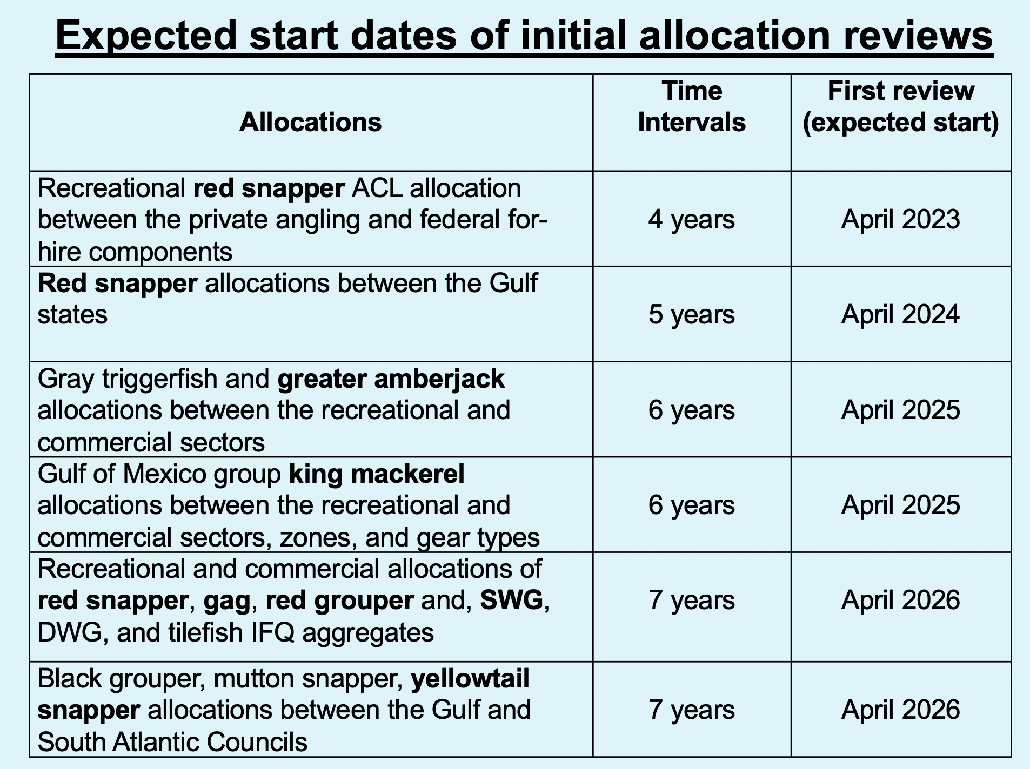

### 

### 4.1 Reef fish FMP

#### 4.1.1 IFQ program details

Two Individual Fishing Quota (IFQ) programs are implemented for species managed within the Reef Fish FMP: (1) the Red Snapper IFQ (RS-IFQ) and (2) the Grouper-Tilefish IFQ (GT-IFQ). Share caps are listed in **Table 4-2** below.

***Table 4-2.*** *Share caps in the Red Snapper (RS-IFQ) and Grouper-Tilefish Individual Fishing Quota (GT-IFQ) programs.*

|  |  |  |
| --- | --- | --- |
| **IFQ program** | **Species** | **Share cap (%)** |
| RS-IFQ | Red snapper (RS) | 6% |
| GT-IFQ | Deep water grouper (DWG) | 14.7% |
| GT-IFQ | Gag grouper (GG) | 2.3% |
| GT-IFQ | Red grouper (RG) | 4.3% |
| GT-IFQ | Shallow water grouper (SWG) | 7.3% |
| GT-IFQ | Tilefish (TF) | 12.2% |

#### 4.1.2 Red snapper

Red snapper (*Lutjanus campechanus*) is managed through the Gulf of Mexico Reef Fish FMP (1984) and subsequent amendments. Quota is first allocated between recreational (49%) and commercial sectors (51%) based on landings data from 1979-1987. The commercial sector is subsequently allocated and managed through the reef fish IFQ program using catch shares (Amendment 26; 2007). The initial IFQ participants received shares according to historical landings (~1990s-2004), up to a cap of ~8%. These shares are transferable to any US citizen or permanent resident. A share cap of 6.0203% is now used ([§ 622.21)](https://www.ecfr.gov/current/title-50/chapter-VI/part-622/subpart-B/section-622.21). The recreational allocation (49%) is then split into for-hire (42.3%) and private recreational sub-sectors (57.7%; Amendment 40: 2015). This recent allocation aims to decrease the likelihood of the larger recreational sector going over quota, and supporting red snapper stock rebuilding. As of 2020, the private sub-sector is then allocated among the 5 gulf states: LA (19.12%), MS (3.55%), AL (26.298%), FL (44.822%), and TX (6.21%) (Amendment 50A-F: 2020) based on 2018-2019 landings from state-specific fishing permits. State-based allocations pass accountability from GFMC to the Gulf states, and permit more local and regional management measures.

#### 4.1.3 Red grouper

Red grouper (*Epinephelus morio*) is managed through the Gulf of Mexico Reef Fish FMP (1984) and subsequent amendments. Quota is first allocated between recreational (40.7%) and commercial (59.3%) sectors based on landings data from 1986-2005 (Amendment 53; 2022). This is a change from the previous allocation of 76% commercial and 24% commercial (Amendment 30B; 2009), triggered by improved recreational catch and effort data due to a transition from the Marine Recreational Fisheries Statistics Survey (MRFSS) to the Marine Recreational Information Program (MRIP) Access Point Angler Intercept Survey (APAIS) and Fishing Effort Survey (FES). The commercial sector is subsequently allocated and managed through the [Grouper-Tilefish IFQ program](https://gulfcouncil.org/wp-content/uploads/Grouper-Tilefish-IFQ-Review-Final-version.pdf) (Amendment 29; 2010). Shares can be held by individuals, groups of individuals, or businesses. With the goal of reducing bycatch, the IFQ program has a multi-use provision that allows some of the red grouper quota to be harvested under gag allocation (and vice-versa). Initial shares were based on logbook landings from 1999-2004. For the first five years of the program, shares could only be sold to and allocation only transferred to entities with valid commercial Gulf reef fish permit, and active GT-IFQ online account. Each IFQ participant can only acquire shares up to the species specific share cap (4.3% for red grouper). Allocations are frequently transferred throughout the season, often due to permit status, and it has become more common–likely due to strengthening of the IFQ network across the Gulf. In June 2023, a Final Amendment was proposed that includes setting the multi-use allocation equal to zero to reduce the catch-quota flexibility of shareholders. However, this has not yet been implemented.

#### 4.1.4 Gag grouper

Gag grouper (*Mycteroperca microlepis*) are managed under the GFMC Reef Fish FMP (1984). The Annual Catch Limit (ACL) was previously allocated between the recreational (61%) and commercial sectors (39%) based on 1986-2005 landings. However, improved data for the recreational sector for the same time perido led the GFMC to increase the recreational allocation by 4% such that the allocation is not 35% commercial and 65% recreational (final amendment 56 in June 2023). This amendment also sets red grouper multi-use allocation equal to zero, which is expected to reduce the catch-quota flexibility of shareholders. Commercial allocation managed by the Grouper-Tilefish IFQ program (Amendment 29; 2010). Shares can be held by individuals, groups of individuals, or businesses. See red grouper for details on this IFQ program.

#### 4.1.5 Deep water grouper complex

Yellowedge grouper (*Hyporthodus flavolimbatus*), warsaw grouper (*Hyporthodus nigritus*), snowy grouper (*Hyporthodus niveatus*), and speckled hind (*Epinephelus drummondhayi*) are managed under the GFMC Reef Fish FMP (1984). Since 2012, ‘implicit’ allocations have existed between recreational and commercial sectors by way of the council setting a total and commercial annual catch limit (ACL). Since 2016, the commercial ACL has been set at 1.024 lbs (gutted weight), 95.7% of the total stock ACL (1.070 million lbs). The commercial sector is managed as a component of the Deep Water Grouper Complex through the Grouper-Tilefish IFQ program (Amendment 29; 2010). See red grouper for details on this IFQ program.

#### 4.4.6 Shallow water grouper aggregate complex

The shallow water grouper aggregate complex includes black grouper (*Mycteroperca bonaci*), scamp (*Mycteroperca phenax*), yellowfin grouper (*Mycteroperca venenosa*), and yellowmouth grouper (*Mycteroperca interstitialis*). This complex is managed under the GFMC Reef Fish FMP (1984). The commercial sector receives 73.9% of the combined SWG quota and the recreational sector receives the remaining 26.1% based on landings during 2001-2004.

#### 4.1.7 Tilefish

The Tilefish complex includes blueline tielfish (*Caulolatilus microps*), golden tilefish (*Lopholatilus chamaeleonticeps*), and goldface tilefish (*Caulolatilus chrysops*) and is managed under GFMC Reef Fish FMP (1984). Historically, tilefish have not had high recreational participation, and therefore there is currently no recreational/commercial allocation. Commercially, the tilefish complex is managed under the Grouper-Tilefish IFQ program (Amendment 29; 2010; see red grouper for more details on IFQ). Although tilefish complex shares are capped at 12.2%, allocations tend to consolidate throughout the year, often above the share cap ([GT-IFQ Program 5-year Review](https://gulfcouncil.org/wp-content/uploads/Grouper-Tilefish-IFQ-Review-Final-version.pdf)).

#### 4.1.8 Greater amberjack

Greater amberjack (*Seriola dumerili*) is managed through the Gulf of Mexico Reef Fish FMP (1984) and subsequent amendments. The stock is first allocated between recreational (80%) and commercial sectors (20%), reflecting the larger historic engagement by the recreational sector between 1993-2019 ([Amendment 54 2023](https://www.federalregister.gov/documents/2023/06/15/2023-12633/fisheries-of-the-caribbean-gulf-of-mexico-and-south-atlantic-reef-fish-fishery-of-the-gulf-of-mexico)). Sector allocations were first established in 2008 at 73% recreational and 27% commercial based on 1981-2004 landings in an attempt to end overfishing and rebuild the stock (Amendment 30A). The transition to the more accurate federal recreational survey MRIP-FES led to the recent increase in recreational allocation.

#### 4.1.9 Gray triggerfish

Gray triggerfish (*Balistes capriscus*) is managed through the GFMC Reef Fish FMP. The stock ACL is allocated between the commercial (21%) and recreational (79%) sectors based on the total allowable catches set between 2008-2013 ([50 CFR Part 622](https://www.federalregister.gov/documents/2021/06/29/2021-13807/fisheries-of-the-caribbean-gulf-of-mexico-and-south-atlantic-reef-fish-fishery-of-the-gulf-of-mexico), [FB21-043](https://www.fisheries.noaa.gov/bulletin/final-rule-increases-gray-triggerfish-catch-limits-gulf-mexico)).

#### 4.1.11 King mackerel

The king mackerel Gulf group is allocated between the commercial (32%) and recreational (68%) sectors based on average landings data from 1975-1979.

#### 4.1.12 Co-managed snapper-groupers

The following species are co-managed with the SAFMC under the Snapper Grouper Fishery of the South Atlantic Region FMP and the Reef Fish Resources of the Gulf of Mexico FMP: yellowtail snapper (*Ocyurus chrysurus*), black grouper (*Mycteroperca bonaci*), mutton snapper (*Lutjanus analis*), and goliath grouper (*Epinephelus itajara*). Neither yellowtail or mutton snapper are allocated in the Gulf of Mexico. See *Section 3.3.9* for spatial yellowtail snapper allocations between the South Atlantic and Gulf of Mexico. Goliath grouper are protected, and therefore are not currently allocated. Jurisdictional allocation policies for these species are described in the SAFMC section of this document. Blackgrouper allocations are managed within the SWG complex.

## 5. Caribbean

The Caribbean Fisheries Management Council (CFMC) oversees fisheries management around three Caribbean islands – Puerto Rico, St. Croix, and St. John/St. Thomas – and for six species categories – spiny lobster, queen conch, reef fish, coral, rays, and pelagic fish.

Historically, the CFMC implemented species-centric fisheries management plans that spatially allocated catch to island groups based on historical landings. However, in response to stakeholder requests, the CFMC transitioned management to three island-based fisheries management plans (**Table 5-1**). The implementation of these plans in October 2022 also added rays and pelagic fish stocks and stock complexes to the list of CFMC-managed fisheries.

There are currently no allocations between sectors in St. Croix or St. John/St. Thomas, or within the Puerto Rico spiny lobster fishery because of a lack of recreational landings data (**Table 5-1**). However, there are implicit allocations between recreational and commercial reef and pelagic fisheries in Puerto Rico. Sector-based ACLs are calculated annually based on sustainable yield limits “from a period of stable and sustainable landings**”**, which is a form of implicit allocation policy because it maintains access between the sectors in proportion to a reference period.

***Table 5-1.*** *Brief summary of FMP-level allocation policies. In 2022, these three island-based FMPs replaced the four species-centric FMPs (the Reef Fish, Spiny Lobster, Corals and Reef Associated Plants and Invertebrates, and Queen Conch FMPs).*

|  |  |  |
| --- | --- | --- |
| **FMP** | **Summary** | **Details** |
| Puerto Rico (reef fish) | Implicit sector allocations | See **Table 5-2** |
| Puerto Rico (pelagic fish) | Implicit sector allocations | See **Table 5-3** |
| Puerto Rico (spiny lobster) | No sector allocations | No recreational landings data |
| St. Croix | No sector allocations | No recreational landings data |
| St. John/St. Thomas | No sector allocations | No recreational landings data |

***Table 5-2.*** *Nominal 2023 Annual Catch Limits (ACLs) by sector for Puerto Rico reef fish stocks (*[*Federal Register 2022*](https://www.govinfo.gov/content/pkg/FR-2022-09-13/pdf/2022-19409.pdf)*) and the implicit percent allocation implied by these catch limits.*

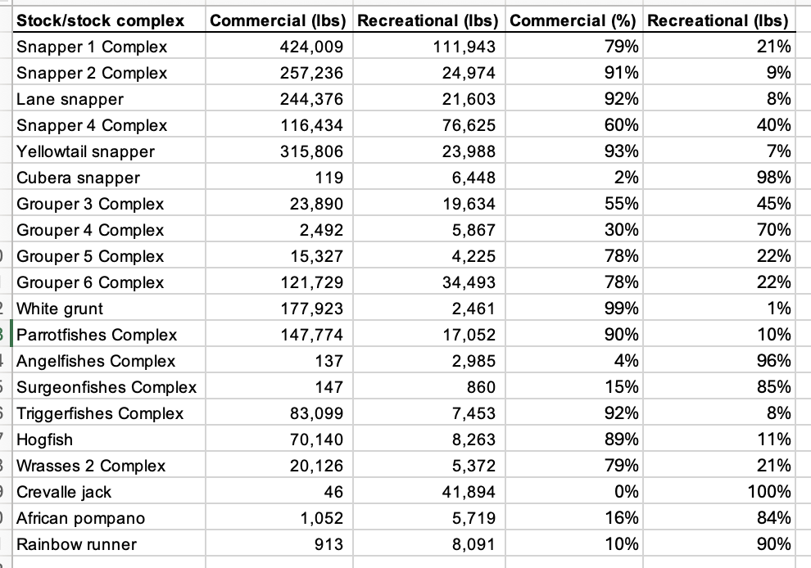

***Table 5-3.*** *Nominal 2023 Annual Catch Limits (ACLs) by sector for Puerto Rico pelagic fish stocks (*[*Federal Register 2022*](https://www.govinfo.gov/content/pkg/FR-2022-09-13/pdf/2022-19409.pdf)*) and the implicit percent allocation implied by these catch limits.*

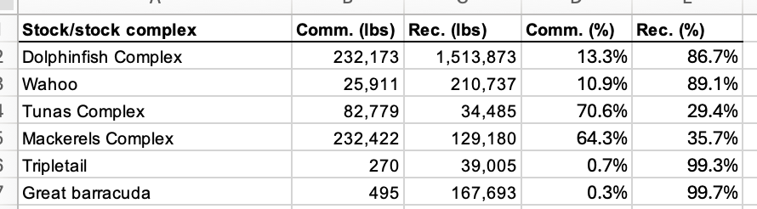

## 

## 6. Pacific

The PFMC implements three fishery management plans, all of which include allocations (**Table 6-1**).

***Table 6-1.*** *Brief summary of the allocation policies used in PFMC FMPs.*

|  |  |
| --- | --- |
| **FMP** | **Allocation policy summary** |
| Groundfish | Sector, subsector, catch shares |
| Coastal Pelagic Species | Spatial (country), seasonal (sardine only) |
| Salmon | Sector, spatial (area) |

### 6.1 Groundfish

The PFMC Groundfish FMP states that the Council will consider the following factors when considering the allocation of stocks managed under the FMP:

1. Present participation in and dependence on the fishery, including alternative fisheries.
2. Historical fishing practices in and historical dependence on the fishery.
3. The economics of the fishery.
4. Any consensus harvest sharing agreement or negotiated settlement between the affected participants in the fishery.
5. Potential biological yield of any species or species complex affected by the allocation.
6. Consistency with the Magnuson-Stevens Act national standards.
7. Consistency with the goals and objectives of the FMP.

#### 6.1.1 Sablefish North of 36°N latitude

The catch of sablefish north of 36°N latitude is allocated using a mixture of sector- and subsector-based allocation rules. First, 10% of the Annual Catch Limit (ACL) is allocated to tribes. Then, after removing catch estimated for research and recreational fisheries (often referred to as “set asides”), the remaining catch is allocated among the limited-entry (LE; 90.6%) and open-access (OA; 9.4%) fisheries. The catch allocated to the LE fishery is further subdivided among trawl (58%) and fixed gear (42%) fisheries. In general, the catch allocated to the fixed gear fishery is then allocated between the primary fishery (85%) and the daily-trip-limit fishery (15%) (**Figure 6-1**). These allocations have evolved over time through complex considerations and negotiations but were originally based on average landings from 1981-1985 ([Agenda Item F.4](https://www.pcouncil.org/documents/2024/03/f-4-attachment-3-analysis-to-inform-selection-of-final-preferred-alternative-for-sablefish-gear-switching-electronic-only.pdf/#page=19)).

This means that the commercial catch is divided into the following 4 subsectors:

1. LE-trawl (52.6%): 58% of 90.6%
2. LE-fixed gear-primary (32.3%): 85% of 42% of 90.6%
3. LE-fixed gear-daily trip limit (5.7%): 15% of 42% of 90.6%
4. OA (9.4%)

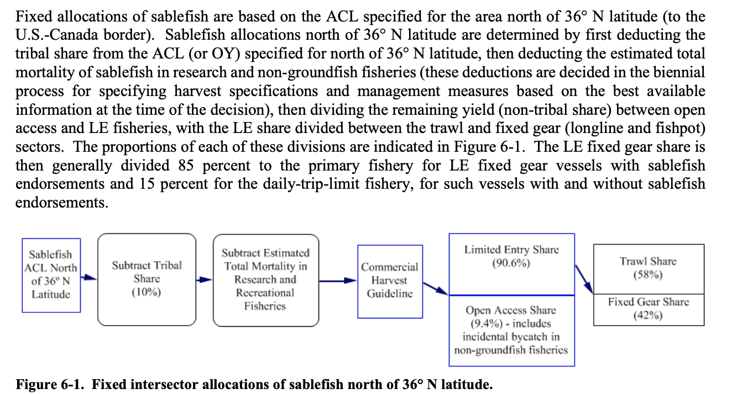

***Figure 6-1.*** *Flow chart illustrating the allocation of catch in the sablefish fishery north of 36° latitude. From the Groundfish FMP.*

#### 6.1.2 Pacific whiting

The catch of Pacific whiting (*Merluccius productus*) is allocated using a mixture of sector and subsector allocation rules. First, projected catches of whiting in recreational, research, and non-whiting fisheries are “set aside” during the annual specification process (i.e., estimated based on current management measures and historical patterns). In some years, catch may also be set aside for vessels fishing with Exempted Fishing Permits (EFPs). A portion of the remaining catch is then set aside for tribal whiting fisheries and the remainder goes to non-tribal commercial fisheries. The non-tribal catch is divided among three limited-entry whiting trawl fisheries: (1) shoreside sector, 42%; (2) at-sea mothership sector, 24%; and (3) at-sea catcher-processor sector, 34% **(Figure 6-2**). These percentages are based on landings from 1994-1996 ([50 CFR Part 660](https://www.govinfo.gov/content/pkg/FR-1997-05-20/pdf/97-13120.pdf)). No more than 5% of the allocation to the shoreside sector may be retained south of 42°N prior to the start of the shoreside sector north of 42°N. We do not count this as a spatial/temporal allocation because it is more of a fair start rule.

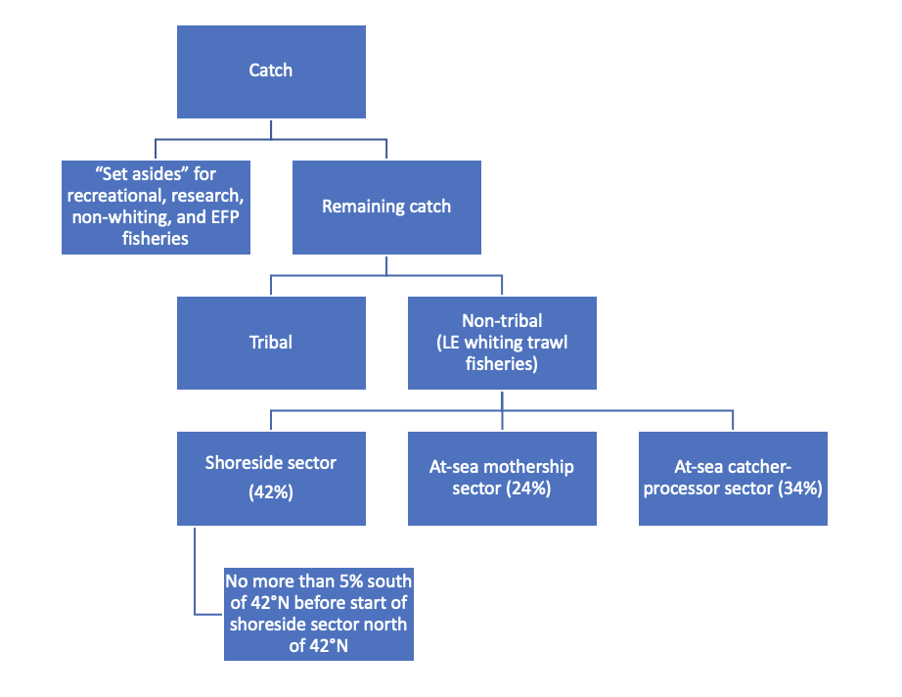

***Figure 6-2.*** *Flow chart illustrating the allocation of catch in the Pacific whiting fishery.*

#### 6.1.3 Amendment 21 and 29 stocks

The catch of Amendment 21 and 29 stocks is allocated using a mixture of sector and subsector allocation rules. First, set asides for research, tribal, non-groundfish, and exempted fishing permits are removed from the Annual Catch Limits (ACLs) or Optimum Yields (OYs). The remainder is then allocated between the Limited-Entry (LE) trawl fishery and non-trawl fishery using the species-specific allocations listed in **Table 6-2** below. Most of these percentages are based on average 2003-2005 total catches by sector ([PFMC 2010](https://www.pcouncil.org/documents/2010/06/groundfish-fmp-amendment-21-feis.pdf/#page=38)). The non-trawl fishery encompassed three fisheries: the limited-entry fixed gear fishery, the open access fishery, and the recreational fishery. Allocations among these three non-trawl fisheries are decided, if needed, in the biennial harvest specifications and management measures process.

​​***Table 6-2.*** *The allocation of catch between limited-entry (LE) trawl and non-trawl sectors. Most percentages are based on average 2003-2005 total catches by sector. The “other flatfish” complex contains: butter sole, curlfin sole, flathead sole, Pacific sanddab, Petrale sole, rex sole, rock sole, and sand sole. The “slope rockfish” complex contains: bank, blackgill redbanded, rougheye, sharpchin, shortraker, yellowmouth, and blackspotted rockfish.*

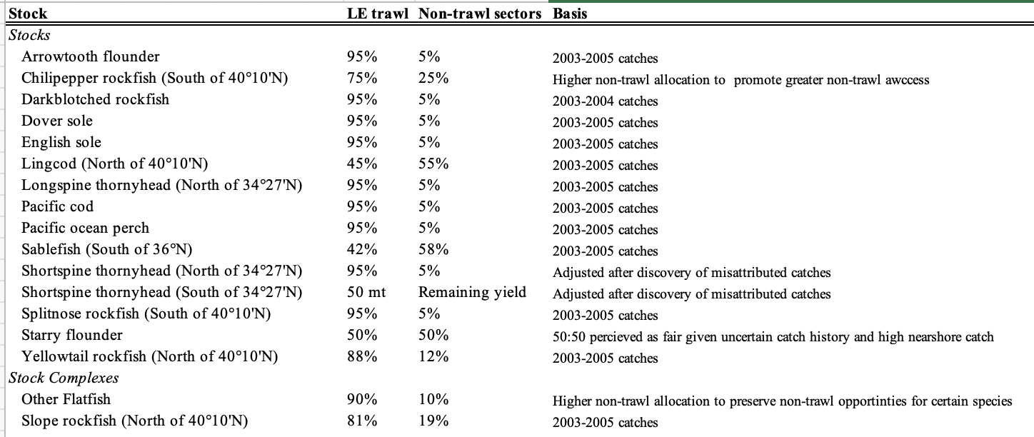

The LE trawl sector catch is further subdivided between the shoreside non-whiting and whiting trawl sectors based on **Table 6-3** below. These percentages are based on 1995-2005 catch percentages.

***Table 6-3.*** *Initial allocation of Amendment 21 species between LE trawl sectors delivering groundfish to shoreside processing plants (i.e., shoreside whiting and shoreside non-whiting). Percentages are based on average catch from 1995-2005.*

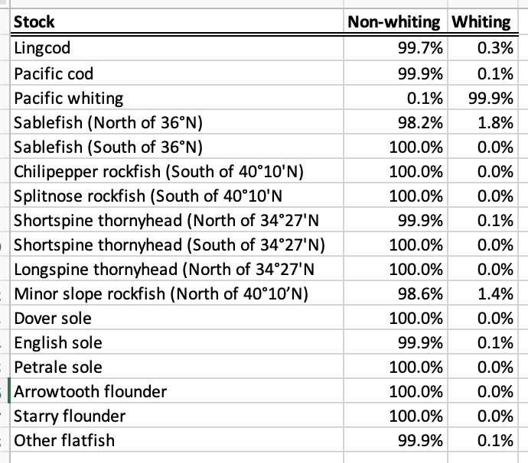

**Figure 6.3**  illustrates a flow chart of allocation for Amendment 21 and 29 stocks.

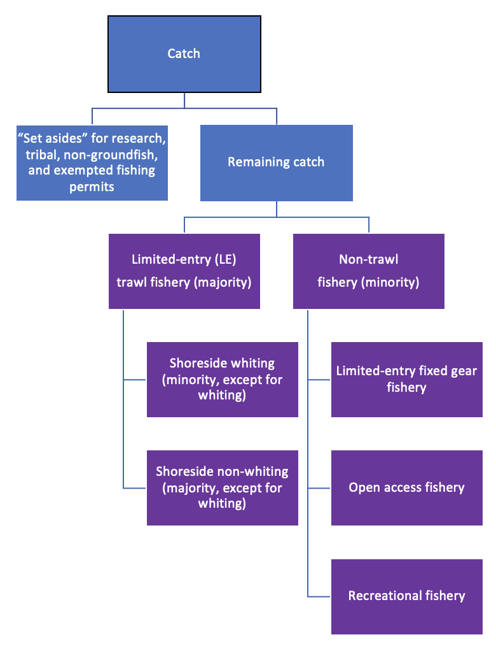

***Figure 6-3.*** *Flow chart illustrating the allocation of catch for Amendment 21 and 29 stocks.*

#### 6.1.4 Catch share program

In 2011, PCGFMP established a catch share program through a framework outlined in Amendments 20 and 21. In the case of whiting, 80% of quota share (QS) went to permit owners, 20% went to processors, and none was left for adaptive management. In the case of non-whiting species, 90% went to permits, none went to processors, and 10% went to adaptive management. Initial share permits were allocated based on historical catch (1994-2003) and processing (1998-2004) in the trawl fishery. Quota for overfished species is determined using 2003-2006 logbook data to calculate the amount of overfished species an entity would need to take its target species. The program includes an Individual Fishing Quota (IFQ) Program for shorebased vessels (targeting whiting and other species), and cooperative programs for at-sea mothership and catcher/processor fleets (primarily targeting whiting). Shares can be controlled by individual fishermen or cooperatives. Shares can be transferred annually (lease) or permanently (sell). Most stocks have vessel use limits (limit on quota registered to a vessel in a year) and/or QS control limits (limit on QS a single entity can control) vary by stock and sometimes area (**Table 6-4**) ([IFQ species and area designations](https://media.fisheries.noaa.gov/dam-migration/ifq-species-areas_2019_update-effective_10-01-2019.pdf); [Data Collection for the Trawl Rationalization Program](https://www.federalregister.gov/documents/2010/01/29/2010-1877/fisheries-off-west-coast-states-pacific-coast-groundfish-fishery-data-collection-for-the-trawl); [Trawl Rationalization Program](https://www.federalregister.gov/documents/2010/10/01/2010-23246/fisheries-off-west-coast-states-pacific-coast-groundfish-fishery-management-plan-amendments-20-and); [Description of Trawl Rationalization (Catch Shares) Program](https://www.pcouncil.org/documents/2017/06/groundfish-fmp-appendix-e-description-of-the-trawl-rationalization-program.pdf/)).

***Table 6-4.*** *Control and vessel limit options for shoreside IFQ sector from* [*Pacific Groundfish FMP Appendix E.*](https://www.pcouncil.org/documents/2017/06/groundfish-fmp-appendix-e-description-of-the-trawl-rationalization-program.pdf/)

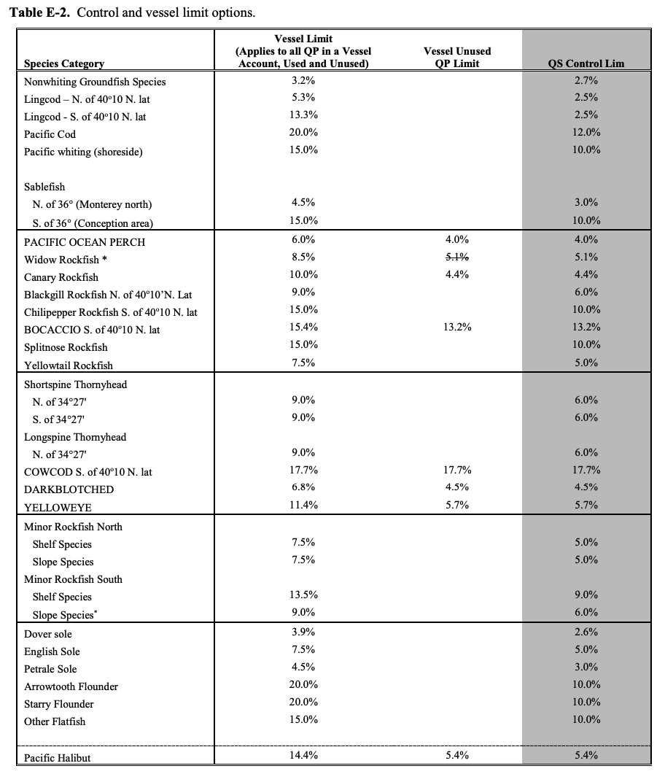

### 6.2 Coastal Pelagic Species

The PFMC Coastal Pelagic Species FMP states that the Council will consider the following factors when considering the allocation of stocks managed under the FMP:

1. Present participation in and dependence on the fishery, including alternative fisheries;
2. Historical fishing practices in, and historical dependence on, the fishery;
3. Economics of the fishery;
4. Agreements or negotiated settlements between the affected participants in the fishery;
5. Potential biological impacts on any species affected by the allocation;
6. Consistency with the MSA national standards; and
7. Consistency with the goals and objectives of this FMP.

#### 6.2.1 International allocations

Many of the stocks managed under the FMP have distributions that extend into other EEZs (Mexico or Canada). Fixed percentages based on the average distribution of the stock are used to allocate the Overfishing Limit (OFL) between the U.S. and Mexico/Canada:

* **Pacific sardine:** 87% U.S., 13% Mexico
* **Pacific chub mackerel:** 70% U.S., 30% Mexico
* **Northern anchovy (central stock):** 82% U.S., 18% Mexico
* **Northern anchovy (northern stock):** unknown between U.S. and Canada
* **Jack mackerel:** 65% U.S., 35% Mexico

These percentages were determined for Amendment 8, which turned the Northern Anchovy Plan into the CPS FMP ([Amendment 8 FEIS](https://www.pcouncil.org/documents/1998/12/cps-fmp-amendment-8-feis.pdf/); [March 2000 Briefing Book](https://www.pcouncil.org/documents/2000/03/d-coastal-pelagic-management-march-2000.pdf/)). They were based on two sources of data: CalCOFI larval data (1951-1985) and fish spotter estimates (1964-1992). Estimates for Pacific sardine were based on the fish spotter data and estimates for Chub mackerel, Jack mackerel, and Northern anchovy were based on average of CalCOFI estimates for the winter through spring and fish spotter estimates for summer through winter. [A 2015 workshop](https://www.pcouncil.org/documents/2015/11/agenda-item-h-1-10.pdf/) revisited these assumptions of Pacific sardine and retained the 87% value among five alternatives.

#### 6.2.2 Pacific sardine

The non-tribal share of the Pacific sardine Harvest Guideline (HG) is allocated seasonally:

* **Jan 1 - Jun 30 (6 months):** 35%
* **Jul 1 - Sep 14 (2.5 months):** 40%, plus portion not harvested from initial allocation
* **Sep 14 - Dec 31 (3.5 months):** 25%, plus portion not harvested from earlier allocations

This is intended to ensure that all regional fishing sectors have at least some access to the directed harvest each year.

This policy went into effect on July 31, 2006 as part of [Amendment 11](https://www.federalregister.gov/documents/2006/06/29/06-5816/fisheries-off-west-coast-states-coastal-pelagic-species-fisheries-amendment-11) to the Coastal Pelagic Species FMP and overrode the policy described below.

**Tribal set aside:** Although tribes ave not requested a set aside for many years, a tribal set aside may be within 120 days of the start of a fishing season. If a request is made, the set aside is removed from the ACL. The magnitude of the set aside is interpreted as up to 50% of harvestable surplus of fish that pass through the tribes’ usual and accustomed (U&A) fishing grounds.

*History of revisions to the original spatial-temporal allocation strategy*

The original FMP, which was adopted in 1998 and was implemented on January 1, 2000, used the following spatial/temporal allocation rule:

* **Jan 1 - Sep 30 (9 months):** 33% to northern subarea, 66% to southern subarea
* **Oct 1 - Dec 31 (12 months):** Remaining quota pooled and split 50-50

The boundary between the subareas was 35°40’ N, near Point Piedras Blancas, California.

The rule was adopted from existing state law, which aimed to balance harvest between Southern California- and Monterey-based fishing fleets.

This original rule was revisited when Pacific sardine biomass began to expand north and a fishery began to develop in Oregon and Washington. Oregon, Washington, and northern California shared the northern portion of the allocation, leading Oregon- and Washington-based fleets to express concern that they were not afforded sufficient fishing opportunities.

In April 2003, the Council recommended an interim framework for the allocation of Pacific sardine to partially address these concerns, while it developed a more comprehensive, longer-term allocation framework. The interim allocation framework:

1. Changed the definition of the subareas by moving the geographic boundary between the two areas from 35°40′ N to 39°N (Point Arena, California);
2. Moved the date when remaining unharvested Pacific sardine is reallocated to the subareas from October 1 to September 1;
3. Changed the percentage of the unharvested Pacific sardine that is reallocated to the northern subarea and southern subarea from 50 percent to both subareas to 20 percent to the northern subarea and 80 percent to the southern subarea; and
4. Reallocated all the unharvested Pacific sardine that remains on December 1 coastwide.

These adjustments were motivated by the difference in the timing of harvest between the different fleets:

1. The southern California-based fleet starts harvesting Pacific sardine January 1, and the harvest increases steadily throughout the year;
2. The Monterey-based fleet starts in August (tied to market squid availability) and harvest increases through January or February of the following year;
3. The Oregon and Washington-based fleets have a more abbreviated season, which starts in June and ends in October.

Because these sectors operate on very different schedules, annual allocations help to ensure that each sector receives a reasonable fishing opportunity.

In June 2005, the Council examined seven alternative long-term allocation schemes, and at that time, adopted the regulations set forth in Amendment 11. The Council also recommended a review of the allocation formula in 2008, due to the fact that the Pacific sardine resource, as well as the fisheries and markets that rely on it, are often dynamic and difficult to predict.

### 6.3 Salmon

The PFMC Salmon FMP has the following key objective related to catch allocations:

*“3. Maintain ocean salmon fishing seasons supporting the continuance of established recreational and commercial fisheries while meeting salmon harvest allocation objectives among ocean and inside recreational and commercial fisheries that are fair and equitable, and in which fishing interests shall equitably share the obligations of fulfilling any treaty or other legal requirements for harvest opportunities.”*

There are several fora to adaptively update the allocation process on an annual basis. The North of Cape Falcon Forum, a state and tribal sponsored forum, convenes pertinent parties during the Council’s preseason process to determine allocation and conservation recommendations for fisheries north of Cape Falcon. The individual states also convene fishery industry meetings to coordinate their input to the Council.

#### 6.3.1 Stocks

The Salmon FMP names 67 stocks of Chinook salmon (*Oncorhynchus tshawytscha*), Coho salmon (*Oncorhynchus kisutch*), and pink salmon (*Oncorhynchus gorbuscha*). A large portion of these stocks are listed as “Endangered” or “Threatened” under the Endangered Species Act (ESA) and are managed based on the ESA consultation standards and guidance provided annually from the National Marine Fisheries Service. Similarly, a large number of stocks originating north of Cape Falcon, Oregon occur in both U.S. and Canadian waters and are managed based on the tenets of the Pacific Salmon Treaty (PST). **Table 6-5** lists the salmon stocks included in the FMP and indicates which are managed through the ESA, PST, or PFMC.

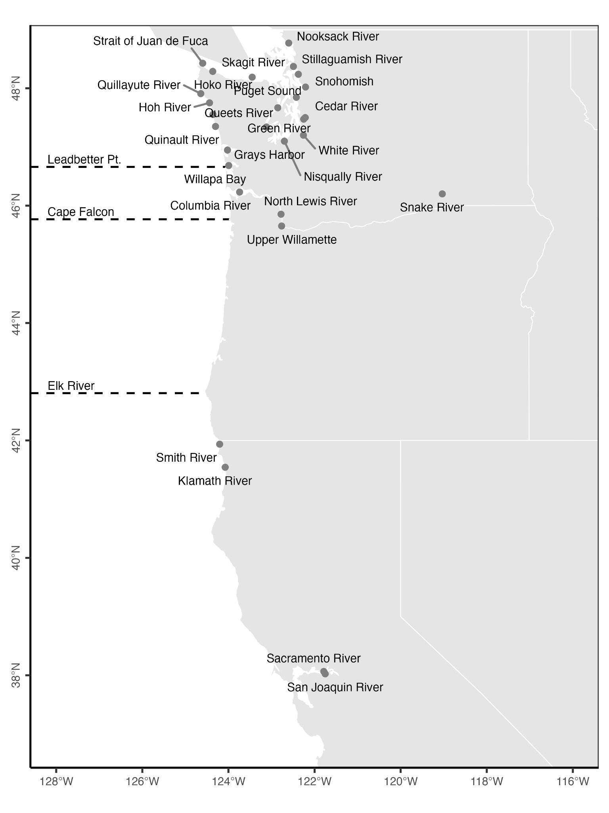

***Figure 6-4.*** *The location of river mouths associated with salmon stocks named in the Pacific Salmon FMP. The lines indicate Elk River, Oregon, Cape Falcon, Oregon, and Leadbetter Point, Washington, which represent important landmarks in the management of Pacific salmon.*

***Table 6-5.*** *Salmon stocks listed in the Pacific Salmon FMP. The management column indicates whether the stock is primarily managed through the Endangered Species Act (ESA) or by the Pacific Salmon Treaty (PST) rather than through the Council process. The table also indicates whether the stock occurs north or south of Cape Falcon, Oregon.*

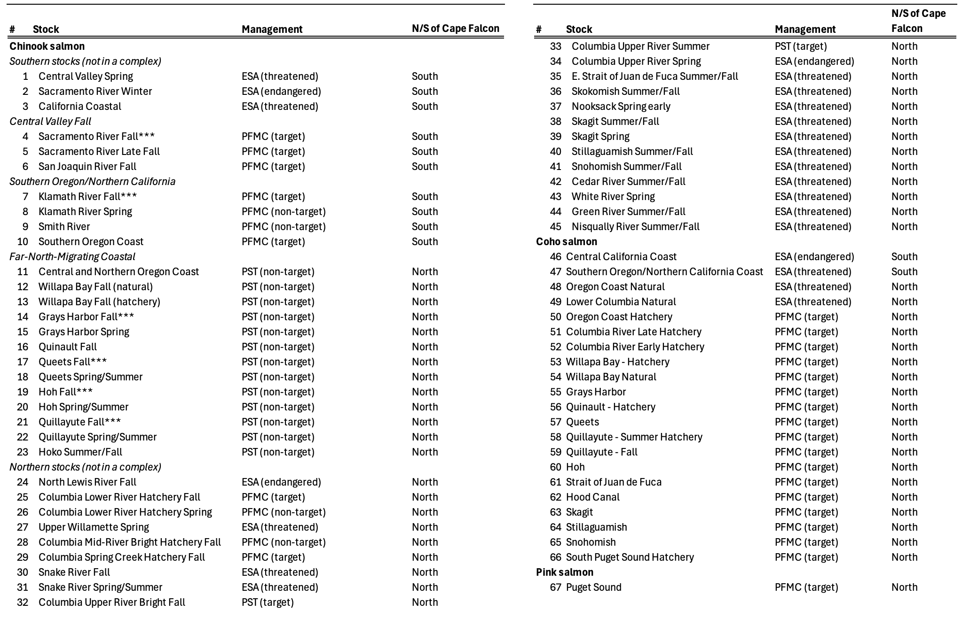

#### 6.3.2 Tribal allocations

**California:** In California, the Yurok and Hoopa Valley Indian tribes of the Klamath River Basin have a federally protected right to the fishery resource of their reservations sufficient to support a moderate standard of living or 50 percent of the total available harvest of Klamath-Trinity basin salmon, whichever is less.

**Oregon:** The U.S. v. Oregon Parties – the State of Oregon, the State of Washington, the State of Idaho, the United States (including the NMFS and the U.S. Fish and Wildlife Service, and the U.S. Bureau of Indian Affairs), the Shoshone-Bannock Tribes, the Confederated Tribes of the Warm Springs Reservation of Oregon, the Confederated Tribes of the Umatilla Indian Reservation, the Nez Perce Tribe, and the Confederated Tribes and Bands of the Yakama Nation – agree that the Columbia River treaty tribes’ are entitled to 50 percent of the harvestable runs destined to reach the tribes’ usual and accustomed fishing grounds.

**Washington:** In Washington, Treaty Indian tribes have a legal entitlement to the opportunity to take up to 50 percent of the harvestable surplus of stocks which pass through their usual and accustomed fishing areas. This is calculated and allocated in the Fishery Regulation Assessment Model (FRAM).

#### 6.3.3 Coho salmon (south of Cape Falcon)

**Sector allocation:** Coho fisheries are prohibited off the California coast. The allocation of south of Cape Falcon Coho salmon between recreational and commercial troll fisheries is based on the total allowable ocean harvest as follows:

* **0-150,000:** Recreational harvest = all harvest
* **150,000-350,000:** Recreational harvest = 150,000 plus 33% of surplus above 150,000
* **350,000-800,000:** Recreational harvest = 217,000 plus 14% of surplus above 350,000
* **>800,000:** Recreational harvest = 280,000 plus 10% of surplus above 800,000

The following figure visualizes this rule graphically:

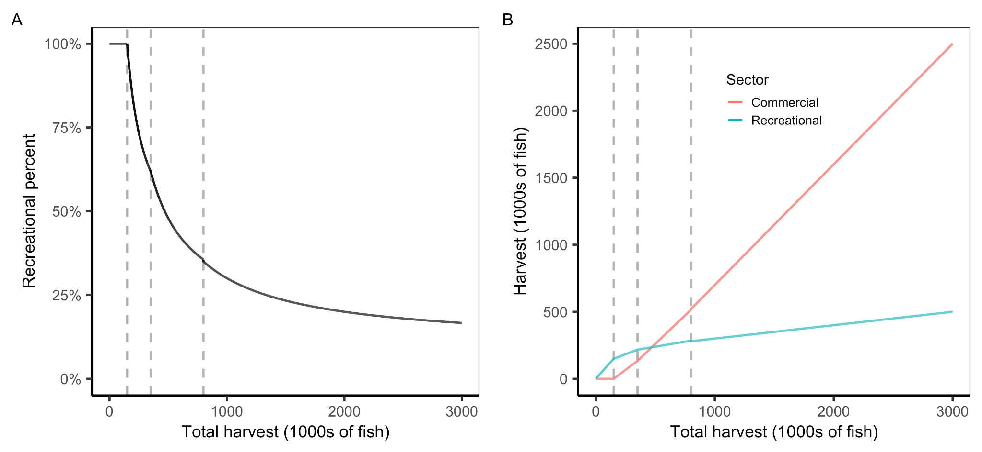

***Figure 6-5.*** *The* ***(A)*** *percent of ocean harvest allocated to the recreational fishery and* ***(B)*** *the amount of ocean harvest allocated to the recreational and commercial trawl fisheries based on the total estimated ocean harvest for the season. The vertical dashed lines indicate breakpoints in the allocation rule, which occur at 150,000, 350,000, and 800,000 fish.*

This rule was developed to provide a stable recreational season while allowing economic benefits to the commercial fishery to increase with increasing stock levels. Furthermore, there are procedures to reallocate unused recreational catch to the commercial fishery. The reallocation procedure is to occur no later than August 15 to allow the commercial fishery time to utilize the recreational surplus, but should occur late in the summer period between Memorial Day and Labor Day that captures the majority of the recreational season.

The allocation rule is also designed to ensure that there are sufficient coho allocated to the commercial fishery at low stock levels to maintain the viability of the Chinook troll fishery. The recreational allocation will be reduced to ensure allowance for incidental catch (“hooking mortality”) in the Chinook troll fishery.

**Spatial allocation:** Quotas may be further subdivided spatially to meet management objectives of the FMP. They will be determined annually based on the following considerations:

1. abundance of contributing stocks
2. allocation considerations of concern to the Council
3. relative abundance in the fishery between Chinook and coho
4. escapement goals
5. maximizing harvest potential

When the recreational catch allocation is <167,000, the quota will be divided among two subareas:

* Central Oregon (Cape Falcon to Humbug Mountain): 70%
* South of Humbug Mountain: 30%

#### 6.3.4 Coho salmon (north of Cape Falcon)

The initial allocation of Coho salmon between sectors (recreational and commercial troll fisheries) is based on the size of the harvestable abundance:

***Table 6-6.*** *Allocation of Coho salmon between the commercial troll and recreational sectors based on forecast harvest levels.*

|  |  |  |
| --- | --- | --- |
| **Harvest** | **Commercial (%)** | **Recreational (%)** |
| 0-300,000 fish | 25 | 75 |
| >300,000 fish | 60 | 40 |

These allocation percentages may be modified annually to meet specific objectives for the commercial and recreational fisheries. There are complex conditions for these deviations.

The recreational portion of the quota will then be distributed geographically such that it is split 50-50 between areas north and south of Leadbetter Point, Washington. The allocation distribution north of Leadbetter is further subdivided but the nature of this subdivision depends on whether there is a fishery in Area 4B in Neah Bay.

***Table 6-7.*** *Allocation of recreational Coho salmon quota between areas when there is and is not a Area 4B fishery.*

|  |  |  |  |
| --- | --- | --- | --- |
| **Region** | **Port Area** | **Without Area 4B** | **With Area 4B** |
| S. of Leadbetter | Columbia River (Cape Falcon to Leadbetter Pt) | 50% | 50% |
| N. of Leadbetter | Westport (Leadbetter Pt to Queets River) | 37% | Plus 17.3% of Area 4B add-on |
| N. of Leadbetter | La Push (Queets River to Cape Flattery) | 2.6% | Plus 1.2% of Area 4B add on |
| N. of Leadbetter | Neah Bay | 10.4% | Minus 18.5% of Area B add on |

The following flow chart illustrates the allocation of north of Cape Falcon Coho salmon.

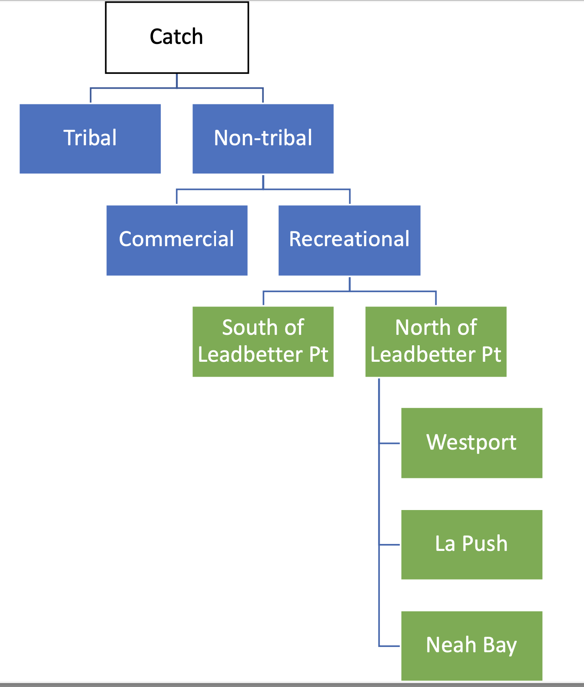

***Figure 6-6.*** *Flow chart illustrating the allocation algorithm for Coho salmon north of Cape Falcon.*

#### 6.3.5 Chinook salmon (north of Cape Falcon)

The initial allocation of Chinook salmon between sectors (recreational and commercial troll fisheries) is based on the size of the harvest level:

|  |  |  |
| --- | --- | --- |
| **Harvest** | **Troll (%)** | **Recreational (%)** |
| 0-100,000 fish | 50 | 50 |
| 100,000-150,000 fish | 60 | 40 |
| >150,000 fish | 70 | 30 |

These allocation percentages may be modified annual to meet specific objectives for the commercial and recreational fisheries. There are complex conditions for these deviations.

## 

## 7. North Pacific

The NPFMC implements six fishery management plans (**Table 7-1**). Of these FMPs, all but the Fish Resources of the Arctic include allocation rules. The NPFMC works closely with ADF&G, and has completely transferred management of the Salmon FMP to the State. Catch shares, especially and limited access privilege programs (LAPP), are common in NPFMC FMPs.

In 2017, the NPFMC instituted the following policy on allocation review triggers: “The Council identified three non-LAPP allocations (the Halibut Catch Sharing Plan and the GOA and BSAI Cod Allocations), and LAPPs as subject to the allocation policy directive. The CDQ allocation is not subject to this review. The Council adopts the LAPP review process for meeting the allocation review policy with the necessary modifications to the LAPP review recommended by staff. The Council adopts the 10-year timeframe as the primary trigger criteria for review for non-LAPP allocations, and the existing Council public input process as the secondary trigger criteria for review. The Council will specify its approach to allocation review at final action for any future allocation decisions.” ([NPFMC 2005](https://www.npfmc.org/wp-content/PDFdocuments/catch_shares/CDQ/CDQmotion1205.pdf); [NMFS 2018](https://media.fisheries.noaa.gov/dam-migration/cdq-program-summary-1018.pdf); [Western Alaska CDQ Program](https://seagrant.uaf.edu/events/fish-com/powerpoints/davis.pdf); [NPFMC Program And Allocation Reviews](https://www.npfmc.org/allocation-and-program-review/); [Anderson and Holliday 2007](https://www.fisheries.noaa.gov/s3//dam-migration/tech_memo_holiday_and_anderson.pdf)).

***Table 7-1.*** *Brief summary of the allocation policies used in NPFMC FMPs.*

|  |  |
| --- | --- |
| **FMP** | **Allocation policy summary** |
| Gulf of Alaska (GOA) Groundfish | Subsector, catch share |
| Bering Sea/Aleutian Islands (BSAI) Groundfish | Subsector, gear, catch share, season, area |
| BSAI King and Tanner Crabs | Subsector, gear |
| Salmon | Country, sector, gear |
| Scallop | No federal or state allocations; opt-in industry allocations through cooperative |
| Fish Resources of the Arctic Management Area | No allocations |

Since 1992, many North Pacific fisheries have allocated a portion of the TAC to the Community Development Quota (CDQ) Program. The CDQ Program provides the opportunity for eligible Alaska villages to participate and invest in Bering Sea (BS) and Aleutian Island (AI) fisheries to support social and economic activity in the region. There are currently six nonprofit CDQ groups representing 65 coastal communities in western Alaska. CDQs are self managed, and must report to ADF&G before the season begins the vessels that will be participating in the fishery, and how the quota will be allocated among the vessels. These CDQ organizations manage and administer allocations, investments, and economic development projects funded by CDQ:

1. AI Pribilof Island Community Development Corporation
2. Bristol Bay Economic Development Corporation
3. Central BS Fishermen’s Association
4. Coastal Villages Region Fund
5. Norton Sound Economic Development Corporation
6. Yukon Delta Fisheries Development Association

CDQ allocations vary by stock. Not all CDQ groups participate in all CDQ eligible fisheries. Substantial amendments to MSA in 2006 led to multiple changes to the CDQ program, including 1) continuation of allocations with no sunset date, 2) a guaranteed increase in multi-species groundfish allocations to 10.7% once/if quotas or sector allocations are implemented, 3) a CDQ allocation of 10.7% for any new directed fisheries, 4) implementation of a 10-year review cycle for allocation among CDQ groups during which the State will decide if the group’s allocation should be adjusted. Allocation among CDQ groups has traditionally been based on a set of criteria (see below), and is currently reviewed and managed by the State, and then reviewed by the NPFMC and the US Secretary of Commerce. The current CDQ group allocation criteria are:

1. Number of participating communities, population, and economic condition.
2. A Community Development Program that contains programs, projects, and milestones which show a well-though out plan for investments, service programs, infrastructure, and regional or community economic development.
3. Past performance of the CDQ group in complying with program requirements and in carrying out its current plan for investments, service programs, infrastructure, and regional or community  
   economic development.
4. Past performance of CDQ group governance, including: board training and participation;  
   financial management; and community outreach.
5. A reasonable likelihood exists that a for-profit CDQ project will earn a financial return to the CDQ group.
6. Training, employment, and education benefits are being provided to residents of the eligible communities.
7. In areas of fisheries harvesting and processing, past performance of the CDQ group, and proposed fishing plans in promoting conservation based fisheries by taking action what will minimize bycatch, provide for full retention and increased utilization of the fishery resource, and minimize impacts to the essential fish habitats.
8. Proximity to the resource.
9. The extent to which the CDP will develop a sustainable fisheries-based economy.
10. For species identified as “incidental catch species” or “prohibited species,” CDQ allocations may be related to the recommended target species allocations.

### 7.1 BSAI Groundfish

The BSAI Groundfish FMP was implemented in 1982 and governs the management of 23 stocks. Species managed by this FMP include Alaska plaice (*Pleuronectes quadrituberculatus*), arrowtooth flounder (*Atheresthes stomias*), Atka mackerel (*Pleurogrammus monopterygius*), Greenland halibut (*Reinhardtius hippoglossoides*), Kamchatka flounder (*Atheresthes evermanni*), northern rockfish (*Sebastes polyspinis*), Pacific cod (*Gadus macrocephalus*), Pacific ocean perch (*Sebastes alutus*), walleye pollock (*Gadus chalcogrammus*), yellowfin sole (*Limanda aspera*), sablefish (*Anoplopoma fimbria*), and shortraker rockfish (*Sebastes borealis*), in addition to complexes of flathead sole, rock sole, skate, blackspotted and rougheye rockfish, octopus, other flatfish, other rockfish, and shark. We exclude halibut from the summary as it is an internationally managed stock.

***Table 7-2.*** *Allocation policies of BSAI groundfish stocks.*

|  |  |
| --- | --- |
| **Stock** | **Allocation policies** |
| Alaska plaice | No allocations |
| Arrowtooth flounder | Subsector (CDQ) |
| Atka mackerel | Spatial, subsector (CDQ, ICA, Amendment 80), catch share (associated subsector allocations) |
| Blackspotted and Rougheye Rockfish Complex | Spatial |
| Flathead Sole Complex | Subsector (CDQ, ICA, Amendment 80), catch share (associated subsector allocations) |
| Greenland halibut | Subsector (CDQ), spatial |
| Kamchatka flounder | No allocations |
| Northern rockfish | No allocations |
| Octopus Complex | No allocations |
| Other Flatfish Complex | No allocations |
| Other Rockfish Complex | Spatial |
| Pacific cod - AI | Catch share (associated subsector allocations), seasonal |
| Pacific cod - BS | Catch share (associated subsector allocations), seasonal |
| Pacific ocean perch | Spatial, subsector (CDQ, ICA, Amendment 80), catch share (associated subsector allocations) |
| Rock Sole Complex | Subsector (CDQ, ICA, Amendment 80), catch share (associated subsector allocations) |
| Sablefish - BS / AI /GOA (jointly managed with GOA, single stock) | Spatial, subsector (incidental, gear, CDQ), catch share |
| Shark Complex | No allocations |
| Shortraker rockfish | No allocations |
| Skate Complex | No allocations |
| Walleye pollock - AI | Spatial, subsector (CDQ, ICA) |
| Walleye pollock - Bogoslof | No harvest, ICA only |
| Walleye pollock - Eastern BS | Subsectors, seasons, catch share |
| Yellowfin sole | Subsector (CDQ, ICA, Amendment 80), catch share (associated subsector allocations) |

#### Key components of BSAI Groundfish FMP

All six **CDQ** groups (See section **7**) participate in the BSAI groundfish fishery. The majority of stocks managed by the FMP are allocated to the CDQ Program (**Table 7-3**).

***Table 7-3.*** *2017 allocation percentages of groundfish TAC for CDQ. From* [*The Western Alaska Community Development Quota Program*](https://media.fisheries.noaa.gov/dam-migration/cdq-program-summary-1018.pdf)*. (Amendment 80)*

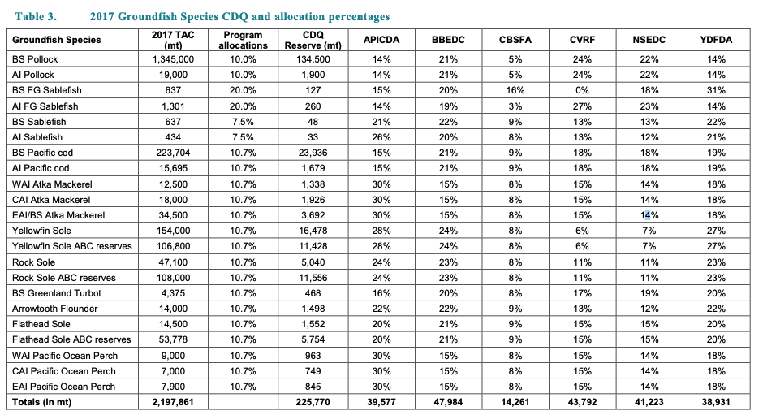

**The American Fisheries Act (AFA) (1998)** restricts foreign participation in the US fisheries industry by reducing the portion of individual vessels that can be owned by non-citizens to 25% (including through lending). Additionally, the AFA established subsector allocations for BSAI pollock, allowed the formation of cooperatives, limited participation by AFA vessels in non-pollock fisheries, and imposed additional catch weighing and monitoring regulations for AFA vessels.

The Mothership Fleet Cooperative (established by the AFA) allows members to transfer shares among themselves. Motherships refer to vessels that receive and process groundfish from other vessels. They participate in sideboarded BSAI Pacific cod fishery, and in the Trawl Limited Access Sector of the yellowfin sole fishery.

***Table 7-4.*** *Mothership cooperative shares.*

#### 

**Amendment 80 (non-AFA)**, implemented in 2008, formed cooperatives in the non-AFA trawl catcher/processor (CP) sector (not eligible under AFA to target pollock) through a Limited Access Privilege Program (LAPP). It also defined all non-Amendment 80 trawl fishery participants (AFA CP, AFA CV, non-AFA CVs) as the BSAI Trawl Limited Access Sector ([TLAS](https://www.ecfr.gov/current/title-50/section-679.2)). Qualifying non-AFA vessels receive cooperative quota for Atka mackerel (section **7.1.2**), Aleutian Islands Pacific ocean perch (section **7.1.5**), flathead sole, Pacific cod (section **7.1.1**), rock sole, and yellowfin sole (section **7.1.6**). Amendment 80 species are allocated between the Amendment 80 sector (non-AFA CP; catch share program), AFA vessels (AFA CP and CV), and non-AFA CV (**Table 7-5**). For all species except for yellowfin sole, allocation between Amendment 80 trawlers and BSAI trawl limited access vessels is set by **Table 7-5**. For yellowfin sole, allocation between these two sectors varies by ITAC (Section 7.1.6). Initial QS for Amendment 80 vessels for Amendment 80 species is based on the highest five years of landings of a given species in a given management area between 1998 and 2004 (and by management area for non-mackerel vessels targeting Atka mackerel). Small allocation adjustments compensated for three vessels that qualified for the program but had no landings during the reference period and were therefore each allocated 0.5% of the total yellowfin sole legal landings, 0.5% of the total rock sole legal landings, and 0.1% of the flathead sole legal landings. Amendment 80 institutes quota holdings caps (30% per individual/entity), quota use caps (30% per indivdual/entity), and vessel use caps (20% per vessel). Management of halibut and crab prohibited species catch limits were also impacted by Amendment 80. Amendment 80 also raised the CDQ allocation of groundfish not already near or above 10% (sablefish and pollock) to 10.7% (**Figure 7-1**). The additional 0.7% of the allocation goes to the Western Alaska Community Development Association (WACDA). Amendment 80 allocates 100% of rock sole and flathead sole to Amendment 80 sectors. To protect fishing access in the Gulf of Alaska (GOA), the Program also included sideboard limit protections for GOA groundfish. Details of other species allocations described in subsections below. [Northern Economics 2014](https://www.fisheries.noaa.gov/s3//dam-migration/amd80-5yr-review1014.pdf); [American Fisheries Act](https://www.fisheries.noaa.gov/alaska/sustainable-fisheries/american-fisheries-act-pollock-fisheries-management-alaska); [2022 Mothership Fleet Cooperative Report](https://www.npfmc.org/wp-content/PDFdocuments/catch_shares/CoopRpts2022/MothershipFleet_AFA.pdf); [BSAI Groundfish FMP](https://www.npfmc.org/wp-content/uploads/BSAIGFAmActionSumm.pdf); [2024–2025 AK Groundfish Harvest Spex](https://www.fisheries.noaa.gov/alaska/commercial-fishing/2024-2025-alaska-groundfish-harvest-specifications); [BSAI Yellowfin Management](https://www.federalregister.gov/documents/2018/06/06/2018-12034/fisheries-of-the-exclusive-economic-zone-off-alaska-yellowfin-sole-management-in-the-groundfish); [50 CFR § 679.2](https://www.ecfr.gov/current/title-50/chapter-VI/part-679/subpart-A/section-679.2); [50 CFR § 679.90](https://www.law.cornell.edu/cfr/text/50/679.90); [BS Flatfish Harvest Spex Flexibility](https://www.npfmc.org/wp-content/PDFdocuments/SPECS/flatfishSpecs112.pdf); [BSAI 2024-25 Groundfish Harvest Spex](https://www.federalregister.gov/documents/2023/12/05/2023-26707/fisheries-of-the-exclusive-economic-zone-off-alaska-bering-sea-and-aleutian-islands-proposed-2024); [50 CFR](https://www.govinfo.gov/content/pkg/CFR-2023-title50-vol13/pdf/CFR-2023-title50-vol13-part679.pdf) [§](https://www.ecfr.gov/current/title-50/chapter-VI/part-679/subpart-A/section-679.2) [679](https://www.govinfo.gov/content/pkg/CFR-2023-title50-vol13/pdf/CFR-2023-title50-vol13-part679.pdf); [Amendment 80 Allocation Protocol](https://www.federalregister.gov/d/E7-9828/p-553).

***Table 7-5.*** *Annual Apportion of Amendment 80 Species ITAC Between the Amendment 80 and BSAI Trawl Limited Access Sectors (Except Yellowfin Sole) (*[*Table 33 to Part 679*](https://www.law.cornell.edu/cfr/text/50/appendix-Table_33_to_part_679)*).*

|  |  |  |  |  |
| --- | --- | --- | --- | --- |
| **Fishery** | **Management area** | **Year** | **Percentage of ITAC allocated to the Amendment 80 sector** | **Percentage of ITAC allocated to the BSAI trawl limited access sector** |
| Atka mackerel | 543 | All years | 100 | 0 |
|  | 542 | 2008 | 98 | 2 |
|  |  | 2009 | 96 | 4 |
|  |  | 2010 | 94 | 6 |
|  |  | 2011 | 93 | 8 |
|  |  | 2012 and all future years | 90 | 10 |
|  | 541/EBS | 2008 | 98 | 2 |
|  |  | 2009 | 96 | 4 |
|  |  | 2010 | 94 | 6 |
|  |  | 2011 | 92 | 8 |
|  |  | 2012 and all future years | 90 | 10 |
| AI Pacific ocean perch | 543 | All years | 98 | 2 |
|  | 542 | 2008 | 95 | 5 |
|  |  | 2009 and all future years | 90 | 10 |
|  | 541 | 2008 | 95 | 5 |
|  |  | 2009 and all future years | 90 | 10 |
| Pacific cod | BSAI | All years | 13.4 | N/A |
| Rock sole | BSAI | All years | 100 | 0 |
| Flathead sole | BSAI | All years | 100 | 0 |

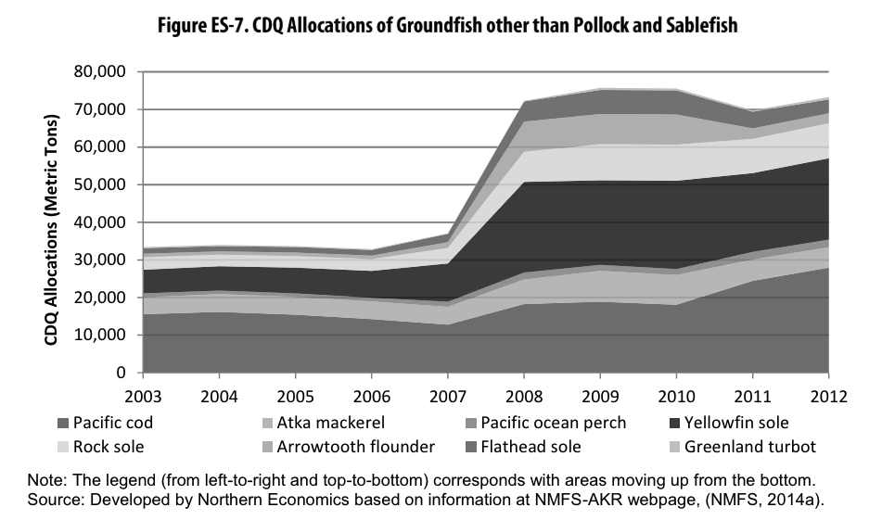

***Figure 7-1.*** *CDQ Allocations of groundfish other than pollock and sablefish between 2003 and 2012, highlighting the impact of Amendment 80 on CDQ allocations. From* [*Northern Economics. (2014) Five-Year Review of the Effects of Amendment 80.*](https://www.fisheries.noaa.gov/s3//dam-migration/amd80-5yr-review1014.pdf)

#### 7.1.1 Pacific cod

Once the TAC is set for BS and AI cod, 10.7% from each goes to CDQ. All CDQ groups participate in the BSAI Pacific cod fishery, and allocations among groups are set by the state of Alaska and reviewed on a 10-year cycle (see section **7** for criteria). Allocations within groups are determined by individual groups. After the CDQ allocation, the remaining AI and BS TAC are combined into a single TAC. This TAC is then allocated across nine subsectors (**Table 7.6**) that vary in gear, operation type, and vessel size. As an Amendment 80 species (section **7**), trawl components include the Amendment 80 sector (non-AFA CP; catch share), AFA vessels (AFA CP and CV), and non-AFA CV. Most subsectors (all but hook-and-line/pot < 60ft) allocate across either 2 or 3 seasons, and often the highest allocation is for the first season because of the roe and high meat quality associated with the first portion of the year. Multiple subsectors allocate ICAs. The hook-and-line/pot gear subsectors allocate 500 mt to ICA. The PCTC Program allocates 1500 mt of Season A quota and 700 mt of Season B quota to ICA. In 2024, the Council implemented the Pacific Cod Trawl Cooperative Program (PCTC; Amendment 122; catch share) for trawl catcher vessels (22.1% of TAC) for seasons A and B. Season C operates outside of PCTC, and is open to all trawl catcher vessels with LLP license endorsements to harvest in the BS and/or AI with trawl gear (not QS goes to license holders and not vessels) ([Amendment 122](https://www.federalregister.gov/documents/2023/08/08/2023-16526/fisheries-of-the-exclusive-economic-zone-off-alaska-amendment-122-to-the-fishery-management-plan-for); [50 CFR § 679.23](https://www.law.cornell.edu/cfr/text/50/679.23); [50 CFR § 679.130](https://www.law.cornell.edu/cfr/text/50/679.130); [BSAI Pacific Cod Sector Allocations](https://www.npfmc.org/wp-content/PDFdocuments/catch_shares/Pcod/BSAIPcodsplit1011.pdf); [Implementing the American Fisheries Act of 1998](https://www.npfmc.org/wp-content/uploads/afalaw.pdf); [Pacific Cod Trawl Cooperative Program](https://www.federalregister.gov/d/2023-16526/p-16)).

All vessel and processor (both shoreside and catcher/processor motherships) participants in seasons A & B of the trawl catcher vessel subsector fishery must join a cooperative as a part of the PCTC program. PCTC quota share (QS) is allocated to qualifying License Limitation Program (LLP) license holders and qualifying processors with a history of participation in the fishery. Original QS were based on 2009-2019 landings and processing activity (minus the lowest year of participation), with the exception of those with LLP licenses with transferable AI endorsements, for which QS was also based on 2004-2009 landings. The Council allocates cooperative quota (CQ) based on combined QS of cooperative harvesters and processors. If Adak or Atka shore processors petition to process fish in a given year, cooperatives must allocate 12% of season A CQ to these shoreplants. The PCTC program establishes QS ownership at 5% for harvesters and 20% for processors. Additionally, it establishes CQ caps at 5% for harvesters and 20% for processors. However, there are exceptions for participations that have historically harvested or processed over these caps. These exceptions are not transferable with QS or CQ transfers. However, PCTC allows transfers of both QS (sale) and CQ (annual transfer allowing cooperatives to account for unforeseen circumstances).

The AFA (American Fisheries Act) subsector resulted from the American Fisheries Act of 1998. AFA vessels can participate in PCTC as long as they are listed on a LLP license with BS/AI endorsements. Harvest of BSAI Pacific cod by AFA catcher vessels is managed through private inter-cooperative agreements.



***Figure 7-2.*** *Flowchart describing allocations of BSAI Pacific cod.*

***Table 7-6.*** *Subsector and seasonal allocations of Pacific cod in BS/AI once CDQ is allocated from* [*Federal Register :: Fisheries of the Exclusive Economic Zone Off Alaska; Bering Sea and Aleutian Islands; Revised Final 2023 and 2024 Harvest Specifications for Groundfish*](https://www.federalregister.gov/documents/2023/12/06/2023-26639/fisheries-of-the-exclusive-economic-zone-off-alaska-bering-sea-and-aleutian-islands-revised-final)*.*

|  |  |
| --- | --- |
| **Subsector** | **Subsector and seasonal allocation** |
| Hook-and-line trawl catcher vessels (CV) >= 60 ft | 0.2%  Season A: 1/1-6/10: 51%  Season B: 6/10-12/31: 49% |
| Jig gear | 1.4%  Season A: 1/1-4/30: 60%  Season B: 4/30-8/31: 20%  Season C: 8/31-12/31: 20% |
| Pot catcher/processors (C/Ps) | 1.5%  Season A: 1/1-6/10: 51%  Season B: 9/1-12/31: 49% |
| Hook-and-line and pot CVs < 60 ft | 2.0% |
| American Fisheries Act (AFA) trawl C/Ps | 2.3%  Season A: 1/20-4/1: 75%  Season B: 4/1-6/10: 25%  Season C: 6/10-11/1: 0% |
| Pot CVs greater >+ 60 ft | 8.4%  Season A: 1/1-6/10: 51%  Season B: 9/1-12/31: 49% |
| Non-AFA trawl C/Ps (Amendment 80)  \**managed through cooperative catch share program with other groundfish* | 13.4%  Season A: 1/20-4/1: 75%  Season B: 4/1-6/10: 25%  Season C: 6/10-12/31: 0% |
| Trawl CVs (now managed through PCTC catch share program)  \**Incidental Catch Amount accounts for projected incidental catch of Pacific cod by trawl catcher vessels engaged in directed fishing for groundfish other than PCTC Program Pacific cod* | 22.1%  Season A: 1/20-4/1: 74%  Season A ICA: **1500 mt**  Season B: 4/1-6/10: 11%  Season B ICA: **700 mt**  Season C: 6/10-11/1: 15% |
| Hook-and-line C/Ps | 48.7%  Season A: 1/1-6/10: 51%  Season B: 6/10-12/31: 49% |

#### 7.1.2 Atka mackerel

The EBS/EAI, CAI, and EAI each get an individual sub TAC of total BSAI TAC. Currently, these are split at 45% EBS/EAI, 23% CAI, and 32% WAI. As an Amendment 80 species (section **7**), 10.7% of each regional TAC is allocated to CDQ. In the EBS/EAI subarea, up to 2% is allocated to the jig fishery. The annual percentage is dependent on the previous jig landings and the predicted future jig landings. There is also an allocation for incidental catch in BSAI trawl and non-trawl sectors. Similar to other Amendment 80 (section **7.1**) species, the remaining TAC is then allocated among BSAI trawl components–the Amendment 80 sector (non-AFA CP), AFA vessels (AFA CP and CV), and non-AFA CV sectors. Within the trawl sectors, TAC is allocated equally between Season A (January 20 - June 10) and Season B (June 10 - December 31). Unharvested catch from Season A can be harvested in Season B ([BSAI 2024-45 Groundfish Harvest Spex](https://www.federalregister.gov/documents/2024/03/11/2024-05093/fisheries-of-the-exclusive-economic-zone-off-alaska-bering-sea-and-aleutian-islands-final-2024-and); [50 CFR § 679.20](https://www.law.cornell.edu/cfr/text/50/679.20)).

#### 7.1.3 Pollock

The Council sets separate TAC for BS and AI subareas. For both subareas, 10% of TAC goes to CDQ. In both subregions, ICA is then set-aside (BS: 50,000mt; AI: 3,420mt). The remaining BS TAC is then allocated across subsectors (**Table 7.7**). As of 1998, the BS pollock fishery is largely allocated through the American Fisheries Act Pollock Cooperatives (see AFA description below). Broadly, 50% goes to the AFA inshore sector, 40% goes to the AFA catcher/processor sector, and 10% goes to the AFA mothership sector. Allocations are further divided by seasons for all subsectors and for CDQ, with 45% allocated to Season A (January 20-June 10) and 55% allocated to Season B (June 10 - November 1) (**Table 7.7**). There is an excessive harvesting share limit of 17.5% and an excessive processing share limit of 30%. For participants in the inshore subsector cooperative allocation program, vessel catch history (vessel’s best 2 of 3 years from 1995-1997 with some vessel specific exceptions) is converted into an annual cooperative quota share (vessel based) that is added to the total cooperative allocation. Participation in inshore cooperatives is optional, and there are a few vessels that instead elect to participate in the inshore open access fishery. Vessels can move between cooperatives, but must participate in the open access fishery for a year in between transitions. Allocations within offshore and mothership cooperatives are not managed by NMFS. Rather, the cooperatives manage allocations internally to prevent overharvest by the subsector. Quota shares are transferable within sectors, but not between inshore and at-sea sectors, that some argue may lead to underages (Criddle and Strong 2013).

As a result of the Consolidated Appropriations Act of 2004, the non-CDQ AI TAC is fully allocated to the Aleut Corporation to foster economic development in Adak, AK. There is a 250 mt ICA for the Bogoslof District, although direct harvest is prohibited. Season A is allocated 40% of AI ABC (including CDQ, ICA, and Aleut Corporation) but unharvested catch can be caught in Season B. There are also spatial allocations for AI ABC across three areas. Reallocation between subregions can occur midseason. For example, in 2024, projected unused amounts of AI pollock by the Aleut Corporation and the AI CDQ was reallocated from the Aleutian Islands subarea to the Bering Sea subarea (50 CFR Part 679). Recurring underage of AI allocation is linked to the rise of Pacific ocean perch in the region, a bycatch concern in the pollock fishery ([BSAI Pollock Reallocation](https://www.govinfo.gov/content/pkg/FR-2024-03-15/pdf/2024-05598.pdf); [50 CFR § 679.23 - Seasons](https://www.law.cornell.edu/cfr/text/50/679.23); [2021 Pollock Conservation Cooperative/High Seas Catchers' Cooperative Joint Report](https://www.npfmc.org/wp-content/PDFdocuments/catch_shares/CoopRpts2021/PCC_HSCC_AFA.pdf); [BSAI 2024-25 Groundfish Harvest Spex](https://www.federalregister.gov/documents/2024/03/11/2024-05093/fisheries-of-the-exclusive-economic-zone-off-alaska-bering-sea-and-aleutian-islands-final-2024-and); [Exempted Fishing Permits](https://www.federalregister.gov/documents/2018/11/20/2018-25327/fisheries-of-the-exclusive-economic-zone-off-alaska-application-for-an-exempted-fishing-permit); [Inshore sector cooperative allocation program](https://www.law.cornell.edu/cfr/text/50/679.62); [BS Pollock Bycatch Management](https://www.federalregister.gov/documents/2016/01/08/2016-00150/fisheries-of-the-exclusive-economic-zone-off-alaska-bycatch-management-in-the-bering-sea-pollock); [Groundfish Quota Programs](https://www.npfmc.org/fisheries-issues/catch-shares-allocations/groundfish-quota-programs/)).

***Table 7-7.*** *Subsector and subsector, seasonal, and area allocations for BSAI pollock.*

|  |  |
| --- | --- |
| **Subsector** | **Subsector, seasonal, and area allocation** |
| BS AFA inshore (deliver to onshore processors) | 50%  Season A: 1/20-6/10: 45%*  Season B: 6/10-11/1: 55% |
| BS AFA offshore catcher/processor:   * catch by catcher/processors * catch by catcher vessels * unlisted catcher processor | 40%  91.5%  8.5%  <=0.5%  Season A: 1/20-6/10: 45%*  Season B: 6/10-11/1: 55% |
| BS AFA motherships (deliver to floating processors) | 10%  Season A: 1/20-6/10: 45%*  Season B: 6/10-11/1: 55% |
| AI Aleut Corporation | 100%  *Area 541: 30%*  *Area 542: 15%*  *Area 543: 5%*  *Season A: 1/20-6/10: Max 40% across all subsectors*  *^these rules apply across all subsectors (CDQ, Aleut, and ICA)* |
| Bogoslof District ICA | 250 mt incidental |

\**No more than 28% from sea lion conservation area (SCA) by 4/1*

#### 7.1.4 Sablefish

Sablefish (*Anoplopoma fimbria)* across the EBS, AI, and GOA are considered a single stock and therefore jointly managed by BSAI and GOA Groundfish FMPs. TACs are set independently for management areas (**Figure 7-3**). TAC has been allocated between fixed and trawl gears since 1986 in GOA, and since 1990 in BSAI. In BSAI, the trawl fleet receives 50% of the BS TAC, and 25% of the AI TAC, and in each subregion 15% is allocated to non-specified reserve that helps facilitate in-season adjustments. Additionally, 7.5% is allocated to the CDQ reserve. In the case of GOA, the trawl fleet receives 20% of the Western and Central GOA TAC, and 5% of the Eastern GOA TAC (full allocation to West Yakutat District). Except for the allocation of sablefish to cooperatives as a secondary species in the Rockfish Program (6.78% to CV cooperatives and 3.51% to CP cooperatives), directed fishing for sablefish in GOA is closed and allocations represent anticipated incidental catch.

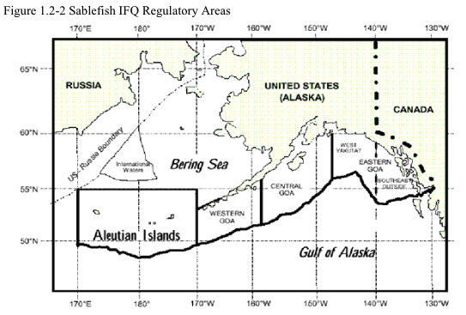

***Figure 7-3.*** *Sablefish management areas.* [*From Halibut Sablefish IFQ Program Review, 2016.*](https://www.npfmc.org/wp-content/PDFdocuments/halibut/IFQProgramReview_417.pdf)

Most of the fixed gear fishery is managed through a catch share program. The Council implemented the IFQ program (which includes quota for both Pacific halibut and sablefish) in 1995 following Amendment 15 to the BSAI groundfish FMP and Amendment 20 to the GOA groundfish FMP. It is now the largest catch share program in the country. Allocation to the IFQ program varies by region, with the program receiving 80% of the TAC in the Western and Central GOA, 95% of the TAC in the Eastern GOA, 50% of the TAC in the BS, and 75% of the TAC in the AI. Twenty-percent of the fixed-gear TAC in the BS and AI are allocated to CDQ. Quota shares (QS) were initially allocated to persons who landed halibut or sablefish using fixed-gear between 1988-1990 using either an owned or leased vessel, as the Council equated record of landings with dependence on the fishery. QS are assigned to both management areas and vessel class (A: Any length, B: >60 ft, C: <= 60 ft; **Table 7.8**). Original QS was set based on the best five out of seven years of landings between 1984-1990, and on the management areas where landings occurred (**Figure 7-3**, **Table 7.8**). Some QS from non-CDQ management areas were reallocated to program participants allocated CDQ management area QS to compensate for CDQ allocations. Vessel class was based on the length of the vessel upon which the participant made landings in the most recent year of participation in the fishery, and whether fish were processed on the vessel (e.g. 1998, 1989, 1990, or 1991).

QS is converted to IFQ annually by multiplying QS by the TAC. Each management area has an individual QS pool that has been largely unchanged since implementation of the program. QS can be transferred between specified areas and vessel sizes with the goal of avoiding consolidation. Beginning in 1996, IFQ participants can “fish down” (IFQ allocated to larger class vessels can be fished on smaller class vessels). The QS an individual can hold is capped at a specified QS unit across the fishery, with the Southeast Outside District having an additional SE cap. Additionally, IFQ landed by a vessel in a given year cannot exceed 1% of the total IFQ TAC of sablefish (in the case of Southeast Outside District, this 1% cap also applies to SE sablefish IFQ TAC). Strict rules on control, use, and transfer of QS reflect the Council’s desire to maintain the small-scale, community based nature of the fishery. However, restrictions unrelated to maintaining the owner-operator characteristic of the fleet have been relaxed since the IFQ was first implemented. For example, the Council can authorize the formation of community quota entities that can buy QS and distribute among residents to keep QS in small coastal communities (Community Quota Entity (CQE) Program; 2004). The CQE program reduces the barrier to entry by allowing residents to lease annual IFQ and eventually build up to buy QS. Allocation policies can be changed by the Council without permission of program participants ([AK Halibut/Sablefish IFQ Program](https://www.fisheries.noaa.gov/alaska/sustainable-fisheries/pacific-halibut-and-sablefish-individual-fishing-quota-ifq-program); [AK Halibut/Sablefish IFQ Program 20-yr Review](https://www.npfmc.org/wp-content/PDFdocuments/halibut/IFQProgramReview_417.pdf); [BSAI Limited Access Management](https://tile.loc.gov/storage-services/service/ll/fedreg/fr058/fr058215/fr058215.pdf#page=41); [AK Halibut/Sablefish Fixed Gear IFQ Program](https://fisherysolutionscenter.edf.org/sites/default/files/2022-08/Catch%20Shares%20in%20Action%20-%20Alaska%20Halibut%20and%20Sablefish%20Fixed%20Gear%20Individual%20Fishing%20Quota%20Program.pdf); [Federal CDQ Regulations](https://nap.nationalacademies.org/read/6114/chapter/15#184); [BSAI 2024-25 Groundfish Harvest Spex](https://www.federalregister.gov/documents/2024/03/11/2024-05093/fisheries-of-the-exclusive-economic-zone-off-alaska-bering-sea-and-aleutian-islands-final-2024-and); [GOA 2024-25 Groundfish Harvest Spex](https://www.federalregister.gov/documents/2024/03/11/2024-05093/fisheries-of-the-exclusive-economic-zone-off-alaska-bering-sea-and-aleutian-islands-final-2024-and); [Quota Share Use Caps](https://www.fisheries.noaa.gov/s3/2024-03/2024QSUseCapsandVesselIFQCaps-FINAL.pdf)).

***Table 7-8.*** *Sablefish quota share distribution by vessel class and area for initial allocation (1995) and in 2015. Percents based on summed QS of individual participants.* [*Source: NMFS. 2015. Transfer Report – Changes under Alaska’s Sablefish IFQ Program, 1995 through 2014.*](https://alaskafisheries.noaa.gov/sites/default/files/reports/sablefishtransferrpt2015.pdf)

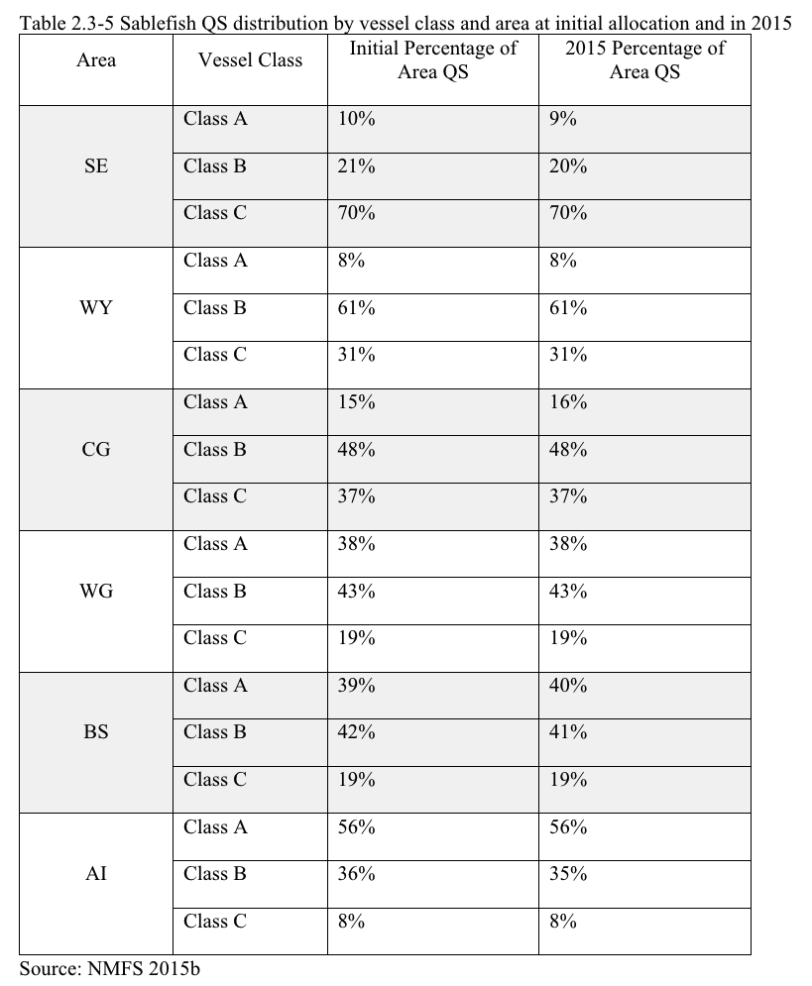

#### 7.1.5 Rockfish

The FMP manages northern rockfish, Pacific ocean perch, shortraker rockfish, blackspotted and rougheye rockfish complex, and the other rockfish complex. The Aleutian Island stock of Pacific ocean perch is an Amendment 80 species (section **7.1**), and therefore 10.7% of each regional TAC goes to CDQ, and the remaining TAC is allocated among the Amendment 80 sector (non-AFA CP), AFA vessels (AFA CP and CV), and non-AFA CV. Some rockfish stocks are allocated by TAC across regions (Bering Sea BS, East Aleutian Islands EAI, Central Aleutian Islands CAI and Western Aleutian Islands WAI) (**Table 7-9**). Northern and shortraker rockfish are not allocated across regions.

***Table 7-9.*** *Spatial allocations of rockfish set by the BSAI groundfish FMP.*

|  |  |  |  |  |
| --- | --- | --- | --- | --- |
| **Species** | **BS** | **EAI** | **CAI** | **WAI** |
| Pacific ocean perch | 29% | 23% | 17% | 31% |
| Northern rockfish | 100% | | | |
| Rougheye and blackspotted rockfish | 46% | | 54% | |
| Shortraker rockfish | 100% | | | |
| Other rockfish* | 43% | 57% | | |

*Other rockfish” includes all *Sebastes* and *Sebastolobus* species except for Pacific ocean perch, dark rockfish, northern rockfish, shortraker rockfish, and blackspotted/rougheye rockfish.

#### 7.1.6 Yellowfin sole

Yellowfin sole is the target of the largest flatfish fishery in the US, and is highly concentrated in the BS with a limited AI population. As an Amendment 80 species (section **7.1**), 10.7% of TAC is allocated to CDQ. There is also an allocation for incidental catch in BSAI trawl and non-trawl sectors. Similar to other Amendment 80 species (Section **7.1**), the remaining TAC is then allocated among BSAI trawl components–the Amendment 80 sector (non-AFA CP) and the BSAI TLAS sector (AFA CP and CV, and non-AFA CV sectors). At lower stock biomass, a higher proportion is allocated to Amendment 80 vessels (**Figure 7-4**). The BSAI trawl limited access sector (TLAS) vessels gain a higher allocation portion at higher stock biomass levels. The ITAC has been above 125,000 mt since 2008. TLAS vessels require a groundfish LLP license with a yellowfin endorsement, but this does not qualify as a LAPP because the endorsement does not assign a portion of TLAS allocation to a person ([BSAI Yellowfin Sole Management](https://www.federalregister.gov/documents/2018/06/06/2018-12034/fisheries-of-the-exclusive-economic-zone-off-alaska-yellowfin-sole-management-in-the-groundfish)).

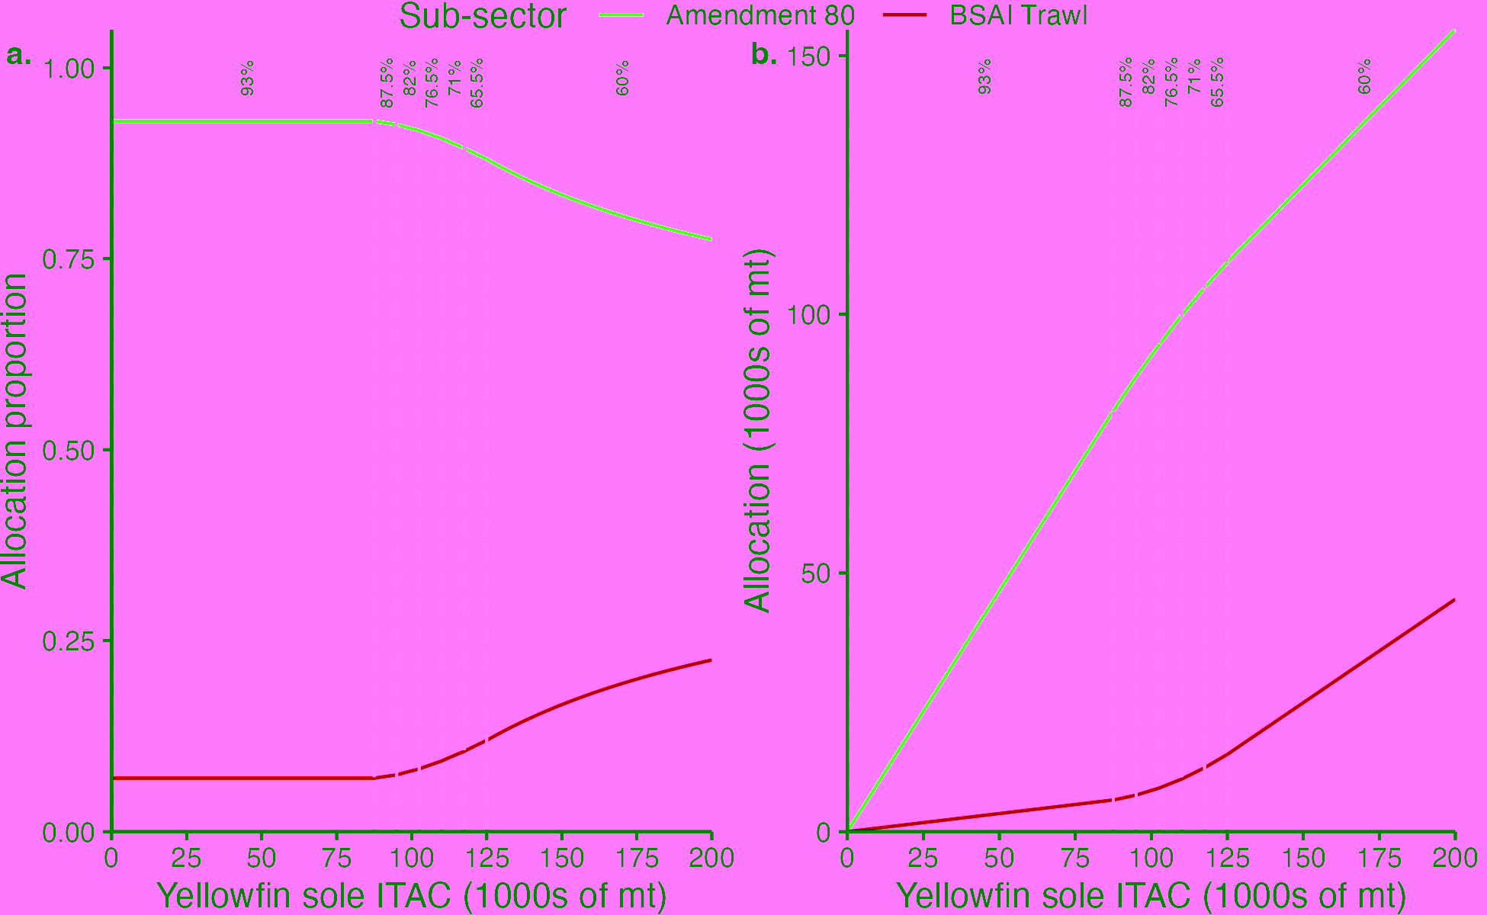

**Figure 7-4.** Allocation by proportion (left) and biomass (right) of yellowfin sole between Amendment 80 and BSAI trawl vessels from [50 CFR Part 679 Table 34](https://www.law.cornell.edu/cfr/text/50/appendix-Table_34_to_part_679). Vertical dashed lines and associated percentages identify the percentage of yellowfin sole in that biomass bin allocated to the Amendment 80 fleet.

### 7.2 GOA Groundfish

The Gulf of Alaska (GOA) groundfish FMP was implemented in 1978 and manages all finfish in the region except salmon, steelhead, halibut, herring, and tuna.

***Table 7-10.*** *Allocation policies for Gulf of Alaska (GOA) groundfish stocks.*

|  |  |
| --- | --- |
| **Stock** | **Allocation policies** |
| Arrowtooth flounder | *No allocation (except minor incidental catch set asides)* |
| Atka mackerel | *No allocation (except minor incidental catch set asides)* |
| Big skate | *No allocation (except minor incidental catch set asides)* |
| Blackspotted and Rougheye Rockfish complex | Spatial (area), catch shares |
| Deepwater flatfish complex | *No allocation (except minor incidental catch set asides)* |
| Demersal shelf rockfish complex | Spatial (area) - though 100% is allocated to the SEO |
| Dusky rockfish | Spatial (area), catch shares |
| Flathead sole | *No allocation (except minor incidental catch set asides)* |
| Longnose skate | *No allocation (except minor incidental catch set asides)* |
| Northern rockfish | Spatial (area), catch shares |
| Octopus complex | *No allocation (except minor incidental catch set asides)* |
| Other rockfish complex | Spatial (area) |
| Pacific cod | Spatial (area), subsector (gear, vessel type), season |
| Pacific ocean perch | Spatial (area), catch shares |
| Rex sole | *No allocation (except minor incidental catch set asides)* |
| Sablefish (*jointly managed with BSAI FMP)* | Subsector (gear), catch shares (see *section 7.1.4)* |
| Shallow water flatfish complex | *No allocation (except minor incidental catch set asides)* |
| Shark complex | *No allocation (except minor incidental catch set asides)* |
| Shortraker rockfish | Spatial, catch shares |
| Other skates complex | *No allocation (except minor incidental catch set asides)* |
| Thornyhead rockfish complex | Spatial (area), catch shares |
| Walleye pollock (Southeast) | Subsector (ICA) |
| Walleye pollock (Western, Central, West Yakutat) | Spatial (area), subsector (ICA), season |

#### 

#### 7.2.1 Pacific cod

Individual TACs are set for Western, Central, and Eastern federal regulatory regions.

**Subsector allocations:** For the Western and Central regions, Amendment 83 (2011) implemented subsector allocations defined by gear, operation type, and vessel size. Initial subsector allocations were set based on historical catch (1995-2005 for Western GOA and 2000-2008 for Central GOA). The Eastern regulatory region is allocated between vessels catching for processing by offshore (10%) and inshore (90%) operations. Jig sector allocations occur before other subsector allocations, and may go up to 6% depending on sector performance up until the most recent year (**Table 7-11**). Decreases in jig allocation are reevaluated every year, and increases are evaluated every two years. If they reach 90% of their allocation, they will receive a 1% increase. If they DO NOT reach 90% of their allocation over 2 years then we decrease their TAC by 1% (Jahn, personal communication). NMFS can reallocate among sectors if a sector is at risk of underharvesting their allocation.

**Seasonal allocations:** For the Western region, all subsector allocations are split between Season A and Season B, which vary by region and subsector. Any overages or underages from season A can lead to season B adjustments.

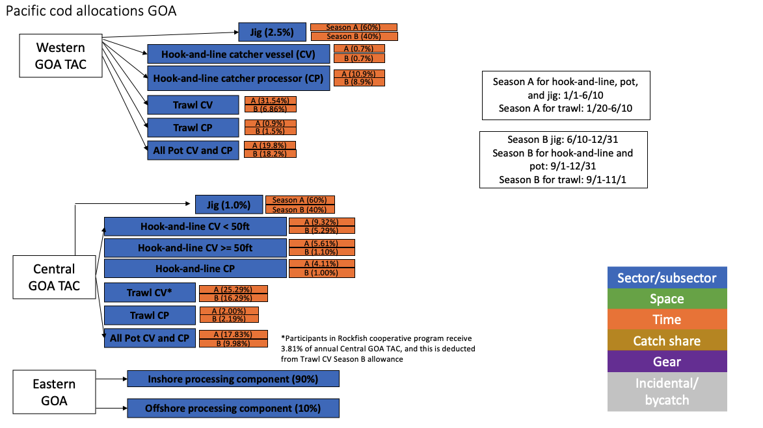

***Figure 7-5****. Flow chart of allocations for GOA Pacific cod.*

***Table 7-11.*** *Jig subsector allocations over time. These will be updated in 2025.*

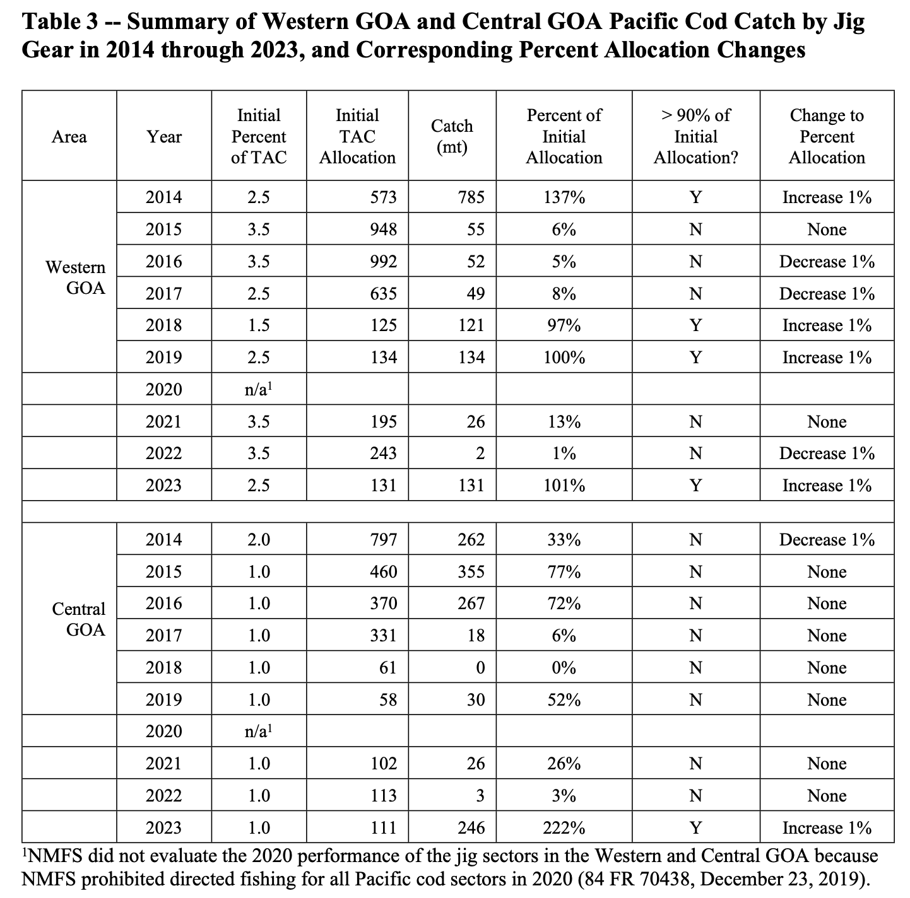

#### 7.2.2 Pollock

Two stocks of pollock are managed through the GOA groundfish FMP: Western/Central/West Yakutat (W/C/WYK) and Southeast Outside (SEO).

**Subsector allocations (and incidental catch set asides):** The resource is fully allocated to inshore components, barring an incidental allocation for non-pollock directed offshore fisheries. The Southeast Outside stock is small, closed to trawling, and is not allocated. In W/C/WYK, 2.5% of the ABC is allocated to the Prince William Sound pollock fishery.

**Spatial and seasonal allocations:** Subsequently, the remaining catch is allocated among statistical areas 610-Shumagin, 620-Chirikof, 630-Kodiak, and 640-West Yakutat as subarea ACLs. Areas 610, 620, and 630 are further allocated across Season A (January 20-May 31) and Season B (September 1-November 1). The overall seasonal allocation is 50% Season A (pre-spawning) and 50% Season B (post-spawning), but how this manifests across subareas varies by year. Area and seasonal allocations are based on recent acoustic and bottom trawl surveys. TAC can be transferred among subareas ([50 CFR § 679.20](https://www.law.cornell.edu/cfr/text/50/679.20); [NPFMC 2021](https://apps-afsc.fisheries.noaa.gov/Plan_Team/2021/GOApollock.pdf)).

***Table 7-12.*** *Area and seasonal allocations of GOA pollock in W/C/WYK for 2024.*

|  |  |  |  |
| --- | --- | --- | --- |
| ***Area*** | ***Area (%)*** | ***Season A, 1/20 - 5/31 (%)*** | ***Season B, 9/1-11/1 (%)*** |
| 610 Shumagin | 18.6% | 14% | 86% |
| 620 Chirikof | 53% | 78% | 22% |
| 630 Kodiak | 23.2% | 27% | 73% |
| 640 West Yakutat | 0.05% | *N/A* | *N/A* |

#### 7.2.3 Rockfish

**Spatial allocations:** The Western, Central, West Yakutat (WYK), Eastern Regulatory Areas, and Southeast Outside District (SEO) statistical regions each get individual TACs for multiple rockfish species (**Table 7-13**). Only the Central statistical region is further allocated. The regional TACs are allocated based on either (1) the biennial GOA trawl survey or (2) both the trawl survey and longline survey for sablefish (**Table 7-13**) ([NPFMC 2024](https://meetings.npfmc.org/CommentReview/DownloadFile?p=93c99820-ac11-4cf3-8809-4c2888ddddae.pdf&fileName=C3e%20GOA%20Rockfish%20Spatial%20Mgmt%20Discussion%20Paper.pdf)).

***Table 7-13.*** *Spatial allocations of rockfish set based on recent survey results.*

|  |  |  |  |  |  |  |
| --- | --- | --- | --- | --- | --- | --- |
| **Species** | **Western** | **Central** | **WYK** | **Eastern** | **SEO** | **Basis** |
| Pacific ocean perch | 6.8% | 80.5% | 3.68% |  | 9.02% | Trawl |
| Northern rockfish | 53% | 47% |  |  |  | Trawl |
| Shortraker rockfish | 7% | 40% |  | 53% |  | Trawl and longline |
| Dusky rockfish | 1.7% | 97% | 1% |  | 0.3% | Trawl |
| Rougheye & blackspotted rockfish | 23% | 30% |  | 47% |  | Trawl and longline |
| Demersal shelf rockfish+ |  |  |  |  | 100% | Trawl |
| Thornyhead rockfish | 19% | 43% |  | 38% |  | Trawl and longline |
| Other rockfish* (OROX) | 58% | | 23% |  | 19% | Trawl and longline |

+Demersal shelf rockfish include

*Other rockfish” includes all *Sebastes* and *Sebastolobus* species except for Pacific ocean perch, dark rockfish, northern rockfish, shortraker rockfish, and blackspotted/rougheye rockfish.

**Incidental catch set asides:** In the Central GOA, an incidental catch allowance (ICA) for catch in non-rockfish fisheries is allocated (3,500 mt of Pacific ocean perch (*Sebastes alutus*), 300 mt of northern rockfish (*S. polyspinis*), and 250 mt of dusky rockfish (*S. ciliatus*). These amounts are updated annually based on recent dynamics.

**Catch shares:** Since 2012, the Central GOA rockfish fishery has been managed through a [catch share program](https://www.fisheries.noaa.gov/alaska/sustainable-fisheries/central-gulf-alaska-goa-rockfish-program) (implemented as a pilot program in 2007 and formally implemented with Amendment 88 and maintained with Amendment 111 in 2021) for groundfish License Limitation Program (LLP) holders for primary and secondary species. Primary species are pacific ocean perch, northern rockfish, and dusky rockfish. Secondary species are the following species: Pacific cod (*Gadus macrocephalus*), rougheye (*S. aleutianus*) and blackspotted rockfish (*S. melanostictus*), sablefish (*Anoplopoma fimbria*), shortraker rockfish (*S. borealis*), and thornyhead rockfish (*S. alascanus*). The non-ICA TAC is first allocated to the small-scale rockfish entry level longline fishery with set caps for primary species (northern rockfish - 2%, Pacific ocean perch - 1%, dusky rockfish - 5%). Yearly allocations can increase in set increments if entry level catch exceeds 90% of allocation in the previous year until the overall Program TAC is met for a given species. The remaining TAC is then allocated to rockfish cooperatives.

Allocations of primary species are primarily (97.5%) based on rockfish landings between 2000-2006 (best 5/7 years) or landings in the entry level trawl fishery (2.5%) in 2007, 2008, or 2009 as a part of the pilot rockfish program (Amendment 68; 2007). CV Program participants collectively also receive secondary species allocations (**Table 7-14**). Qualifying LLP holders join a cooperative associated with a processor, and cooperatives then receive an annual CQ for all rockfish species based on collective QS of cooperative members. Although there is no formal allocation between CV and CP, each subsector is allocated catch based on summed QS of participants across cooperatives. CQ can be transferred between cooperatives within CV and CP subsectors, and from CP sector to CV sector (except for shortraker/rougheye). Individuals are capped at 4% of CV QS and 40% of CP QS. Cooperatives are capped at 30% CV QS. Vessels are capped at 8% CQ of CV sector and 60% CQ of CP sector. Processors are capped at 30% CQ of CV sector for primary species, Pacific cod, and sablefish. Program participants also receive a portion of halibut PSC limit (References: [50 CFR 679.81](https://www.ecfr.gov/current/title-50/chapter-VI/part-679/subpart-G/section-679.81); [50 CFR § 679.83](https://www.law.cornell.edu/cfr/text/50/679.83); [50 CFR Appendix Table 28e](https://www.law.cornell.edu/cfr/text/50/appendix-Table_28e_to_part_679); [McIwain and Hill 2013](https://fisherysolutionscenter.edf.org/sites/default/files/2022-08/Catch%20Shares%20in%20Action%20-%20United%20States%20Central%20Gulf%20of%20Alaska%20Rockfish%20Cooperative%20Program.pdf); [Bonney 2022](https://meetings.npfmc.org/CommentReview/DownloadFile?p=50b89c34-9006-4b11-815d-6eb1e2788242.pdf&fileName=PPT%20B11%20Central%20GOA%20Rockfish%20Program.pdf); [NOAA 2021](https://media.fisheries.noaa.gov/2021-05/rockfish-program-SECG-0521.pdf?null=); [2023 and 2024 Harvest Specifications for GOA Groundfish](https://www.federalregister.gov/documents/2023/03/02/2023-04315/fisheries-of-the-exclusive-economic-zone-off-alaska-gulf-of-alaska-final-2023-and-2024-harvest)).

***Table 7-14.*** *Portion of secondary species CGOA TAC allocated to Rockfish Program participants by subsector.*

|  |  |  |  |  |  |
| --- | --- | --- | --- | --- | --- |
| Subsector | Pacific cod | Sablefish | Thornyhead rockfish | Rougheye rockfish | Shortraker rockfish |
| CV | 3.81% | 6.78% | 7.84% | MRA may not exceed 9.72% | MRA may not exceed 9.72% |
| CP | MRA | 3.51% | 26.50% | 58.87% | 40% |

### 

### 7.3 BSAI King and Tanner Crabs

The [BSAI King and Tanner Crab FMP](https://www.npfmc.org/wp-content/PDFdocuments/fmp/Crab/CrabFMP.pdf) was implemented in 1989 and manages four red king crab (*Paralithodes camtschaticus*) stocks, two blue king crab (*Paralithodes platypus*) stocks, two golden (brown) king crab (*Lithodes aequispinus*) stocks, one tanner crab (*Chionoecetes bairdi*) stock, and one snow crab (*Chionoecetes opilio*) stock (**Table 7-15)**. It excludes the following stocks managed by the State of Alaska: Aleutian Islands tanner crab, Dutch Harbor red king crab, St. Matthew golden king crab, and St. Lawrence blue king crab.

***Table 7-15.*** *Properties of BSAI crab rationalization program by stock.*

|  |  |  |  |  |  |
| --- | --- | --- | --- | --- | --- |
|  |  | **Quota share basis** | | **Quota share caps** | |
| **Species** | **Stock** | **Vessels** | **Processors** | **Owners** | **Crew** |
| Red king crab | Aleutian Islands | 1992-1995 | 1996-1999 | 10% | 20% |
| Red king crab | Bristol Bay | 1996-2000 | 1997-1999 | 1% | 2% |
| Red king crab | Pribolof Island | 1994-1998 | 1996-1998 | 2% | 4% |
| Red king crab | Norton Sound | *Rationalization program does not apply* | |  |  |
| Blue king crab | St. Matthew Island | 1994-1998 | 1996-1998 | 2% | 4% |
| Blue king crab | Pribolof Island | 1994-1998 | 1996-1998 | 2% | 4% |
| Golden king crab | Aleutian Islands | 1996-2000 | 1996-1999 | 10% | 20% |
| Golden king crab | Pribolof Island | *Rationalization program does not apply* | |  |  |
| Tanner crab | Eastern Bering Sea | 1991-1996 | 1997-1999 | 1% | 2% |
| Snow crab | Eastern Bering Sea | 1996-2000 | 1997-1999 | 1% | 2% |

**Catch shares:** In 2005-2006, the NPFMC proposed the BSAI Crab Rationalization Program (CRP) to *“allocate crab resources among harvesters, processors, and coastal communities for nine BSAI crab fisheries (Amendment 18-19 of FMP).”* The CRP allocates 90% of stocks to IFQs and 10% to community development quota (CDQ) programs and the Adak Community Development Corporation (ACDC) (**Table 7-16**). The ACDC and CDQ programs are both managed by ADF&G. CDQs existed before crab rationalization, but rationalization changed the CDQ program and established the ACDC because Adak was not a CDQ community. Almost all CDQ harvest is fished jointly with IFQs, but IFQ is not necessary to participate in CDQ.

In the case of crab rationalization, initial quota shares (QS) were vessel based and issued to license holders based on crab landings by vessel owners (both catcher vessels and catch processors) and crew in qualifying years that vary by stock (**Table 7-15**). Initial QS for processors was based on three year averages for processing history, and also varied by species. To receive QS, participants needed to be active as of June 2002. Class A shares went to catcher vessel owners (CVO), and restricts landings to processors with a QS. Class B shares also went to CVO, but with no delivery requirements. Class C went to crew that made landings with an Interim Use Permit (catcher vessel crew (CVC) or catcher-processor crew (CPV)), and made up 3% of all QS in the fishery. CV QS are region specific (North vs. South of 56˚20’N). Now, QS can only be obtained through transfers from quota holders. IFQ is calculated annually based on QS. Vessel QS is capped between 1-10%, varying by stock, but initial allocations above this limit are grandfathered in. Processor QS is capped at 5%, but again, initial allocations above this limit are grandfathered in. IFQ caps are two times the QS ownership cap, and apply to vessels that are not a part of the voluntary cooperative program. With approval, those with QS can pool IFQ into cooperatives with processors. IFQ can also be leased, or used on a vessel that the QS owner holds less than 10% of ownership of, or on a vessel where the QS owner is not present. There is a crew loan program to assist crew and captains in buying harvestable amounts of QS. See stock specific details below.

***Table 7-16.*** *CDQ and ACDC catch allocations for all BSAI stocks (*[*Annual management report for shellfish fisheries of the Bering Sea*](https://www.adfg.alaska.gov/FedAidPDFs/FMR19-33.pdf)*).*

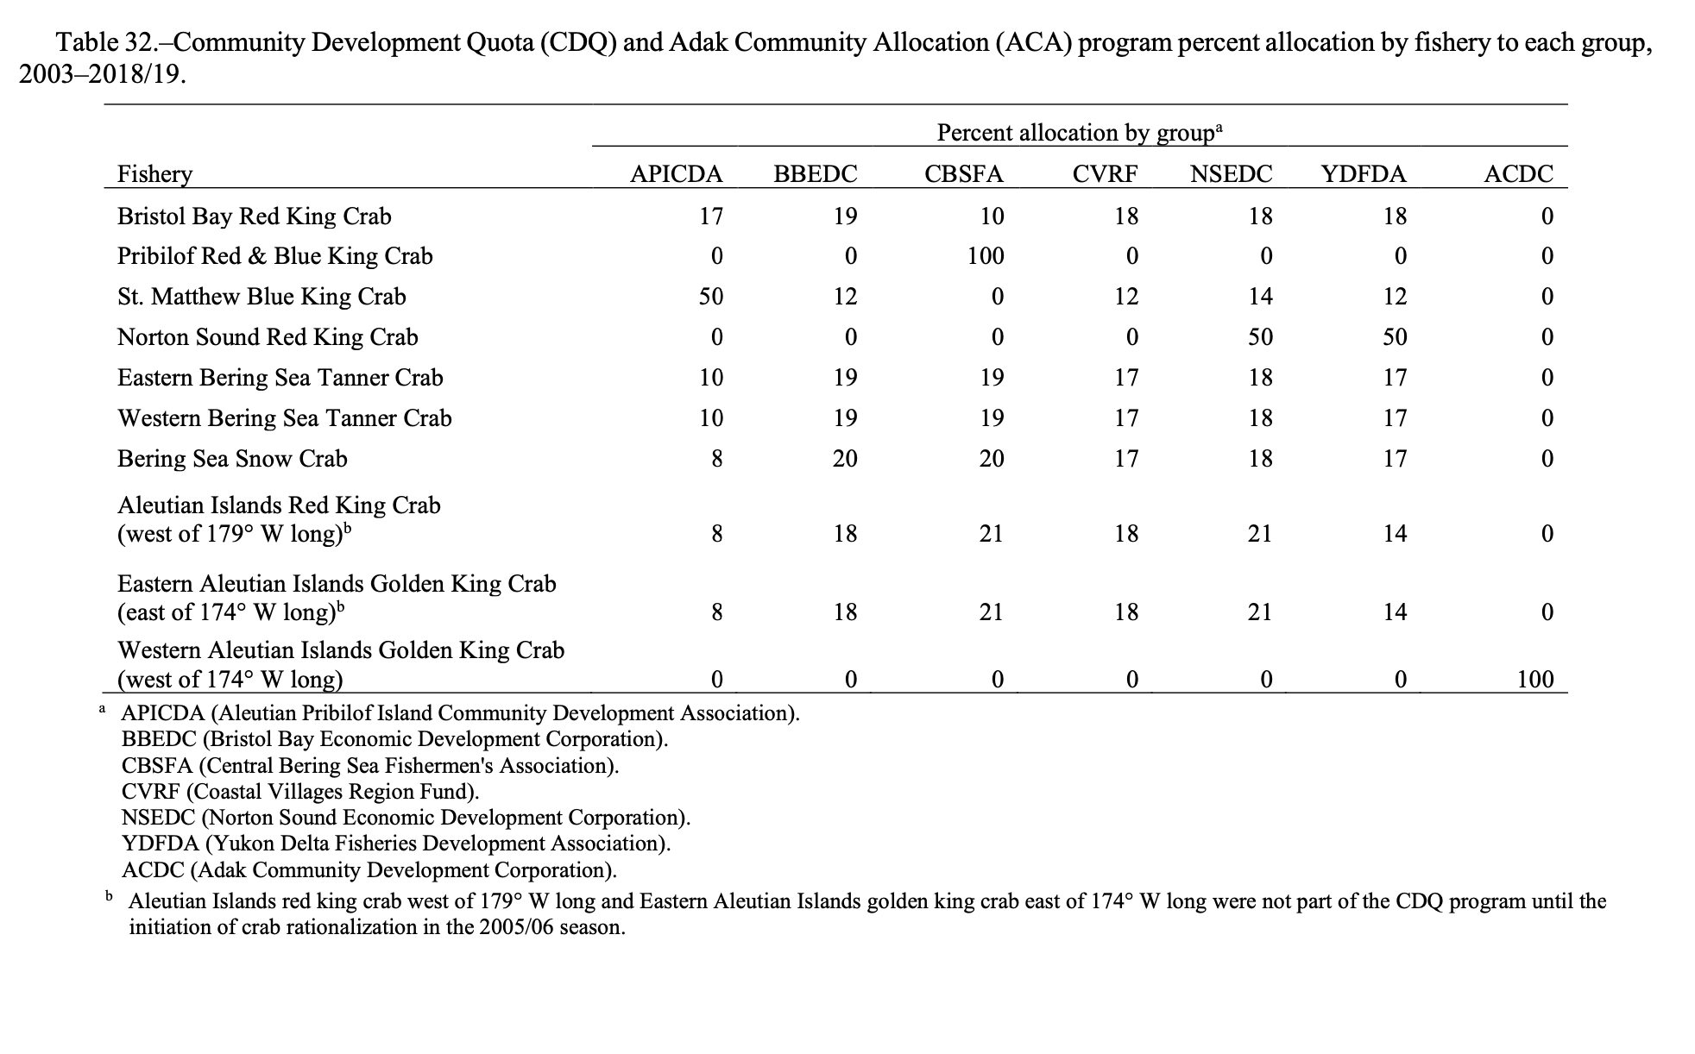

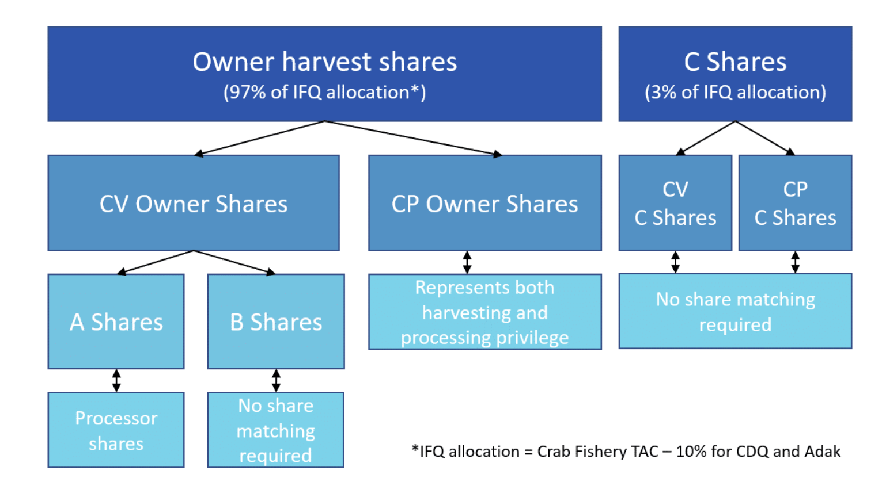

***Figure 7-6.*** *Allocation of crab TAC within crab rationalization program (*[*NPFMC website*](https://www.npfmc.org/fisheries-issues/fisheries/bsai-crab-allocations/)*).*

#### 7.3.1 Red king crab

**Aleutian Islands:** Western AI Red King Crab (west of 171˚W) is managed by two districts, east (Adak) and west (Petrel) of 179˚W. This fishery was not a part of the CDQ program until rationalization. Initial vessel QS based on best three years of landings between 1992/93-1995/96 (four seasons). Initial QS for processors based on 1996/97-1999/2000. The Catcher Vessel Owner and Catcher Processor Owner (CVO/CPO) use cap is 10.0% of initial QS pool. The Catcher Vessel Crew and Catcher Processor Crew (CVC/CPC) use cap is 20.0%.

**Bristol Bay:** Bristol Bay red king crab follows typical rationalization rules. Initial vessel QS based on best four seasons between 1996-2000. Initial processor QS based on processing 1997-1999. Fishing for the Bristol Bay stock was closed for the 2021/2022 and 2022/2023 fishing seasons however, the fishery opened for the 2023-2024 season. The Catcher Vessel Owner and Catcher Processor Owner (CVO/CPO) use cap is 1.0% of initial QS pool. The Catcher Vessel Crew and Catcher Processor Crew (CVC/CPC) use cap is 2.0%.

**Pribilof Island:** Fishing of red king crab has been closed in Pribilof region since 1999 to avoid bycatch of blue king crab. However, if it were to reopen, fishery follows typical rationalization rules. Initial vessel QS based on dropping one season between 1994-1998. Initial processor QS based on processing 1996-1998. The Catcher Vessel Owner and Catcher Processor Owner (CVO/CPO) use cap is 2.0% of initial QS pool. The Catcher Vessel Crew and Catcher Processor Crew (CVC/CPC) use cap is 4.0%.

**Norton Sound:** The crab rationalization program does not apply to the Norton Sound red king crab fishery, as king crab in this region is already managed through an exclusive permit program that prohibits participants from participating in any other BSAI crab fisheries. CDQ receives 7.5% of total commercial guideline harvest level, and this quota share can be caught in summer (on or after June 15 - ~August) and winter (~November 15-May 15, opening varies year to year) seasons. As of 2017, the BOF responded to the surge in nearshore winter commercial harvest by allocating 8% of total commercial guideline harvest level to the winter commercial fishery (small fishery using hand lines and pots). If the winter commercial fishery does not catch their allocation, this allocation rolls over to open access summer fishery ([2024 Norton Sound Red King Crab Fishery Harvest Spex](https://www.adfg.alaska.gov/static/applications/dcfnewsrelease/1558459779.pdf); [2015 Norton Sound Red King Crab Outlook](https://www.adfg.alaska.gov/static/applications/dcfnewsrelease/530730302.pdf); [Red King Crab](https://www.fisheries.noaa.gov/species/red-king-crab); [2023 Norton Sound summer commercial king crab fishery](https://www.adfg.alaska.gov/static/applications/dcfnewsrelease/1478714304.pdf); [BSAI Crab Rationalization Program](https://www.npfmc.org/fisheries-issues/fisheries/bsai-crab-allocations/#:~:text=The%20Bering%20Sea%20Aleutian%20Island,and%20Pribilof%20golden%20king%20crab.); [BSAI Crab Rationalization Program FAQ](https://media.fisheries.noaa.gov/dam-migration/bsai-crab-rat-faq-101518.pdf); [The Community Development Quota Program in Alaska](https://nap.nationalacademies.org/read/6114/chapter/5#60); [Norton Sound Red king crab harvest strategy](https://www.law.cornell.edu/regulations/alaska/5-AAC-34-915); [Norton Sound Red King Crab 2022 SAFE Report](https://meetings.npfmc.org/CommentReview/DownloadFile?p=21893b73-6044-4bec-926f-550a4ca72749.pdf&fileName=Norton%20Sound%20Red%20King%20Crab%20SAFE%202022.pdf); [BSAI 2022 Shellfish Mgmt Report](https://www.adfg.alaska.gov/FedAidPDFs/FMR22-28.pdf); [W-AI Red King Crab 2020 SAFE Report](https://meetings.npfmc.org/CommentReview/DownloadFile?p=a789aa73-b30e-4dd5-954f-111f1c709a27.pdf&fileName=C1%2010%20WAIRKC%20SAFE.pdf); [AI Golden King Crab 2023 SAFE Report](https://meetings.npfmc.org/CommentReview/DownloadFile?p=8ba5387c-5334-4702-80cf-08d3ae5926bc.pdf&fileName=AIGKC_SAFE_2023.pdf)).

#### 7.3.2 Blue king crab

**St. Matthew:** Fishery follows typical rationalization rules. Initial vessel QS based on dropping one season between 1994-1998. Initial processor QS based on processing 1996-1998. The fishery closed in 2023-2024. The Catcher Vessel Owner and Catcher Processor Owner (CVO/CPO) use cap is 2.0% of initial QS pool.. The Catcher Vessel Crew and Catcher Processor Crew (CVC/CPC) use cap is 4.0%.

**Pribilof Island:** Fishing of blue king crab has been closed in Pribilof region since 1999 . However, if it were to reopen, fishery follows typical rationalization rules. Initial vessel QS based on dropping one season between 1994-1998. Initial processor QS based on processing 1996-1998. The Catcher Vessel Owner and Catcher Processor Owner (CVO/CPO) use cap is 2.0% of initial QS pool. The Catcher Vessel Crew and Catcher Processor Crew (CVC/CPC) use cap is 4.0%.

#### 7.3.3 Golden king crab

**Aleutian Island:** AI Golden King Crab is managed east (Dutch Harbor) and west (Adak) of 174˚W longitude with a separate TAC for each area. East of 174˚, the stock is allocated between IFQs (90%) and CDQ (10%). West of 174˚, the stock is allocated between IFQs (90%) and Adak Community Allocation (ACA) (10%). Initial vessel QS is based on landings between 1996/97-2000/01 (all five seasons), and is regionally specific (Dutch Harbor (EAI) vs. Adak western AI)). Initial QS for processors was based on processing in 1996/97 - 1999/2000. The Catcher Vessel Owner and Catcher Processor Owner (CVO/CPO) use cap is 10.0% of initial QS pool. The Catcher Vessel Crew and Catcher Processor Crew (CVC/CPC) use cap is 20.0%.

**Pribolof Islands (no allocations):** The crab rationalization program does not apply to the Pribilof Islands golden king crab fishery. This stock is not allocated.

#### 7.3.4 Tanner crab

**Eastern Bering Sea:** BS Tanner Crab is managed as two separate fisheries, east and west of 166˚W, and has a separate TAC for each fishery. The Tanner crab fishery follows typical rationalization rules. Initial vessel QS based on best four seasons between 1991/92-1996 (out of six), and is regionally specific (east of 166˚W vs. west of 166˚W). Initial QS for processors based on 50% Bristol Bay red king and 50% EBS snow crab processing between 1997-1999. The Catcher Vessel Owner and Catcher Processor Owner (CVO/CPO) use cap is 1.0% of initial QS pool. The Catcher Vessel Crew and Catcher Processor Crew (CVC/CPC) use cap is 2.0%.

#### 7.3.5 Snow crab

**Eastern Bering Sea:** BS snow crab follows typical rationalization rules. Initial vessel QS based on best four seasons between 1996-2000. Initial processor QS based on processing 1997-1999. Directed fishery closed in 2022-2023, and 2023-2024. The CVO/CPO use cap is 1.0% of the initial QS pool. The CVC/CPC use cap is 2.0%.

### 7.4 Salmon

The [NPFMC Salmon FMP](https://www.npfmc.org/wp-content/PDFdocuments/fmp/Salmon/SalmonFMP.pdf) was implemented in 1979 and was comprehensively revised in 1990 and again in 2011.

**International allocations:** As fish that originate in one EEZ are often fished in another, the U.S. and Canada entered into the [Pacific Salmon Treaty](https://www.psc.org/wp-admin/admin-ajax.php?juwpfisadmin=false&action=wpfd&task=file.download&wpfd_category_id=45&wpfd_file_id=2337&token=&preview=1) in 1985 to coordinate management efforts. However, the original Treaty did not reflect a true compromise between Canada and the U.S. on whether rights to fish should be based on origin (Canada) or current location (U.S.). In 1999, continued negotiations led to an eventual compromise setting harvest rates by stock abundances ([Anderson et al. 2022](https://www.orca.wa.gov/wp-content/uploads/PacificSalmonTreatyFY23.pdf)). A number of transboundary stocks have a transboundary TAC set by the Pacific Salmon Commission. As a few examples, the U.S. has a 25.7% share of the Fraser River pink salmon TAC, 16.5% share of the TAC of Fraser River sockeye, 50% of Stikine River sockeye salmon. Allocations vary by estimated run size and enhancement success.

**Sector and subsector allocations:** The NPFMC delegates the regulatory authority for implementing the FMP to the Alaska Department of Fish and Game (ADF&G) because the large majority of salmon fishing occurs within state waters. Allocation policies follow those set by the Alaska Board of Fisheries. For Chinook salmon, an annual harvest ceiling (AHC) is established by the Pacific Salmon Commission under the Pacific Salmon Treaty. First, the AHC is allocated to purse seines (4.3%), drift gillnets (2.9%), and set gillnets (1,000 mt). Then, the remaining portion of the harvest ceiling (~92%) is allocated between the troll fishery (80%) and the sport fishery (20%). If the net and sport sectors are aiming for underage, the Board can reallocate a portion to the troll fishery. For coho salmon, ADF&G aims to maintain allocations of coho salmon in the Southeastern Alaska and Yakutat commercial salmon fisheries at traditional levels (1971 through 1980) of 61% troll, 19% purse seine, 13% drift gillnet, and 7% set gillnet. Coho near Dixon Entrance are managed in coordination with Canada under the Pacific Salmon Treaty.

(References: [5 AAC 29.060](https://www.law.cornell.edu/regulations/alaska/5-AAC-29-060); [McDorman 2009](https://repository.law.umich.edu/cgi/viewcontent.cgi?referer=&httpsredir=1&article=1130&context=mjil); [Emery 1919](https://publications.gc.ca/collections/Collection-R/LoPBdP/BP/bp429-e.htm); [Bennet 2018](https://www.biv.com/news/resources-agriculture/pacific-salmon-treaty-30-looms-bc-fishing-industry-8252766); [Kwong 2018](https://www.kcaw.org/2018/06/20/sitka-salmon-fleet-to-governor-walker-dont-sign-a-bad-treaty/); [Woolsey 2018](https://www.kcaw.org/2018/03/24/in-a-tough-year-for-trollers-mallott-backs-alaskas-salmon-treaty-team/); [FAO Miller](https://www.fao.org/4/Y4652e/y4652e09.htm)).

### 7.5 Scallop

The [NPFMC Scallop FMP](https://www.npfmc.org/wp-content/PDFdocuments/fmp/Scallop/ScallopFMP.pdf) was implemented in 1995 and governs the management of scallop fisheries in nine management zones (scallop registration areas) off the coast of Alaska. The fishery is co-managed by ADF&G and the NPFMC. The FMP covers weathervane scallops (*Patinopecten caurinus*), which are targeted in the fishery, and other scallop species that are not targeted. The FMP does not formally allocate scallop catch. However, in 2000, six of the nine scallop permit owners voluntarily created the Weathervane Scallop Cooperative with the goal of extending the season, reducing bycatch, and reducing the race to fish ([Brawn and Scheirer 2008](https://www.fao.org/4/a1497e/a1497e30.pdf)). The cooperative does not receive an allocation of the scallop harvest, but regulates vessel allocations of members within the guideline harvest limit set by ADF&G in addition to crab bycatch. The cooperative negotiates allocations of both scallop and crab bycatch annually after setting aside a reserve for non-cooperative vessels. Annual allocation is frequently leased from permit holders with cooperative allocation to other vessels in the cooperative.

### 7.6 Arctic Fish Resources

There are no fisheries currently authorized to operate in the Arctic; thus, there are no allocation policies. However, the FMP specifies rules for if and when commercial fisheries are authorized.

### 7.7 Prohibited Species

***Table 7-17.*** *2017 allocation percentages of prohibited species TAC for CDQ. From* [*The Western Alaska Community Development Quota Program*](https://media.fisheries.noaa.gov/dam-migration/cdq-program-summary-1018.pdf)*.*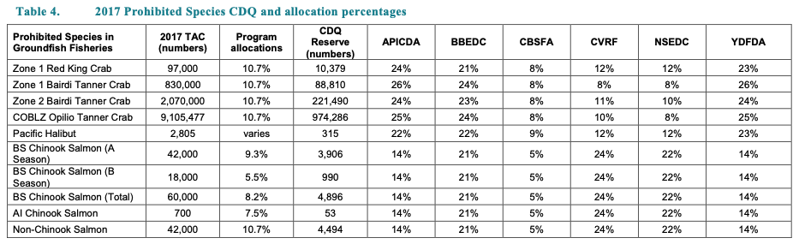

## 

## 8. Western Pacific

The WPFMC replaced its five species-based Fishery Management Plans (FMPs) with five place-based Fishery Ecosystem Plans (FEPs) in 2009. These FEPs direct management for the following ecosystems: American Samoa Archipelago, Hawaii Archipelago, Mariana Archipelago, Pacific Remote Island Areas, and Pacific Pelagic Fisheries.

None of the FEPs include explicit catch allocations although some stocks are managed using commercial and non-commercial Annual Catch Limits, which are a form of implicit allocation. The Western and Central Pacific Fisheries Commission (WCPFC), a regional fishery management organization, allocates catch for some highly migratory pelagic species to member countries, but the WPFMC does not perform any allocation itself.

|  |  |  |
| --- | --- | --- |
| FEP | Species | Allocation policy |
| American Samoa Archipelago | Bottomfish complex | None |
| Hawaii Archipelago | Deep 7 bottomfish complex, Uku, Crustaceans, Precious corals | None |
| Guam (Mariana Archipelago) | CNMI shallow/deepwater bottomfish complexes and Guam shallow/deepwater bottomfish complex | None |
| Pacific Remote Island Areas | Limited fishing occurs. | None |
| Pacific Pelagic | Tunas, billfishes, sharks, other pelagics | None; Development of international allocations are managed through collaboration with the Western and Central Pacific Fisheries Commission (WCPFC) |

### 

## 

## 9. Highly Migratory Species

***Table 9-1.*** *Brief summary of the allocation policies used in HMS FMPs.*

|  |  |
| --- | --- |
| **FMP** | **Allocation policy summary** |
| Consolidated Atlantic Highly Migratory Species |  |
| US West Coast Fisheries for Highly Migratory Species | De facto sector allocations, no formal allocations |

### 9.1 Atlantic

The Consolidated Atlantic Highly Migratory Species (HMS) FMP was implemented by NOAA Fisheries in 2006 and governs the management of HMS. Before 2006, there were individual FMPs for tuna, swordfish, and sharks. Many HMS are managed in compliance with recommendations from the International Commission for the Conservation of Atlantic Tunas (ICCAT). ICCAT allocates quota across countries using the following criteria: (1) past or present fishing activities, (2) the status of stocks and fisheries, (3) the status of participants (i.e., various needs and requirements), and (4) compliance with ICCAT Conservation and Management Measures (CMMs) and responsibilities around data submission and research.

***Table 9-2.*** *Allocation policies of Atlantic HMS stocks.*

|  |  |
| --- | --- |
| **Stock** | **Allocation policy summary** |
| Albacore - North Atlantic | No domestic allocation |
| Atlantic sharpnose shark - Atlantic | Spatial (regional) with transferability (NBSC) |
| Atlantic sharpnose shark - Gulf of Mexico | Spatial (regional) with transferability (NBSC) |
| Bigeye tuna - Atlantic | No domestic allocation |
| Blacknose shark - Atlantic | Spatial (regional) with transferability |
| Blacknose shark - Gulf of Mexico | Spatial (regional) with transferability |
| Blacktip shark - Atlantic | Spatial (regional) with transferability |
| Blacktip shark - Gulf of Mexico | Spatial (regional) with transferability |
| Blue marlin - Atlantic | No domestic allocation |
| Blue shark - North Atlantic | No domestic allocation |
| Bluefin tuna - Western Atlantic | Spatial (area), sector, subsector, seasonal, catch share, set-asides |
| Bonnethead - Atlantic | Spatial (regional) with transferability (NBSC) |
| Bonnethead - Gulf of Mexico | Spatial (regional) with transferability (NBSC) |
| Bull shark - Atlantic and Gulf of Mexico | Spatial (regional) with transferability (LCS) |
| Dusky shark - Atlantic and Gulf of Mexico | Spatial (regional) with transferability |
| Finetooth shark - Atlantic and Gulf of Mexico | Spatial (regional) with transferability (NBSC) |
| Great hammerhead - Atlantic and Gulf of Mexico | Spatial (regional) with transferability (hammers) |
| Smoothhound Complex - Gulf | Spatial (regional) with transferability |
| Lemon shark - Atlantic and Gulf of Mexico | Spatial (regional) with transferability (LCS) |
| Longbill spearfish - Western Atlantic | None |
| Nurse shark - Atlantic and Gulf of Mexico | Spatial (regional) with transferability (LCS) |
| Oceanic whitetip shark - Atlantic and Gulf of Mexico | Spatial (regional) with transferability |
| Porbeagle - Northwestern Atlantic | No domestic allocation |
| Roundscale spearfish - Atlantic | No domestic allocation |
| Sailfish - Western Atlantic | None |
| Sandbar shark - Atlantic and Gulf of Mexico | No domestic allocation |
| Scalloped hammerhead - Atlantic and Gulf of Mexico | Spatial (regional) with transferability (hammers) |
| Shortfin mako - North Atlantic | None |
| Silky shark - Atlantic and Gulf of Mexico | Spatial (regional) with transferability (LCS) |
| Skipjack tuna - Western Atlantic | None |
| Smooth dogfish - Atlantic | Spatial (regional) with transferability (smooth) |
| Smooth hammerhead - Atlantic and Gulf of Mexico | Spatial (regional) with transferability (hammers) |
| Spinner shark - Atlantic and Gulf of Mexico | Spatial (regional) with transferability (LCS) |
| Swordfish - North Atlantic | No domestic allocation |
| Thresher shark - Atlantic and Gulf of Mexico | No domestic allocation |
| Tiger shark - Atlantic and Gulf of Mexico | Spatial (regional) with transferability (LCS) |
| White marlin - Atlantic | No domestic allocation |
| Yellowfin tuna - Atlantic | None |

#### 9.1.1 Albacore tuna

NOAA Fisheries also works closely with ICCAT to manage albacore tuna (*Thunnus alalunga*) in the Atlantic. ICCAT allocates a portion of the overall quota to the US (711.5mt (2%) in 2022-2023). There is no domestic allocation for albacore tuna. US fishermen catch ~1% of international catch of North Atlantic albacore ([North Atlantic Albacore Tuna](https://www.fisheries.noaa.gov/species/north-atlantic-albacore-tuna); [ICCAT Mgmt](https://www.iccat.int/com2023/ENG/PLE_102_ENG.pdf)).

#### 9.1.2 Sharks

**Spatial allocations:** Most sharks are not allocated, and many are prohibited. However, some sharks receive regional or sub-regional quota, which can be transferred in season ([Commercial Shark Quota Transfer](https://www.federalregister.gov/documents/2023/03/24/2023-06137/atlantic-highly-migratory-species-commercial-shark-quota-transfer)). NOAA is currently considering changing regional splits to base them on recent catch history ([Amendment 16 Scoping](https://www.fisheries.noaa.gov/s3/2023-05/Amendment-16-Scoping-Document.pdf)). The species with regional allocations are: Blacktip, aggregated LCS, hammerhead, non-blacknose small coastal, smoothhound. The species without regional allocations are: sandbar, blue, porbeagle, common thresher ([NOAA](https://www.fisheries.noaa.gov/atlantic-highly-migratory-species/2024-atlantic-shark-commercial-fishery-landings-and-retention)).

***Table 9-3.*** *2024 proposed quotas for Atlantic shark management.*

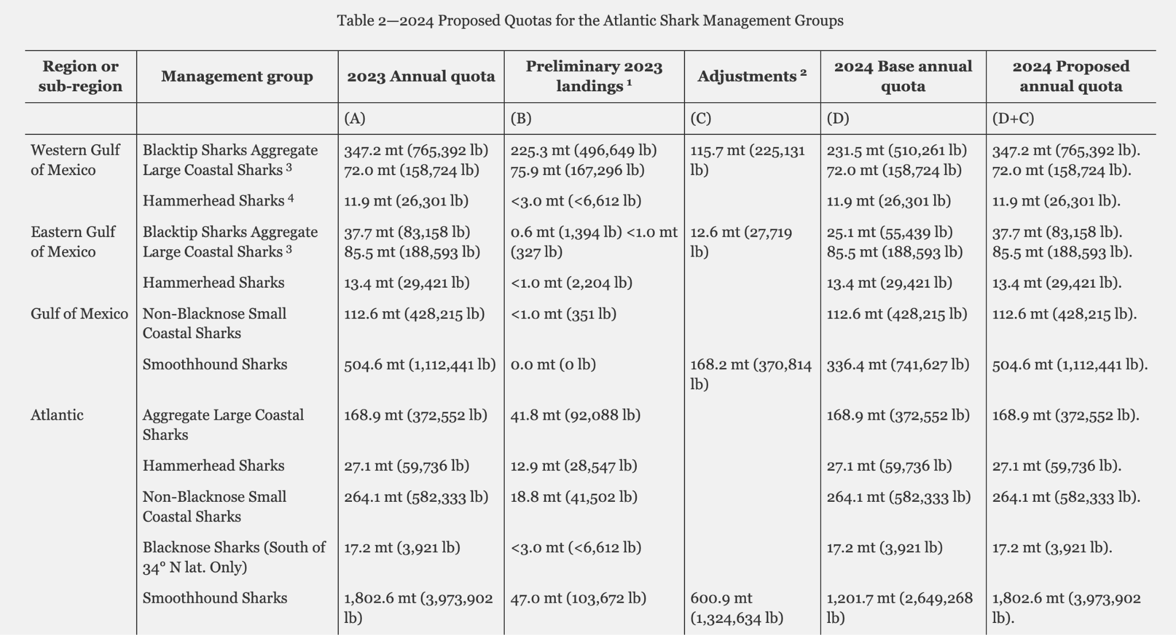

**Exempted Fishing Permits (EFPs):** NOAA Fisheries issues HMS exempted fishing permits (EFPs), scientific research permits (SRPs), Display permits, and letters of acknowledgement under the authority of the Magnuson-Stevens Act (16 U.S.C. 1801 et seq.) and/or ATCA (16 U.S.C. 971 et seq.). EFPs, SRPs, and Display permits authorize the collection of HMS, including sharks, from federal waters in the Atlantic Ocean and Gulf of Mexico for the purposes of scientific data collection and public display when research and/or collection activities would otherwise be prohibited by regulations ([2022 Atlantic Shark quotas](https://www.govinfo.gov/content/pkg/FR-2021-08-06/pdf/2021-16770.pdf); [50 CFR § 635.27 - Quotas](https://www.law.cornell.edu/cfr/text/50/635.27)).

#### 9.1.3 Bigeye tuna

US quota set similarly to other tuna species, following ICCAT instruction. The US received 2.26% of the international allocation, however US fishermen typically catch <1% of international catch of North Atlantic bigeye tuna ([Atlantic Bigeye Tuna](https://www.fisheries.noaa.gov/species/atlantic-bigeye-tuna)). There is no domestic allocation for bigeye tuna ([ICCATT 2022](https://www.iccat.int/com2022/ENG/PA1_505A_ENG.pdf)).

#### 9.1.4 Blue marlin, white marlin, and roundscale spearfish

The United States does not receive a formal allocation of these species by ICCAT, however, ICCAT calls for the US to limit its landings to 250 recreationally caught Atlantic blue marlin and white marlin/roundscale spearfish combined on an annual basis.

#### 9.1.5 Bluefin tuna

NOAA Fisheries works closely with the International Commission for the Conservation of Atlantic Tunas (ICCAT) to manage bluefin tuna (*Thunnus thynnus*) in the Atlantic. The ICCAT gives an annual recommendation for the US tuna quota plus a buffer for bycatch related to pelagic longline fisheries in the Northeast Distant gear restricted area (NED) (**Table 9-4**). International allocation of the TAC is based on the TAC available. US percent allocations are higher at lower TAC (maximum of 54.02%), and lower (minimum of 49.00%) at higher TAC. Note that each year, the United Kingdom (in respect of Bermuda) can transfer up to the amount of its adjusted quota in each year of 2023-2025 to the United States to support cooperative research.

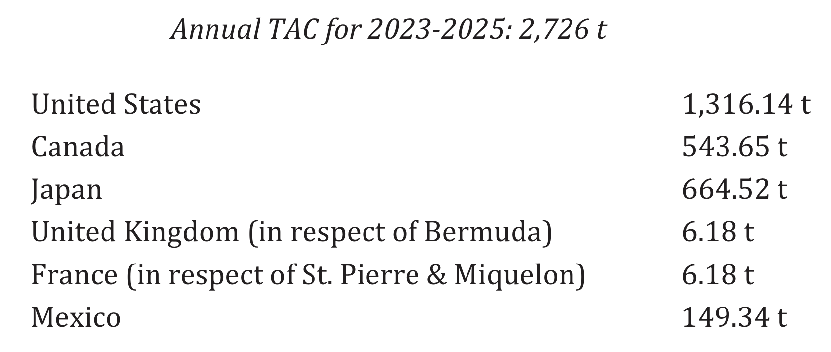

***Table 9-4.*** *International allocation of bluefin tuna quota set by ICCAT for 2023-2025.*

Of the quota recommendation from ICCAT, 68mt of US quota is allocated to the Longline category quota, and 31.2mt is set-aside for inseason or annual adjustments and research. The remaining quota is then divided among subsectors (47.1% general, 19.7% angling, 3.9% harpoon, 18.6% purse seine, an additional 8.1% to longline, 0.1% trap, and 2.5% reserve). The general quota is also allocated across four seasons (Jun-Aug = 50%, Sep = 27%, Oct-Nov = 13%, Dec = 5.2%, Jan-Mar = 5.3%). The angling quota is also allocated by size/quality (school, large school/ small medium, trophy) and by area (See **Figure 9-1**), and receives an additional reserve allocation (set-aside) for in-season or annual adjustments and fishery-independent research (See **Table 9-5**). For example, in December 2023, NOAA Fisheries transferred quota from the reserve to the general commercial category for the December season ([Quota Transfer and Adjustment: Atlantic Bluefin Tuna General Category (Commercial) Fishery](https://www.fisheries.noaa.gov/action/quota-transfer-and-adjustment-atlantic-bluefin-tuna-general-category-commercial-fishery)).

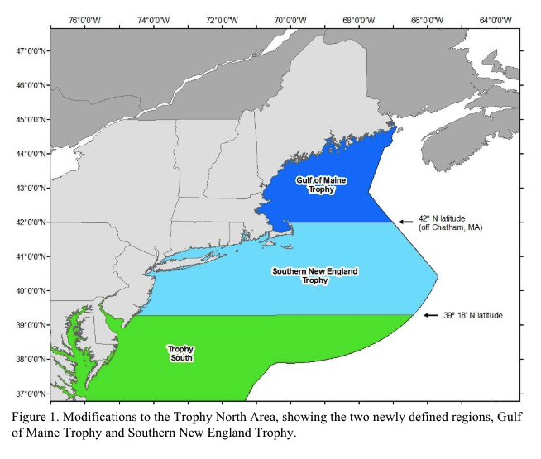

***Figure 9-1.*** *Bluefin tuna trophy management areas.*

***Table 9-5.*** *Sector allocations in the Atlantic bluefin tuna fishery* [*2022 Bluefin Tuna/Albacore Quotas*](https://www.govinfo.gov/content/pkg/FR-2022-03-07/pdf/2022-04542.pdf)*.*

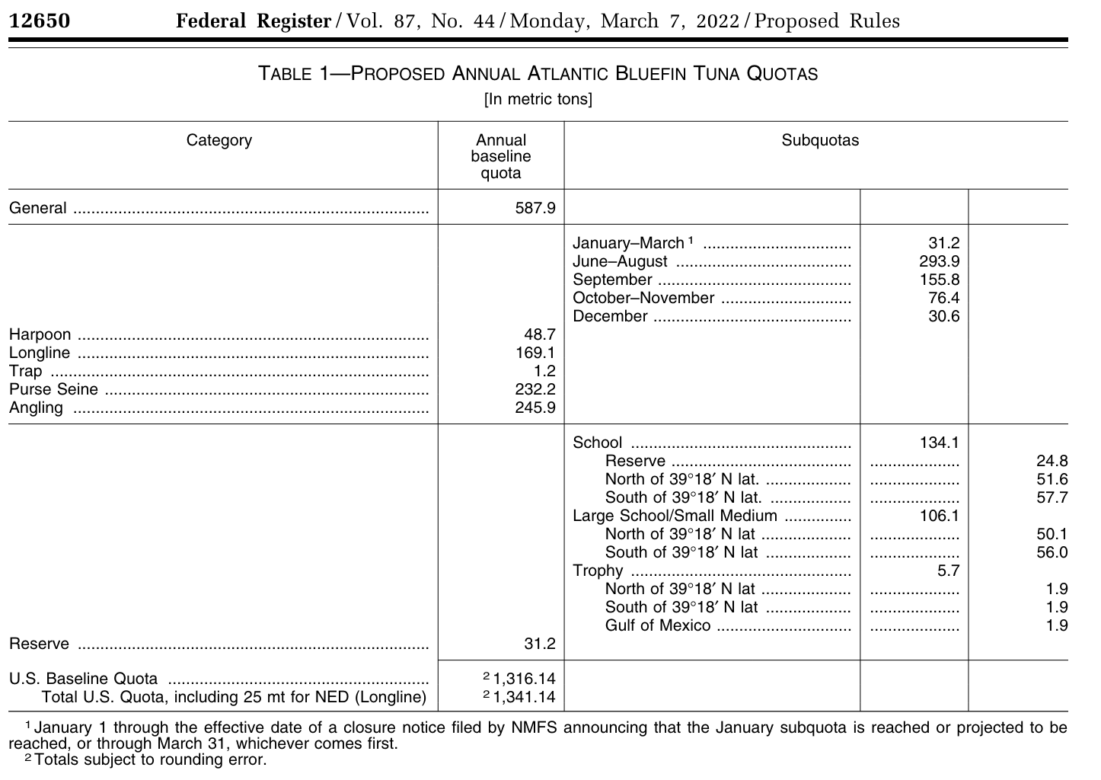

***Table 9-6.*** *2023 sector allocations in the Atlantic bluefin tuna fishery.*

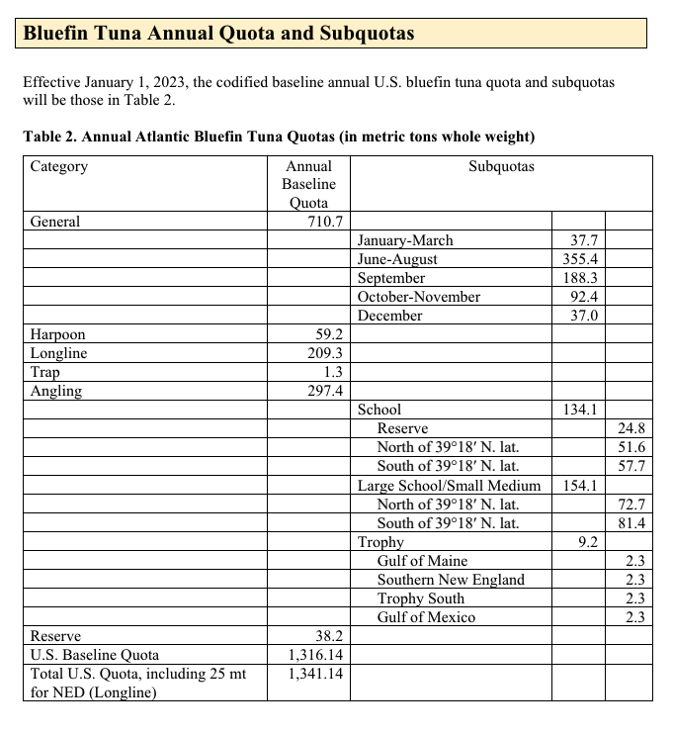

The longline allocation (longline cannot target bluefin, but often caught incidentally) is managed through the Individual Bluefin Quota (IBQ) program. Atlantic Tunas Longline permits are assigned high, medium, or low tier IBQ shares based on eligibility criteria and vessel history. IBQ shares which were initially determined by landings and bluefin interactions between 2006 and 2012 lead to annual IBQ allocations. Permit holders must have been active in 2013, and must have logged one HMS set between 2006 and 2012 to receive shares. Annual allocations can be leased by other longline permit holders, or by purse seine category participants. Shares are linked to a permit, and cannot be severed ([2022 Atlantic Bluefin Tuna and North Atlantic Albacore Quotas](https://www.federalregister.gov/documents/2022/06/01/2022-11722/atlantic-highly-migratory-species-atlantic-bluefin-tuna-and-north-atlantic-albacore-quotas); [Amendment 13–Bluefin Tuna Management](https://media.fisheries.noaa.gov/2022-10/A13%20Compliance%20Guide%20Oct%202022.pdf); [Atlantic HMS IBQ Program FAQ](https://media.fisheries.noaa.gov/dam-migration/a7-ibq-faq.pdf)).

#### 9.1.6 North Atlantic swordfish (*Thunnus alalunga*)

The US quota for North Atlantic swordfish is set following ICCAT guidelines. Currently, the US is allocated 30% of the international North Atlantic swordfish TAC. There are no domestic allocations ([2023 ICCAT Management Recommendations](https://www.iccat.int/com2023/ENG/PLE_102_ENG.pdf); [ICCAT North Atlantic Swordfish Recommendations](https://www.iccat.int/Documents/Recs/compendiopdf-e/2021-02-e.pdf)).

***Table 9-7.*** *Country-level quota allocations of North Atlantic swordfish.*

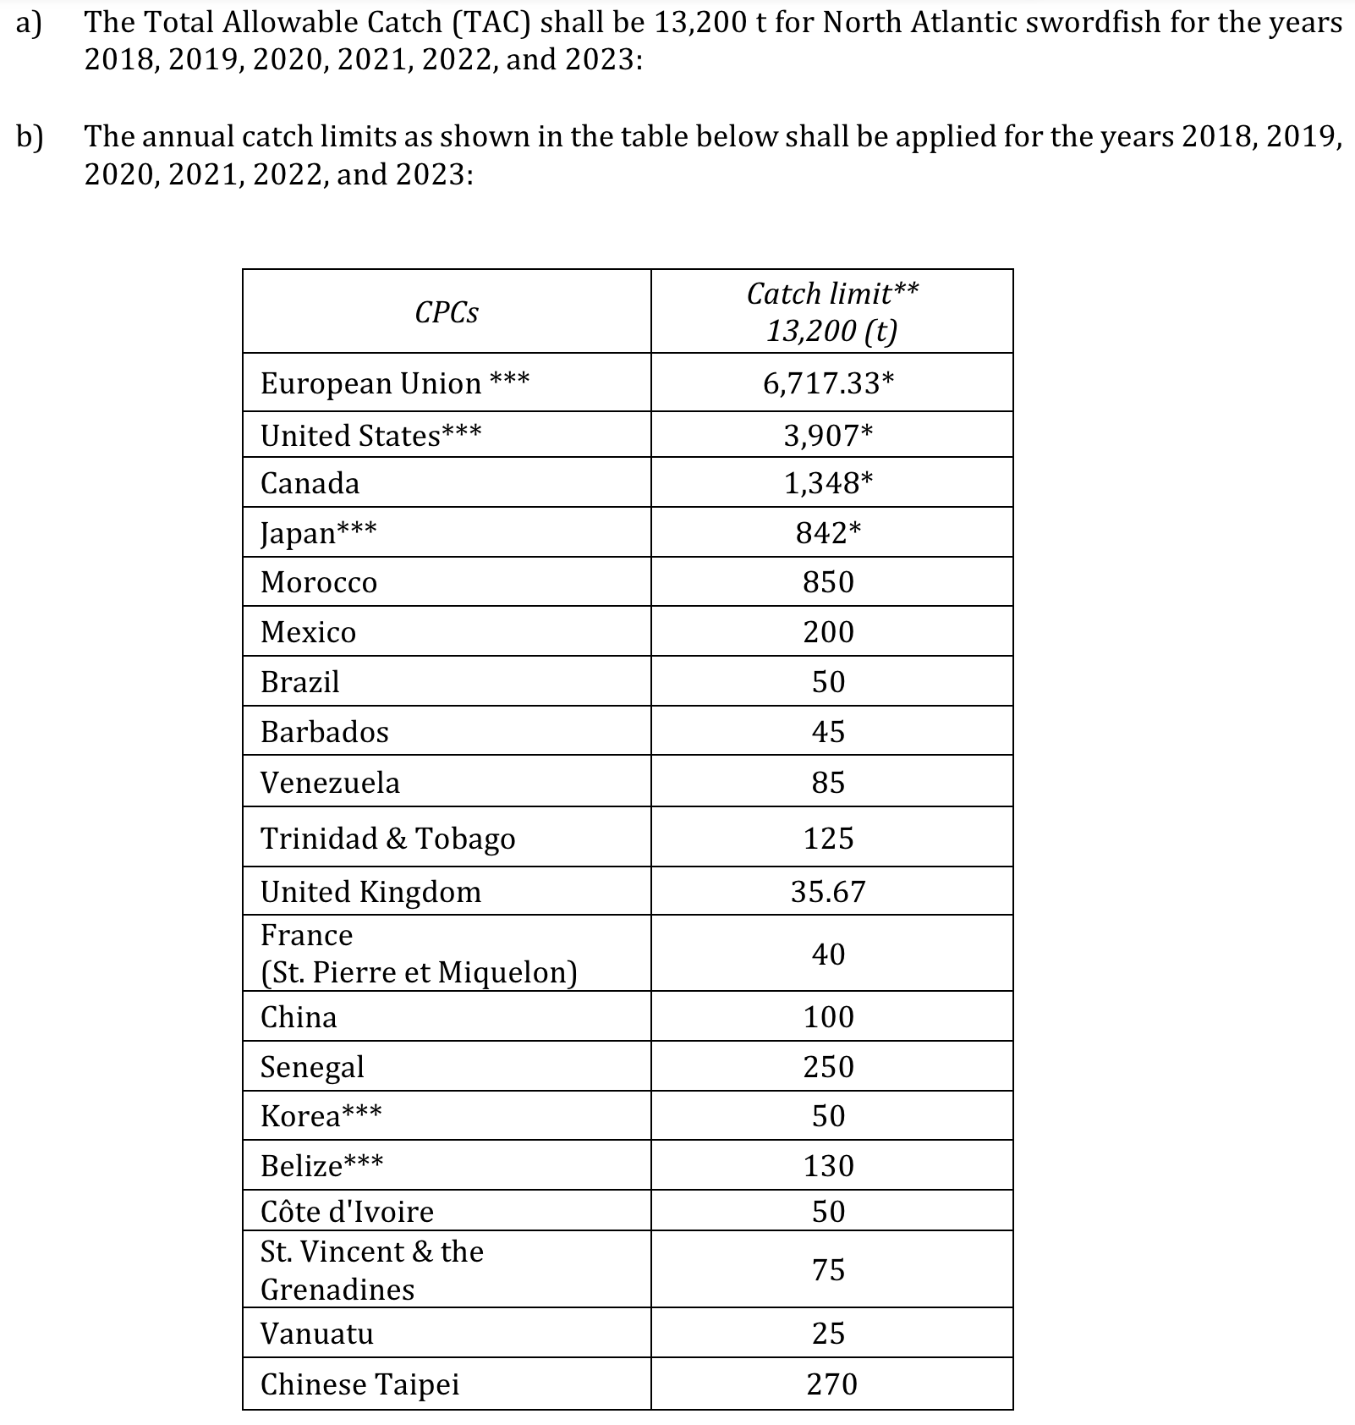

*\* Notwithstanding the adjustment of the EU quota by 0.67 t in light of the Trade and Cooperation Agreement between the UK and the EU, which established their respective shares of North Atlantic swordfish and other stocks, catch limits of these four CPCs are based upon quota allocation shown in 3 c) of the 2006 Supplemental Recommendation by ICCAT to Amend the Rebuilding Program for North Atlantic Swordfish (Rec. 06-02). 71*

*\*\* The following transfers of annual catch limits shall be authorized: From Japan to Morocco: 100 t for each of 2018 and 2019; and 150 t for each of 2020, 2021, 2022, and 2023 From Japan to Canada: 35 t From EU to France (St. Pierre et Miquelon): 40 t From Venezuela to France (St. Pierre et Miquelon): 12.75 t From Senegal to Canada: 125 t From Trinidad & Tobago to Belize: 75 t From Chinese Taipei to Canada: 35 t From Brazil, Japan, and Senegal, to Mauritania: 25 t each for a total of 75 t for 2018, 2019, 2020, 2021, 2022, and 2023, on the condition that Mauritania submit its development plan per paragraph 5 of this Recommendation. If a development plan is not submitted, these transfers are considered null. Future decisions regarding access to the North Atlantic swordfish fishery by Mauritania shall be contingent upon submission of its development plan. From Trinidad and Tobago to Morocco: 25 t for each of 2020, 2021, 2022, and 2023 From Chinese Taipei to Morocco: 20 t for each of 2020, 2021, 2022, and 2023 These transfers do not change the relative shares of CPCs as reflected in the above catch limits.*

*\*\*\* Japan shall be allowed to count up to 400 t of its swordfish catch taken from the South Atlantic management area against its uncaught North Atlantic swordfish catch limits. The European Union shall be allowed to count up to 200 t of its swordfish catch taken from the South Atlantic management area against its uncaught North Atlantic swordfish catch limits. The US shall be allowed to count up to 200 t of its swordfish catch taken from the area between 5°N and 5°S, against its uncaught North Atlantic swordfish catch limit. Belize shall be allowed to count up to 75 t of its swordfish catch taken from the area between 5°N and 5°S, against its uncaught North Atlantic swordfish catch limit. Korea shall be allowed to count up to 25 t of swordfish catch taken from the South Atlantic management area in 2018, 2019, 2020, 2021, 2022, and 2023 against its uncaught North Atlantic catch limit*

### 9.2 Pacific

The [Pacific Highly Migratory Species (HMS) FMP](https://www.pcouncil.org/documents/2023/04/fishery-management-plan-for-west-coast-fisheries-for-highly-migratory-species-through-amendment-8.pdf/) was implemented in 2003 and governs the management of highly migratory species–tunas, billfish, sharks. There are no formal allocations, but the FMP authorizes allocation of quota if deemed necessary. Because there is no commercial sale of striped marlin, this stock has a 100% de facto allocation to the recreational sector. However, we count this as prohibited commercial catch. There is incidental catch by bottom longline, trawl, pot gear, small mesh drift gillnet, set/trammel gillnets (non-HMS gear).

***Table 9-8.*** *Allocation policies of Pacific HMS stocks.*

|  |  |
| --- | --- |
| **Stock** | **Allocation policy summary** |
| Albacore - North Pacific | No allocations |
| Bigeye thresher - Pacific | No allocations |
| Bigeye tuna - Eastern Pacific | No allocations |
| Bigeye tuna - Western and Central Pacific | No allocations |
| Blue shark - North Pacific | No allocations |
| Dolphinfish - Pacific | No allocations |
| Pacific bluefin tuna - Pacific | No allocations |
| Pelagic thresher - North Pacific | No allocations |
| Shortfin mako - North Pacific | No allocations |
| Skipjack tuna - Eastern Pacific | No allocations |
| Skipjack tuna - Western and Central Pacific | No allocations |
| Striped marlin - Eastern Pacific | De facto 100% recreational |
| Striped marlin - Western and Central North Pacific | De facto 100% recreational |
| Swordfish - Eastern Pacific | No allocations |
| Swordfish - Western and Central North Pacific | No allocations |
| Thresher shark - North Pacific | No allocations |
| Yellowfin tuna - Eastern Pacific | No allocations |
| Yellowfin tuna - Western and Central Pacific | No allocations |